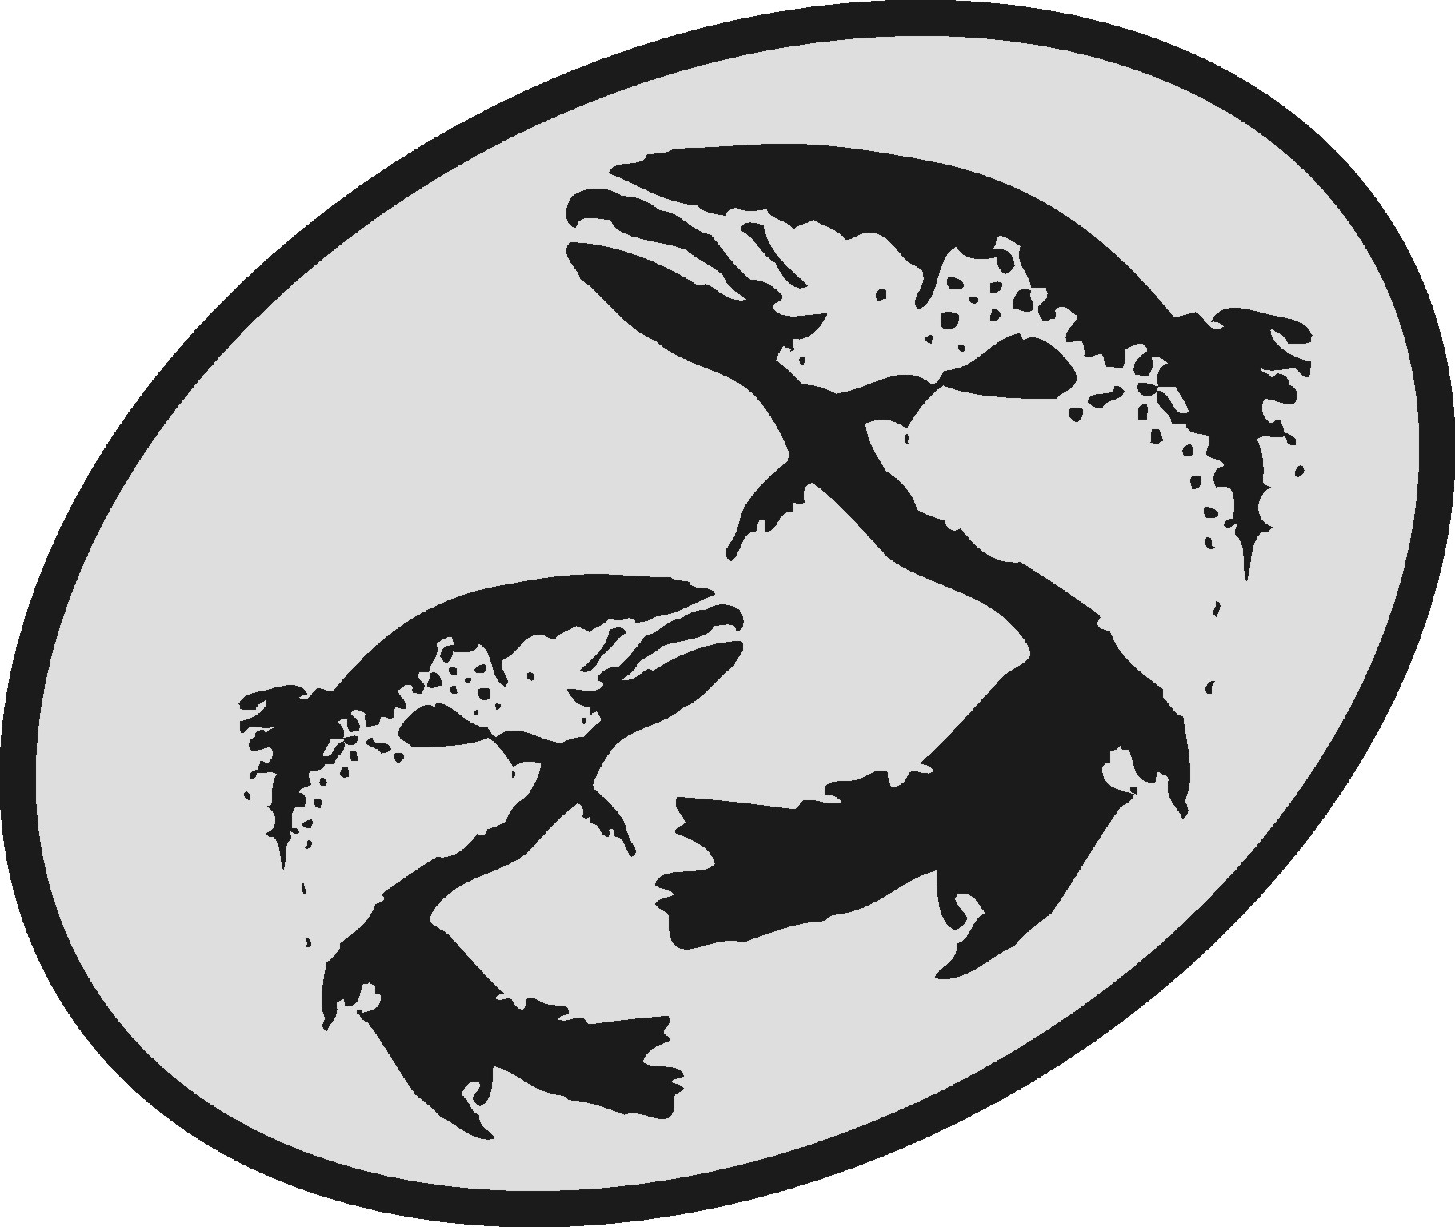The Atlantic Salmon Conservation Foundation

Final Report

This form has been developed to simplify the reporting of your accomplishments to the ASCF. Please use this form for your Final Report, do not send final report in other formats.

The information you provide will be used to document the specific and overall accomplishments of your project and the effectiveness of the ASCF grants and may be subject to audit.

This report is distinct, and may be different, from other final reports you may prepare for your project. The ASCF wishes to receive those reports in addition to this report.

Please note:

- Your Final Report and a statement of expenditures are due on the date provided in Schedule “C” of your contribution agreement.
- Attach copies of receipts for all ASCF funded expenditures.
- Any remaining balance of ASCF grant funds must be returned to the ASCF with the Final Report.
- Do not “refer to attachments” for information requested in this form.
- A final report is required on the date agreed top in your funding agreement. If it is not submitted, future applications to ASCF will not be considered. Amendment of the dates for reporting may be made by mutual agreement.
- Send reports, copies of receipts, photos, maps and final payment invoice to:

darla@salmonconservation.ca (IN, NB or QC projects)
krystal@salmonconservation.ca (NS, PEI or NL projects)
or
The Atlantic Salmon Conservation Foundation
480 Queen Street, Suite 200
Fredericton, NB E3B 1B6
Need help?
For projects that are Interprovincial, in New Brunswick or in Québec, please contact Darla Saunders (Darla@salmonconservation.ca).
For projects in Nova Scotia, Prince Edward Island or Newfoundland and Labrador, please contact Krystal Binns (krystal@salmonconservation.ca).

Office Numbers : Phone: 506-455-9900 Fax: 506-455-9905

Section A Project Information
Year Grant Acquired: 2016 End date: 30-11-2016
Organization: Nashwaak Watershed Association Inc.
Project title: Geomorphic assessment and action planning in the Nashwaak River

Contact: Marieka Chaplin
Address: P.O. Box 314, Station A, Fredericton, E3B 4Y2
Phone: 506-261-4664 Fax: n/a E-mail: director@nashwaakwatershed.ca
ASCF Grant Amount: $ 15,000
Section B Project Description
Category of Project (check all that apply):
- Development of an Atlantic salmon and salmon habitat watershed plan | x
- Protection and restoration of salmon habitat
- Rebuilding of stocks and restoration of salmon populations
- Restoration of access to critical salmon habitat
- Education and awareness on the importance of salmon conservation

Summary
Please state the importance, the objectives as stated in your funding agreement and the major results of this project.
A river’s geomorphology describes how water and sediments move across the landscape to create the river habitats that influence species presence in a watershed. The banks of the Nashwaak River are experiencing extreme eroding in some areas, which has generated community interest and concern that sediments from eroding banks will destroy salmon spawning beds and infill pools. The NWAI sought to understand what larger geomorphic processes were operating throughout the watershed and affecting large scale trends in bank erosion and deposition. Understanding geomorphology is key to prioritizing areas of the river for habitat protection and/or restoration.

The objectives of the project were to:
- Understand erosion and deposition processes in the Nashwaak River
- Describe degredation and threats to salmon habitat within each geomorphic unit
- Develop a short-term (3-year) action plan to prioritize projects, based on the need and capacity of the NWAI, to improve salmon habitat in the upper Nashwaak River

The major results of the project were:
- A geomorphic study was conducted by Parish Aqautic Services on the mainstem of the Nashwaak River from 8 km upstream from Stanley to the mouth of the river in Fredericton (~65 km). Additionally, NWAI staff surveyed the lower 3 km of the Tay River and the lower 3 km of the Penniac Stream.
- A final report on the survey was produced (and is attached) that included two maps: one that divides the river into geomorphic stability classes and the other that describes that primary geomorphic process occurring in each assessed reach. Additional maps were produced for the tributaries surveys that also describe stability classes and dominant processes.
- From the geomorphic survey and an information gathering exercise, the NWAI has drafted an action plan (that is attached) to guide monitoring, restoration, and education activities for the next 3 years with a focus on salmon habitat.

Project performance and evaluation:
Please provide an evaluation and assessment of the performance of your project according to the performance measures outlined in the funding agreement. Include problems you encountered and how they were solved, unexpected outcomes, budget inaccuracies, timing changes, and recommendations for future work.
Overall, the project progressed smoothly and results were as expected and on time. However, a few problems were encountered:
- Due to a changeover in staff for the NWAI, staff and volunteers were not as involved in the field work as we had hoped. However, NWAI’s project coordinator and one board member did receive training in the geomorphic assessment protocol and they were able to independently survey parts of the tributaries.
- Due to the timing of funding provided by other partners on the project, our Action Plan is still in its draft stages but it has been reviewed by all staff and board members.
- Due to the timing of funding provided by other partners, the infographics that will accompany the final Action Plan and Technical Report, will be prepared after Christmas and be finalized in March. The infographics will be passed on to ASCF when they have finalized.
Many recommendations for future work arose from this year’s assessment and action planning. It is clear that there is much to be done to protect and restore salmon habitat within the Nashwaak and its tributaries. Due to financial and staffing limitatons, the NWAI has carefully prioritized monitoring, restoration, and education projects that will be both effective in protecting and improving salmon habitat but that will also be within our budget and capacity.

Performance measure  Please take from Attachment “A” of the Funding Agreement | Results
Length of river assessed | 65 km of the main stem of the Nashwaak was assessed.  3 km of the Tay River and 3 km of the Penniac Stream were also assessed
Number of units (reaches) identified with associated description of the dominant geomorphic process | The main stem was divided into 59 reaches, the Tay into 5 reaches and the Penniac into 4 reaches. The dominant geomorphic process and stability class was defined for each reach and can be found on the maps in the attached final report.
Produce a map illustrating geomorphic units | Maps are included in the final assessment report.
Number of potential action items produced for each reach | Action items were not produced per reach but rather per area (community to community, for example between Taymouth and Durham Bridge). These actions were prioritized by NWAI and fed into the Action Plan
Produce a map showing degraded areas and threats to salmon | A number of maps are included in the final report, which outline areas of habitat degragation (e.g., bank erosion near a cold water input).
Summary report describing the results of the assessment, action items to address degradation and threats to salmon habitat, and prioritization of action items | The final report, as delivered by Parish Aquatic Services, is attached, as is the NWAI’s 3 year action plan.
List of restoration projects and a proposed 3 year schedule for the action plan | A number of potential restoration projects were added to our Action Plan and prioritized. So far, grant applications have been written for at least three projects, due to begin next year.

Section C Project Results

Stream(s) or river(s) where project took place: Nashwaak River, Tay River, Penniac Stream
Total length (km) of stream if known: 113 km (total length of Nashwaak River)
Geographic area inventoried, mapped or assessed (km²): 65 km of the Nashwaak, 3 km of the Tay and 3 km of the Penniac. Both left and right banks were assessed.
UTM/GPS coordinates: Start: lat. 46.3115, lon. -66.8011
End: lat. 45.9591, lon. -66.6180
If applicable, please provide the following information as they apply to your project. Please include only new achievements that have not been reported to ASCF in past projects.

Check | Indicator | Measure | Project Achievement
Development of Atlantic salmon and salmon habitat watershed plan
x | Watershed plans developed/implemented | Number of watersheds involved | 1
 |  | Number of plans | 1
 |  | Km² of watershed under planning and priority setting | ~40 km² of floodplain along the mainstem of the river
Restoration of salmon habitat
 | In-stream habitat restored | Area (m²)
 | Estuarine habitat restored | Area (m²)
 | Lake habitat restored | Area (m²)
 | Riparian area restored or stabilized | Area (m²)
 | Trees and shrubs planted | Number of trees/shrubs
 |  | Area (m²)
 | In-stream structures installed | Number of structures
 | Non-native species removed | Number of species
 | Other species protected or restored | Number of species
Rebuilding of stocks and restoration of salmon populations
 | Fry released/raised | Number of fish
 | Parr released/raised | Number of fish
 | Smolts released | Number of fish
 | Grilse released | Number of fish
 | MSW released | Number of fish
 | Fish tagged | Number of fish tagged
 | Total fish released | Number of fish
 | Stock assessment | Number of fish
Restoration of access to salmon habitat
 | Restored access to habitat | Area (m²)
 | Debris removed | Tonnes
Education and Awareness on the importance of salmon conservation
 | Type of project | Community stewardship
 |  | Education and awareness
 |  | Volunteer training
 | Target Audience and participants | Number of Grade k-12
 |  | Number of Post Secondary
 |  | Number of Landowners contact
 |  | Number of Volunteers
 |  | Number of Public presentations
 |  | Number of Community planning
Other indicators of success
 |  | Value or unit of measure
 |  | Value or unit of measure
Section D Communications and Media

Yes | x | Often, see below | No
- Did you use the ASCF logo or sign?
If No, please explain why not:
_______________________________________________________________________

Yes | x | No
- Did you provide recognition to the Foundation for its grant?
Please explain the nature of the recognition:
The ASCF logo was included on a signboard with our other funders’ logos displayed at all of our community events; we displayed the ASCF sign at our AGM; the ASCF logo was included on our annual newsletter that was distributed to 10,000 households and business in the watershed; a number of social media posts also thanked ASCF for helping to fund our work; our intern participated in a tasting event at an NB liquor store in October; and, finally, the ASCF sign is displayed daily in our office.

- Please indicate which communication tools were used to highlight the project as well as the quantity (check all that apply). Be sure to attach any news clippings to the Final Report.
Newspaper |  | _____________ quantity
Interview |  | _____________
Brochure | x | ____Our annual newsletter, attached_________
Website | x | _____________
Other | x | __Social media posts (Facebook and Twitter) , presentation at annual general meeting.

Yes | x | No
- Are you submitting a project report (other than this one)?
If yes, please be sure to send the foundation a pdf copy.

- Did you send your data and results to another organization or data warehouse where people can access the information? Please state the organizations:
___No____________________________________________________________________

Section E Partner and Funding Information
- Please list all involved partners in the project and their contributions.
Please verify that the total below matches the total presented in Part 5 of the Budget.
Organization name | Type of group* | Description or function of partner | Amount
 |  |  | Cash | In-kind
ASCF | NG | Funding partner | 15,000
Environmental Trust Fund | G | Funding Partner | 55,000
Wildlife Trust Fund | NG |  | 12,000
NWAI | NG | Volunteers of the organization |  | 7,000
Environment Canada NWCF | G |  | 7,000
Sub-total |  |  | 89,000 | 7,000
Total (Cash + In-kind Sub-totals) |  |  | 96,000
*Government (g), non-government (ng)

- Total number of staff paid through ASCF grant: __0______ and staff paid through other organizations:____2 full time and 2 part time____.

- Total number of volunteers involved in the project _10__ and their total hours worked for the project ___250_____.

- Statement of Expenditures
Please provide a detailed financial statement of ASCF grant expenditures, in-kind and other funds using the Budget spreadsheet.

Be sure to attach copy of receipts for ASCF expenditures only to this Final Report.

Section G Recommendations to ASCF
To assist us in improving our process, please provide any comments or suggestions you may have on your experience with the ASCF.

