Executive Summary
The Nashwaak Watershed Association Inc. (NWAI) restarted sampling water quality to monitor various parameters in 2017 after a 14-year hiatus. In 2017, samples were taken once a month from May to November at 11 historic sites and two new sites within the watershed and were analyzed by the RPC lab in Fredericton using their surface water package and Escherichia coli. Results were compared to the Canadian Councils of the Ministers of the Environment (CCME) guidelines and to historic (1980 – 2005) data to infer trends in parameters. In general, the urban sites closer to the mouth of the river had inferior water quality compared to the uninhabited headwaters sites.
Although water quality in 2017 was generally good throughout the watershed, some measured parameters different from levels that would be considered optimal. We have attributed exceedances in water quality guidelines to an increase in sedimentation of the streams due to a number of different activities including soil mining, agriculture, and removal of riparian vegetation. Exceedances in E. coli concentrations in headwater areas are likely due to either the failure of septic tanks on camp properties or the presence of animals near the sampling site. Conversely, several water quality parameters, particularly ammonia and pH, were optimal and appeared to be improving.
In 2017 we deployed 30 temperature loggers around 10 different tributaries to measure water temperature every two hours between May and October. We retrieved 28 loggers and analysed the recorded temperatures. Meteorological conditions cause extremely hot and dry conditions in the summer of 2017, which resulted in very low water levels and warm water temperatures. Many sites exceeded 28°C. Only one site, MacPherson Brook, remained below 20°C all summer, indicating that it is a very important thermal refuge for fish. Over time, the increased monitoring of temperature on our ecologically important tributaries will help us to understand the source of thermal inputs and the location of thermal refuges within the watershed.
Through our other projects, including our Landover Conservation Program, we have focused on educating watershed residents about the importance of native riparian vegetation and promoting environmentally friendly land-uses on retired agricultural properties in order to keep our streams cool and clean. We will continue to develop and expand our Education and Outreach programs to increase awareness and understanding of watershed processes and promote landowner stewardship. We will also continue to work with the City of Fredericton to improve their floodplain properties and encourage the development of green infrastructure.

Contents
Executive Summary 1
Introduction and background 2
Historical water quality data 3
Point Source Inputs 3
Non-Point Source Inputs 4
Historical Temperature Data 6
Objectives: 6
Methods: 6
Water quality monitoring 6
Study Area and Land-use 7
Station Descriptions 7
Temperature monitoring 11
Results 14
Water Quality Monitoring 14
Water Quality Discussion 26
Temperature Monitoring 27
Discussion of Water Temperature 30
Challenges 30
Conclusions 31
Appendix B: Logger data 31

Introduction and background
There are large temporal gaps in monitoring the Nashwaak watershed’s health. Long-term monitoring can support the use of statistical trend assessment to help evaluate the influences of human activities & other factors on the watershed over long periods. The Department of Fisheries and Oceans (DFO)’s Ecological Restoration of Degraded Habitats handbook recognizes both water quality and high temperatures as limiting factors to fish populations. Water quality and temperature were noted as data deficient areas in our 2017-2020 Action Plan.
Maintaining the quality of the surface water is extremely important for ensuring a healthy watershed. Due to a broad range of natural & anthropogenic influences, the quality & temperature of a river’s water can vary substantially over time & space. Much has changed in the watershed over the last 15 years, including urbanization, putting stress on the river due to an increased human population, which has led to the removal of riparian vegetation and the release of pesticides, fuels, nutrients, and bacteria. Our 2016 geomorphic survey of the lower Nashwaak recognized large areas of erosion, especially downriver from Taymouth. Bank erosion increases siltation of rivers and leads to increased levels of metals and suspended sediments. Erosion was particularly noticeable in areas where riparian vegetation had been removed. Additionally, the Sisson Brook Mine will soon begin construction. Having a knowledge of what the water quality is before it begins operating will allow us to calculate its effects. Therefore, in 2017 NWAI resumed monitoring water quality at 11 historic sampling sites and at two new sites.
Going forward, the regular monitoring of water quality will allow us to:
- Identify problem areas or industries;
- Assess the condition of the river and how it has changed over the last decade and a half;
- Define and approach private landowners in problem areas and discuss management options with them;
- Determine how the changes in water quality are affecting wildlife and habitat, particularly Atlantic salmon;
- Make decisions on the management of the river’s health; and
- Promote community stewardship of the Nashwaak River by making the information public.

The risk of extreme temperature events in a river increases with riparian zone alteration and water extraction (Caissie, 2006). The removal of forests requires road networks, which typically lead to an increase in water temperatures and sediment in rivers. Both factors impact the distribution of cool- and cold-water fishes (Curry & Gautreau, 2010). Other factors that increase river temperatures include higher air temperatures, sedimentation, and input from water treatment plants. Though most present-day industrial and municipal operations are regulated to protect aquatic ecosystems, the persistent impacts from historical forestry operations remain unknown.
Warmer water contains less oxygen than colder water so as river temperatures rise and dissolved oxygen decreases, fish begin to experience stress, particularly salmonids (salmon, charr, and trout species). To escape warm waters in the mid-summer, many fish species will move to smaller, cooler tributaries or pools near cold seeps to survive. High temperatures can delay migration; exhaust energy reserves, which can result in reproductive failure; reduce egg survival; slow growth of fry and smolts; and decrease resistance to disease (McCollough, 1999).
“Spring-fed creeks” occur in areas where there are deep deposits of coarse soils that infiltrate a large portion of rain or snowmelt and where water tables are large and steeply sloped. Spring-fed creeks have more uniform and stable flows and temperatures. They can be extremely productive habitat for cold-water fish and can provide a refuge for fish from high summer water temperatures. Major upwelling or groundwater discharge areas are also critical locations for spawning and egg incubation. Areas of coarse gravel or sand with upwelling groundwater are the most sensitive and rare environments in a salmonid stream. Spring-fed streams are ecologically important as, being fed by groundwater, they are less susceptible to variations in air temperature & can buffer changes in climate. They support animals that don’t occur in the main stem & maintain the base flow of the river.
Adult Atlantic salmon are less tolerant to high temperatures than juveniles. A DFO (2012) report determined that incipient lethal temperature (or the temperature that a fish can tolerate for at least seven days) was 27.8°C for juveniles, while for adults it was around 25°C. The report noted that juvenile and adult salmon begin aggregating near cool water sources and stopped feeding when minimum night time temperatures remained above 20°C for two consecutive nights. Therefore, 20°C is considered the threshold minimum temperature for assessing physiological stress in Atlantic salmon (DFO, 2012).
Determining the location of, & protecting, cold-water tributaries were noted as High Priority action items in our management plan. Monitoring the temperature of our ecologically important tributaries will help us to:
- Better understand the sources of thermal inputs and where the cold-water (<20°C) refuges, which are so important to species such as the Endangered Atlantic salmon and other salmonids, are located within the watershed (as recommended by DFO’s Ecological Restoration of Degraded Habitats document);
- Communicate the importance of cold-water refuges to the public; and
- Protect, manage, and restore those areas in the future.

Historical water quality data
In 1996, and from 1999 to 2002, NWAI conducted monthly water quality monitoring at 18 sites. Additional data (1980, 1988, 2005) for some of those sites were obtained from the Department of Environment and Local Government (DELG). Only one site in the watershed (NASH-B at the Marysville Bridge) was monitored between 2005 and 2016. These data are available in our 2017 State of the Nashwaak Report. Therefore, the NWAI resumed water quality and temperature monitoring in 2017 at 13 sites after a 15-year hiatus. A site map can be found in Figure 1.

Point Source Inputs
Point source pollution can be traced back to a specific source, such as a discharge pipe. Point source inputs in the Nashwaak watershed include:
- Storm water outfalls in Marysville, Barkers Point, and Stanley
  - Carry materials such as petroleum hydrocarbons, metals, road salt, pathogens, and silt;
  - May alter discharge (flow) regimes.
- Municipal waste water treatment plants in Barkers Point and Stanley
  - Can introduce suspended solids, bacteria, chlorine, ammonia, biochemical oxygen demand (BOD), phosphorus, and nitrate;
  - Waste water can alter the temperature and oxygen levels of the receiving waters;
  - All waste water outfalls in the watershed are required to be licensed by the NB DELG and when facilities are operating in accordance to the permit limits, the discharge should not result in a violation of the water quality criteria.
- Lumber mill in Devon, sawmill at McGlaggon Bridge (closed?), and veneer mill in Napadogan (closed in 2008)
  - Potential contamination by hydrocarbons, suspended solids, metals, and BOD.
- Former army encampment at McGivney
  - Used as an ammunitions depot between the late 1930s and mid-1950s, and
  - Potential continued contamination from ammonium, nitrate, hydrocarbons, and explosives.

Non-Point Source Inputs
Non-point source pollution comes from many diffuse sources and cannot be pinpointed to a specific location. Non-point source pollution poses a significant threat to New Brunswick’s rivers. Carried by snowmelt, rain water, and ground water, non-point source pollution contributes sediments, nutrients, toxins, and pathogens to watercourses (Maine Rivers, 2005). Non-point source pollution in the Nashwaak watershed includes:
- Urbanization in Marysville and Fredericton
  - Can alter streams and rivers by culverts and ditching;
  - Construction can lead to sediment runoff;
  - Hard surfacing of land can lead to run off and altered discharge patterns that cause erosion downstream;
  - Increased flashiness of streams; and
  - Increased human populations lead to increased releases of contaminants to the environment (metals, fuels, oils, pesticides, etc.).
- Active and closed domestic and industrial dump sites at Ryan Brook, Cross Creek Station, Durham Bridge, and Tay River
  - A wide array of potential contaminants not easily quantified due to the lack of knowledge about what’s buried there. Possibilities include chloride, hydrocarbons, metals, and BOD.
- Cattle access to the river below Durham Bridge and on the Tay River due to inadequate fencing
  - Introduction of bacteria and nutrients, erosion of banks leading to suspended solids loading.
- Agriculture
  - Removal of riparian vegetation and introduction of bacteria, nitrate, phosphorus, and suspended solids through surface run-off and erosion; and
  - Spreading of manure can introduce pathogens and decrease oxygen content of water.
- Topsoil mining below Durham Bridge and aggregate (gravel) mining operations
  - Increases suspended solids in run-off as well as nutrient and bacteriological loading when manure is spread of re-seeding; and
  - Leads to eroded banks and widening of the river.
- Industrial/commercial activities in Marysville and Barkers Point
  - A wide array of potential contaminant issues including hydrocarbon, metals, etc.
- Public and logging road construction and maintenance
  - Exposes soils leading to suspended solids loading and altered discharge pattern changes;
  - Culverts can impact fish passage if not properly installed; and
  - Increases salt, chemical, and nutrient runoff.
- Forestry
  - Exposes soils over a large land mass, leading to suspended solids loading, metal leaching, reduction of shading, herbicide spraying that can contaminate waters, and road construction that can impact fish passage and change drainage patterns; and
  - Clear cutting can alter the timing of snow melt and reduce biodiversity.
- Camp development in the headwaters and septic leaks
  - Introduction of nutrients and bacteria.
- Bank erosion, especially near Taymouth
  - Introduction of metals, suspended solids loading, etc.
- Future mine development at Sisson Brook
  - Potential for contamination by metals and hydrocarbons;
  - Increased road construction will alter drainage patterns; and
  - Diversion of water for the mine

The underlying bedrock of the Nashwaak watershed consists of metamorphic and igneous rocks near the headwaters and of sandstone in the central and lower watershed. These sediments contribute to high concentrations of metals such as aluminum and iron. The bedrock is covered by moraine blankets deposited by glaciers between 85,000 and 11,000 years ago. Most soils are well-drained to moderately well-drained but are highly erodible (Parish Aquatic Services, 2016).
Alluvial (river-associated) deposits along the riverbanks consist of gravel and sandy gravel. Recent alluvial deposits cover the Tay and Nashwaak River valleys (DNR, 2007). These deposits tend to be capped with a 0.5 to 1 m thick band of more fertile fine-grained silts and sands.
Ultimately, the characteristics of the bedrock and soils play major roles in the movement of water over and through the watershed. Where and how the water moves provide opportunities for some plants and animals and constraints for others.

Historical Temperature Data
Limited historical temperature data exist for the Nashwaak watershed. Temperatures loggers were placed by the NWAI in at least seven locations in 2002 and several locations in 1999; however, the whereabouts of the raw data is unknown. Information was pulled from a NWAI’s Water Classification report (NWAI, 2004). For the logger data from reports, measurements ranged from 0.3 to 25°C for the main stem of the river. Temperatures peaked from the last week of June to first week of August and then dropped off quickly in September. NWAI’s Water Classification report (NWAI, 2004) noted that overall results for the watershed were within acceptable range for salmonids and two tributaries (Messer’s Brook and an unnamed tributary to the Tay River near its mouth) displayed temperatures of 8-11°C throughout the year, which are exceptional temperature regimes. Mean summer temperatures from the 2002 logger data ranged from a low of 14.38±2.48°C for Cathle Brook to a high of 17.05±3.81°C for Cross Creek Stream; however, data was not taken over exactly the same time period and it’s unclear if erroneous data (the loggers being in a vehicle, for example) were included in the calculations.
Temperature was also measured for some water quality grab samples taken between 1999 and 2015. Measurements grab samples ranged from a low of 0.03°C in February 2011 to a high of 28.3°C in August 2015 (both extremes were measured at station NASH-B, Marysville Bridge). Temperature of water quality grab samples exceeded 20°C 23 times.

Objectives:
The overarching objective of the monitoring project was to increase the NWAI’s knowledge of the health of our watershed to grow our capacity to make restoration and management decisions based on sound science. Evaluation of trends will allow the NWAI to better develop and evaluate watershed and habitat management initiatives, assess the effects of particular industries on water quality and temperature, predict future river conditions, communicate the health of the watershed to public, and assess the effects of our habitat restoration activities.

Methods:

Water quality monitoring
Monthly sampling for water quality was carried out at 11 historic sampling sites throughout the watershed between May and November. In addition, two new sites (Campbell Creek and MacPherson Brook) were sampled twice throughout the summer (Fig. 1). We chose these sites (out of 18 historic sites) based on our budget, ease of access (it appeared as if some historic locations were no longer accessible without an ATV), and location (i.e., evenly spread throughout the watershed). One site, NASH-B, was sampled regularly by DELG staff. Sites were chosen to capture the water quality from the headwaters to the mouth.
Grab samples were taken according to DELG instructions in sterilized bottles provided by RPC Fredericton. A field sheet, provided by DELG, was completed that included information such as: weather, rainfall, bank stability, presence of garbage, and presence of people swimming or fishing. Physical parameters (pH, temperature, and TDS) were measured with a handheld probe (Oakton PT Testr 35) and recorded on the field sheet. The probe was calibrated for pH in May and again in July using the solutions provided by Oakton. We allowed the probe to stabilize for 30-60 seconds before taking a reading. All field sheets were scanned and emailed to DELG. Blank DELG and RPC field sheets can be found in Appendix B.
Samples were stored in a cooler containing ice packs until they could be delivered to the lab (RPC Fredericton). If the samples could not be delivered to the lab on the same day that they were taken, samples were stored in the refrigerator overnight and delivered to the lab the next morning.
Samples were analyzed for E. Coli and the surface water package by RPC. Data were entered into a central database and graphically compared to historic (1980-2005) data. Parameters were compared to standards developed by the Canadian Council of Ministers of the Environments (CCME). These standards depend on the uses for which that water is intended. We considered the standards for the protection of aquatic life and those for recreational waters that were relevant to our analytical package. Results over the CCME limits were highlighted in our database.

Study Area and Land-use
The Nashwaak watershed is located in central New Brunswick and has a drainage area of ~1,700 km². The watershed is sparsely populated (~15,000 people) except for the lower 5 km and remains relatively undeveloped, with 92% of the land covered by forest. Ecologically, the Nashwaak watershed contributes significantly to the biodiversity of the province, containing rare and unique species and habitat, including at least 31 species of rare or endangered animals and 13 species of rare or endangered plants.
A variety of activities take place throughout the watershed ranging from commercial forestry, soil mining, agriculture, and residential development near the river’s mouth. Each land-use creates a different impact on the rivers and streams. Although there has been a marked improvement from the past decades, the Nashwaak River is still affected by several point and non-point source types of pollution including: chemical, toxic, and deoxygenating wastes from industry, forest spraying, agricultural and urban runoff, etc.

Station Descriptions

Figure 1 Map of the water quality sampling sites. Active sites (those sampled in 2017) are denoted in green while inactive sites (those not sampled since 2005 or earlier are denoted in red.
Stations sampled in 2017 are described below:

NASH-A: Barker’s Point (DELG Station 10535)
This station is on the mainstem of the Nashwaak near the mouth of the river, with approximately 1,627 km² of drainage area above. Additive drainage from Fisher and Kaines Brooks (14 km²) is comprised of 46% forested land, 10% agricultural land, 40% urban development, and 4% roadways. Pollution sources of note at this station include a major lumber mill in Devon, urban storm water inputs, industrial and commercial activities, and dense human occupation. This area is used extensively for hiking, fishing, canoeing, and cycling.
NASH-B: Marysville (DELG Station 10536)
This station is located just above the bridge in Marysville. Campbell Creek and McConaghy and Second Gore Brooks. Additive drainage is comprised of 87.4% forested land, 6% urban development, and minor wetland, agricultural land, road ways, and gravel pits. There is significant development along both sides of the river near this station. Pollution sources of note include urban development, storm water inputs, and dense human occupation. This area is used extensively for fishing and recreation.
This site is sampled by DELG.
NASH-D: Penniac Stream (DELG Station 10539)
This station is located on the Penniac Stream just above the new bridge on rte. 628. Several tributaries drain to this station: the North Branch of the Penniac Stream, as well as Gilmore, Whitlock, Allen, Jakes, Moore, Baxter, Moosehole, and Estey Brooks. Additive drainage is comprised of 92.6% forested land, 4% agriculture, 2% wetland and minor human occupation, gravel pits, and roadways. Pollution sources of note include forestry practices, top soil mining, and significant cattle grazing. This area is used for hunting, fishing, and recreation.
This station has data from 1988, 1999 to 2002 and 2005. Data cover May to October.
NASH-F Dunbar Stream (Station ID 10541)
This station is on Dunbar Stream about 30 m upstream from the confluence with the Nashwaak and downstream from Dunbar Falls. The station also receives water from Thomas Lake (2 Ha), Stickles Lake (1.5 Ha), North and South Dunbar Brooks, Tinkettle Brook, and Seymour Brook. Pollution sources of note include forestry and agriculture. A major waterfall (Dunbar Falls) prevents fish from ascending the stream but provides recreational opportunities for residents.
NASH-G Tay River (Station ID 10542)
This station is on the Tay River approximately 50 m upstream from its confluence with the Nashwaak River. This station also receives water from the North Tay River, the South Tay River, Robinson, Pidgeon, Limekiln, Big, Barker, and Little Tay Brooks. Additive drainage is 93% forested and 5% agricultural land. Pollution sources of note include camp lot development, forestry, and major bank erosion in the lower 3 – 5 km of this river. The Tay River is popular for swimming and angling.
NASH-I Young’s Brook/ Nashwaak Bridge (DELG Station 10544)
NASH-I is located on the mainstem of the Nashwaak above the confluence with Young’s Brook near the community of Nashwaak Bridge while NASH-I2 is located at the mouth of Young’s Brook. As they are so close the data were analyzed together and called NASH-I. Station NASH-I2 was sampled in 2017. The station also receives water from Schoolhouse, Cathle, and Falls Brooks. Additive drainage is small (25 km²) and 98% forested land with minor agriculture and human occupation. Important pollution sources include a former sawmill at Cathle Brook, camp development, and minor agriculture near Ward Settlement. This area is popular for swimming and angling.
NASH-J and J2 Cross Creek Stream (DELG Station 16938)
Station NASH-J is located on Cross Creek stream approximately 400 m upstream from the walking bridge near the mouth of the stream. Station NASH-J2, sampled in 2017, is located approximately 50 m above the walking bridge. As they are so close the data were analyzed together and called NASH-J. This station receives water from Arnold, McGivney, Six Mile, Five Mile, Four Mile, and Two Mile Brooks as well as from the North and West Branches of Cross Creek Stream and from Arnold Brook Lake (<0.5 Ha). Additive drainage is 81.3% forested land, 7% agriculture, and minor human occupation and wetlands. Pollution sources of note include agriculture near Williamsburg, Centreville, and Greenhill, a small sawmill, a former army encampment at Five Mile Brook, and a closed landfill.
Cross Creek has traditionally been the second most productive salmon producing tributary to the Nashwaak River. There is a heavily used walking trail along the stream and it is a popular place to swim. Just upstream from the mouth there is a double waterfall.
NASH-L: Currieburg (DELG Station 10547)
This station is located on the Nashwaak River downstream of Currieburg. It receives water from Grand John Lake (12 Ha), Rocky Brook Lake (4 Ha), Fleetwood Lakes (2 Ha), and Mountain, Rocky, Grand John, Wadham, McLean, Middle, Meadow, and Ryan Brooks. The 232 km² drainage to this site is comprised of 93% forested land and 6% wetland. There is little human occupation in this area aside from hunting camps. Pollution sources of note include a closed landfill on Ryan Brook, gravel pits at the headwaters of McLean and Rocky Brooks, a cluster of camps near Grand John Brook, and forestry. There are a series of waterfalls at Rocky Brook known as the Rocky Brook Stairs.
NASH-T: Napadogan Stream (DELG 15449)
This station is located on the Napadogan Stream about 8 km above the confluence with the Nashwaak River at the intersection with the Saint Anne Nackawic Haul Road. This station also receives water from Mud Lake (7 Ha), Napadogan Lake (20 Ha), Martha Lake (1.5 Ha), East, Bird, and Sisson Brooks. The 71 km² drainage to this location is comprised of 98% forested land and 2% wetland. The major source of pollution minor camp development, forestry, and road construction. The Sisson Brook Mine could cause future pollution issues.
NASH-N: Narrows Mountain (DELG Station 10549)
This station is located on the Nashwaak River at Valley Road Bridge near Narrows Mountain. Elevations in this region are around 185 m. The station receives water from Hayden Brook and several unnamed tributaries. The 218 km² drainage area is 100% forested land with minor logging road development. Sources of pollution are minor camp development and forestry practices.
NASH-P and NASH-P2: South Sisters Brook (DELG Station 10551)
NASH-P was located on the Nashwaak River at the bridge below South Sisters Brook. AS this site was not accessible in 2017, samples were taken at NASH-P2, ~100 m downstream of South Sisters Brook. This station receives water from Doughboy Lake (3 Ha), Little Doughboy Lakes, Silver Lake (3 Ha), Cedar Lake (3 Ha), East, Doughboy, Little Doughboy, North Sisters, and South Sisters Brooks, as well as several unnamed tributaries. Land use draining to this site (147 km²) is ~100% forested. Sources of pollution include minor camp development, forestry, and road construction.
NASH-Q: Gorby Gulch (DELG Station 10552)
This station is located on the mainstem of the Nashwaak approximately 20 m upstream from the Gorby Gulch Road Bridge. This is the uppermost monitored location on the mainstem and is at an elevation of 275 m. This station receives water from Upper Nashwaak Lake (93 Ha), Governor’s, Otter, and Welch Brooks, and the East and West Branches of the Nashwaak River. The 87 km² of land drainage above the station is 100% forested. Pollution source include minor camp development, forestry, and road construction.
MacPherson Brook
This station is located near the mouth of MacPherson Brook in Giant’s Glen. It receives water only from that brook. The 10 km² land drainage above the station is almost entirely forested with minor development and agricultural land. Pollution sources include sedimentation of the stream due to an eroding bank, agriculture, and forestry practices.

Campbell Creek
This station is located just below the bridge over Campbell Creek on River Street. This station also receives water from First and Second Gore Brooks, and some unnamed tributaries. The 28 km² land drainage is almost 100% forested. There is an old dam, which has sprung a leak and drained the former head pond, above the station that is impeding water flow and preventing fish passage. There is also a large beaver dam at the culvert above the dam. Pollution sources include the beavers, sedimentation from the draining of the former head pond, road salt, and forestry practices.

Temperature monitoring
NWAI consulted with PhD candidate Antóin O’Sullivan at Canadian Rivers Institute (CRI) regarding the placement and casings for the loggers. Funding allowed us to purchase 30 HOBO 64K Pendant Loggers from Onset. Key tributaries were selected for monitoring based on locations (spread throughout the watershed), size (a mixture of larger and smaller tributaries), and ease of access. We chose tributaries close to our water quality monitoring sites in order to allow us to keep an eye on them and check them monthly.
HOBOware software was used to set up and launch the loggers. A delayed start was chosen so that the loggers did not record the temperature of the office or vehicle before they were deployed. The loggers were set to recorded water temperature every two hours. Casings were made to protect the loggers from UV radiation, current, and debris. The casings were made from grey PVC pipe cut to 15 cm lengths drilled with 5 mm diameter holes. The PVC was attached to a 60 cm piece of coated rebar with a hose clamp and two zip ties. After launching, the logger was inserted into the PVC pipe and secured with a length of high tensile multi-strand wire and a zip tie was secured through the top of the pipe to prevent the logger from floating to the surface (Fig. 2). The design was similar to that used by students at the Canadian Rivers Institute (CRI) and by NWAI staff at previous jobs.
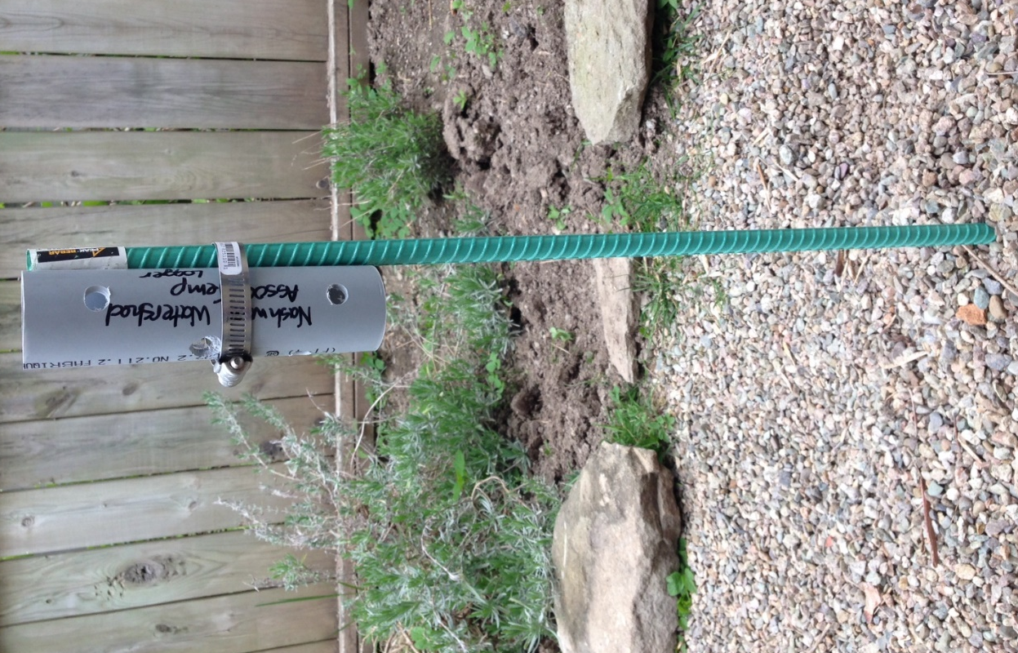
Figure 2. A logger in its casing prior to deployment. Zip ties were added for extra security.
The loggers were deployed throughout the watershed between 31 May and 12 June when water levels started to drop (Fig. 3). We placed one logger in the main stem >50 m upstream from the tributary, one >50 m downstream from the tributary and one in the tributary close to, or at, the mouth (Fig. 4). We chose locations where water was at least knee deep and there was appropriate substrate. Sand, gravel, and cobble substrates were the easiest; silty substrate and bedrock provided challenges. The rebar was hammered into the substrate at least 1 foot so that the bottom of the PVC casing sat flush with the substrate. The pendant logger was pushed down inside the casing to ensure that it was in the deepest water possible. Rocks were piled in a cairn around the logger to prevent it from moving to much and to help us in locating it. A waypoint was taken at each logger location.
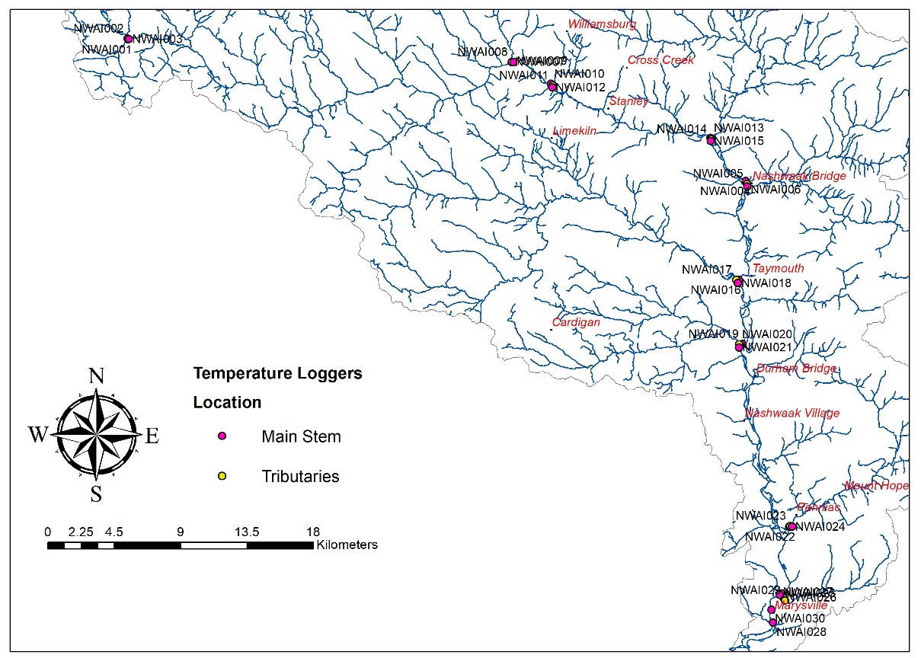
Figure 3. A map of the location of the 30 loggers installed in 2017. Pink denotes the loggers placed in the main stem of the river and yellow denotes the loggers placed in the tributaries.
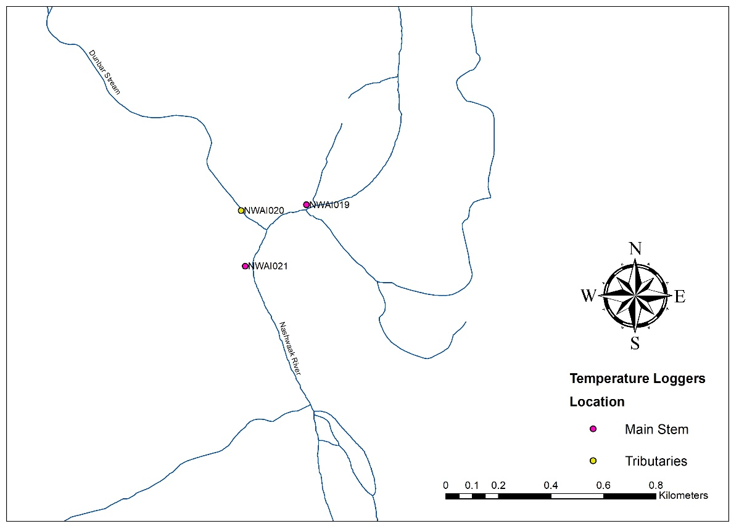
Figure 4. An example of the upstream-downstream-mouth layout of the loggers at Dunbar Stream
We checked on the loggers at least monthly. Most had to be moved at the end of July/start of August to ensure that the loggers remained submerged. In most cases, this meant finding an appropriate place (slightly deeper) within a 2-metre radius of the initial location. No loggers were moved more than a few metres or to water that was drastically deeper. One logger was collected on 12 September and 27 were collected between 13 and 16 October. Two loggers were lost. One logger (below Campbell Creek) was taken some time in August and the other (above Marysville Bridge) was lost upon retrieval from the site when a wire broke. Loggers were read out immediately upon returning to the office. Temperatures that were recorded while the loggers were sitting in the truck or office were not included in the dataset.

Results

Water Quality Monitoring
Complete water quality data tables are available in Appendix A. Selected parameters are presented in the tables and figures below. Data were grouped per decade (1980s, 1990s, etc.) and analysed graphically per site to look at changes over time or between sites. Not all sites had data for a specific parameter or date, which made comparisons, in some cases, very difficult. Limits for certain contaminants have been developed by the Canadian Council of Environment Minsters (CCME, 1999).
Overall water quality improves moving upstream in the watershed. Patterns of water quality parameters were as expected based on land use patters. Areas of concern are from the Penniac Stream downstream to the mouth of the river.

Field Observations
The NWAI recorded field observations at the time of sampling. The field sheet was provided by DELG. Observations included bank conditions, weather, presence of swimmers, etc. A blank field sheet can be found in Appendix B.
Temperature, total dissolved solids, and pH were measured with an Oakton PTTsr 35 probe at the same site where grab samples were taken.

Total Dissolved Solids
Total dissolved solids (TDS) is a measure of the combined organic and inorganic substances suspended in water. It is measured in mg/L. TDS comprise inorganic salts (mainly calcium, magnesium, potassium, sodium, bicarbonates, chlorides, and sulfates) and a small amount of organic matter dissolved in water.
There is no CCME limit for TDS but 1,000 mg/L is considered brackish. With enough data, a normal range can be determined and fluctuations outside of this range can serve as an indication of a problem.
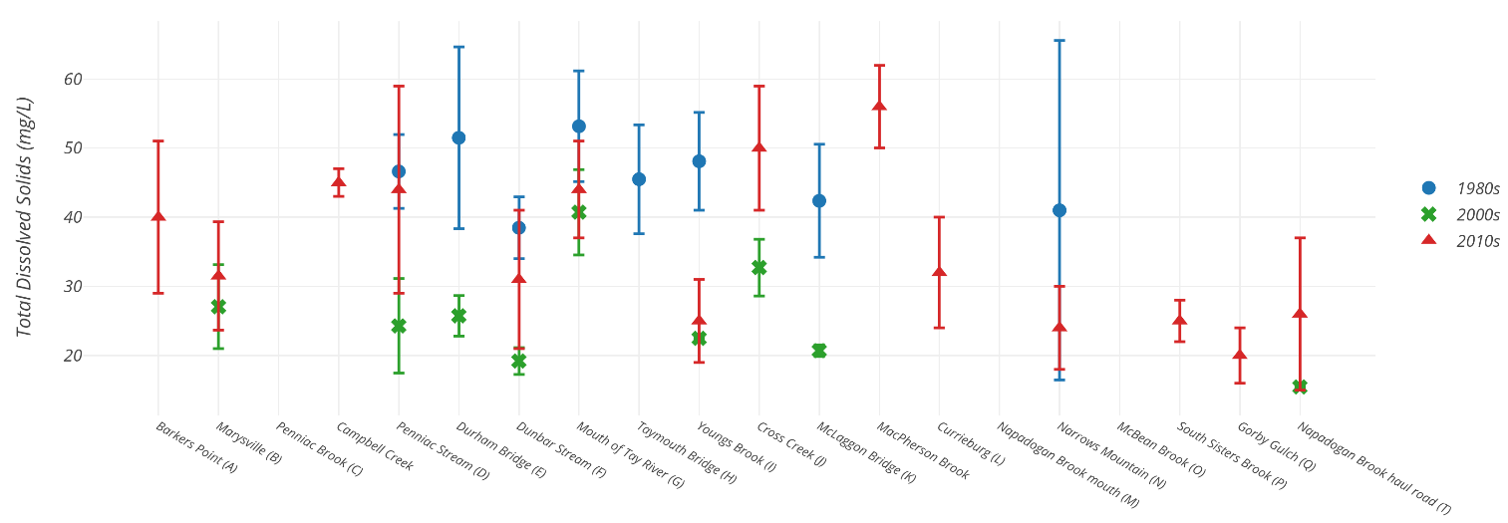
Figure 5 Mean total dissolved solid contents (mg/L) per site per decade for the Nashwaak watershed. Error bars represent standard deviation.
Field measurements of TDS contents were available for selected sites from the 1980s and 2000s and for all sampled sites in 2017 (Fig. 5). TDS contents were, in general, lowest in the 2000s and highest in the 1980s. Most results were within the 25 to 50 mg/L range (now considered the normal range for the Nashwaak Watershed) with the headwater sites having slightly lower values (20 -30 mg/L).
Potential sources of TDS include agricultural and residential run-off, storm-water run-off, and road salts. TDS may also arise from weathering of rocks and erosion of soils, which could explain the elevated levels at the mouth of the Tay and near Durham Bridge and Penniac Stream where soils mining is more common.

Suspended Sediments and Turbidity
Turbidity is a measure of the extent to which light penetration in water is reduced due to the amount of sediment suspended in the water column. Suspended sediments are fine particles, primarily clays, silts, and fine sands that require low water velocities to remain in suspension. It naturally varies depending on soil type, shoreline erosion, and surrounding land use. Generally, values below 10 NTU are acceptable. Values greater than 10 NTU mean that light will be blocked from reaching aquatic plants and feeding of zooplankton will be disrupted. 50 NTUs is the CCME limit for recreational uses while the CCME guideline for the protection of aquatic life is an increase of 8 NTUs from background values for short-term exposure or 2 NTUs for longer exposure. Turbidity normally spikes during and immediately after periods of high rainfall or snowmelt.
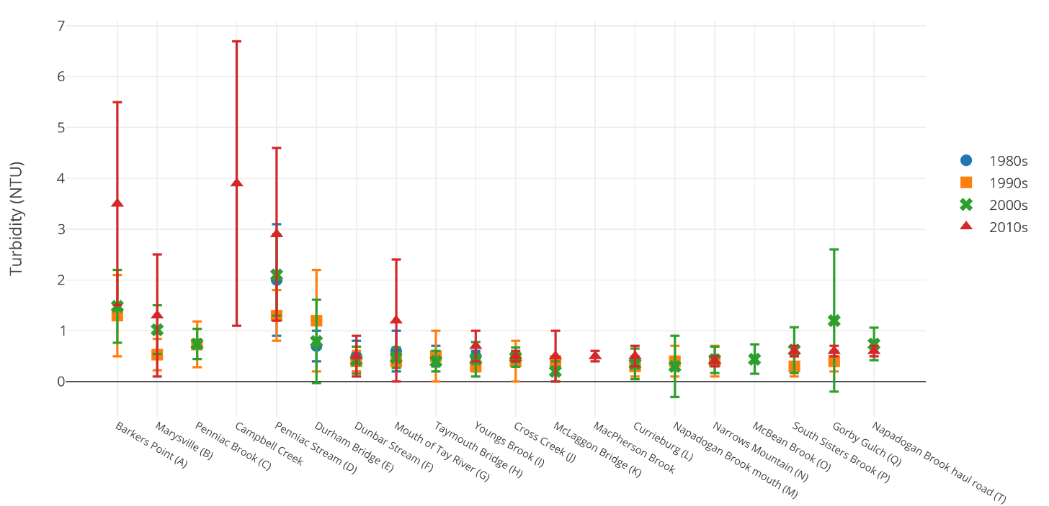
Figure 6 Turbidity (NTU) per site per decade in the watershed. Error bars represent standard deviation.
Values were, in general, very low for all sites (median values of 0.4 to 2.1) (Fig. 6). Values were highest in 2017 and 2005. Slight increases were observed near Gorby Gulch, and Marysville, with Barker’s Point, Campbell Creek, and Penniac Stream exhibiting the highest values. Visual observations following significant summer precipitation in 2001 and 2002 noted an increase in turbidity on the Penniac Stream and below Durham Bridge. Residents also note that streams “run muddy” (i.e., have higher turbidity values) after heavy rainfalls. Topsoil mining, sedimentation due to forestry practices, and road construction were determined to be major sources in NWAI’s 2004 report.
Suspended sediments consist of clay, silt, fine particles of organic and inorganic matter, plankton and other microscopic organisms. The CCME guideline for the protection of aquatic life is an increase of no more than 25 mg/L for short term exposure (<24 hours) and 5 mg/L for longer term exposure. Suspended sediment loads have, in general, increased at most sites from the 1980s to the 2000s but were not measured in 2017 as it was not part of RPC’s surface water package. Increased sediment loads can aggrade channels, which in turn leads to bank erosion and the destruction of habitat. It appears, however, that detection limits increased from the 1980s to the 2000s, making comparisons difficult.

pH
pH is a measure of the acid/basic nature of the water. It is the logarithmic measurement of free hydrogen ions in a solution. It is measured on a scale from 0-14 with 0 being acidic, 14 being basic, and 7 being neutral. The buffering capacity of a stream is its ability to resist changes in the pH.
pH varies naturally but can be affected by human interference, surficial geology, wastewater run-off, the presence of wetlands, and by acid rain. Low pH levels create stress for fish while high pH can lead to death or damage to eyes and gills. CCME limits for pH are between 6.5 and 9.0. pH must be measured in the field because the value will change and approach 7 as carbon dioxide from the air dissolves in the water. Data comparisons have been challenging because pH was not regularly monitored in the field between 1980 and 2002. Lab measurements were not compared here.
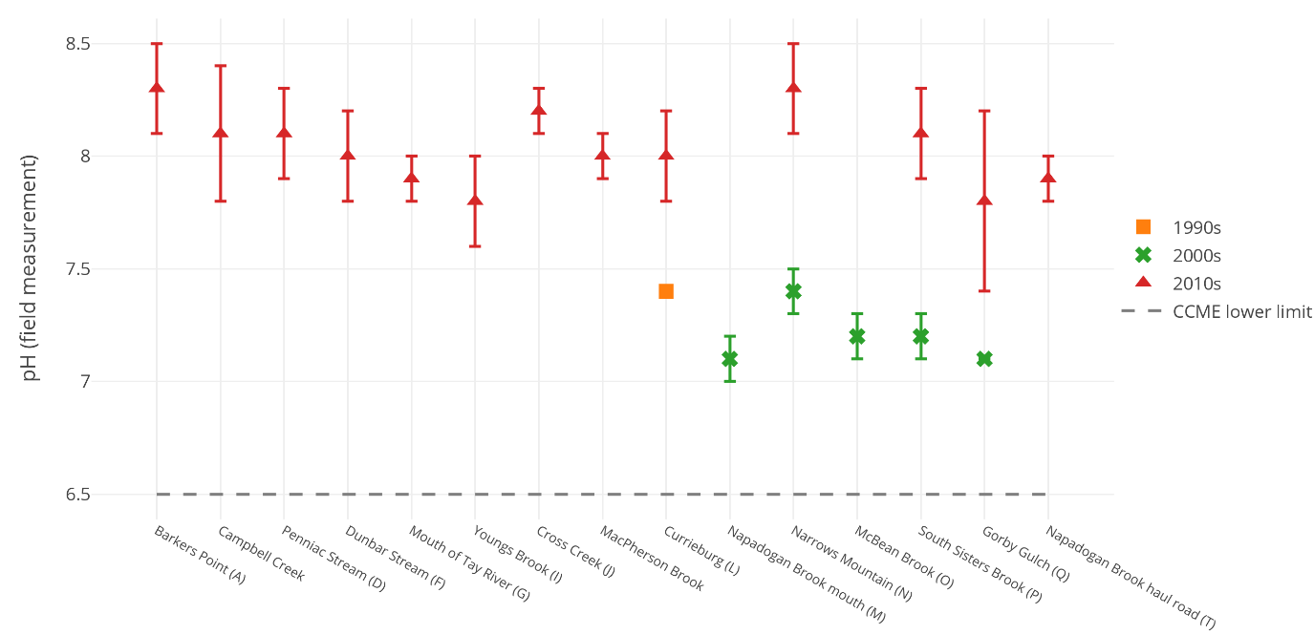
Figure 7. pH (values measured in the field) per site per decade in the watershed (for those sites where data were available). Errors bars represent standard deviation. Historic field measurements were not available for most sites.
For the data available, pH levels for the watershed were within the CCME limits and within a small range (mean values ranged only from 7.8 to 8.3 in 2017) (Fig. 7). In general, pH is lower (more acidic) in the upper reaches of the watershed and higher near the mouth of the river, though there are exceptions. Data also show that pH has increased (become less acidic) at every site from the 1990s/2000s to the 2010s, but, as mentioned above, little historic data are available for field measurements. Values measured in 2017 are considered protective of aquatic life.

Dissolved Oxygen
DO was not measured in 2017, except by DELG at NASH-B as it was not part of the RPC surface water package. Dissolved oxygen (DO) is a widely used and important indicator of aquatic health. Organisms require oxygen dissolved in the water to survive. Levels below 6.5 mg/L can cause stress, especially for cold water fish, and levels below 9.5 mg/L can cause stress to early life forms. Dissolved oxygen decreases as water temperature increases (i.e., warm water can hold less oxygen than the same volume of cold water). Sewage or algal blooms resulting from elevated nutrients can lower the DO content by consuming oxygen.
Rivers, in general, can accept and assimilate a certain amount of oxygen-demanding wastes. However, if too much organic material is discharged, oxygen can become severely depleted leaving insufficient oxygen for aquatic organisms. Fish under stress from low oxygen levels become more susceptible to the effects of other substances discharged into the river.
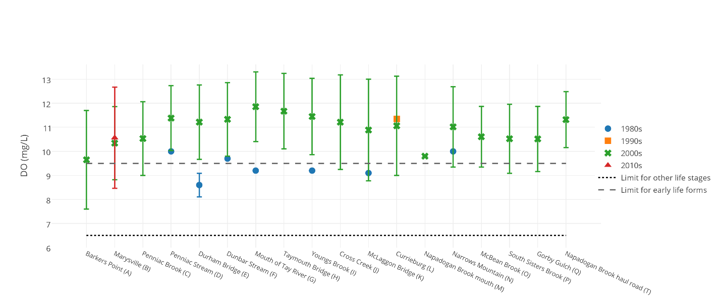
Figure 8 Mean dissolved oxygen content (mg/L) per site per decade. Error bars represent standard deviation. Dashed lines indicate CCME limits for early life forms (9.5 mg/L) and all other life stages (6.5 mg/L).
In general, DO contents have increased from the 1980s, when several sites in the middle of the watershed (Durham Bridge, mouth of the Tay, Young’s Brook, and McLaggon Bridge) were below the CCME limit for early life stages (Fig. 8). About half of the results at Barker’s Point in the 2000s and a third of the results from Marysville in both the 2000s and the 2010s were below the limit as well. One or two samples from the headwaters sites in the 2000s were also below the limit. All the exceedances happened in the summer, when temperatures were the highest. Average DO contents (across all data) ranged from a low of 9.65 at NASH-A to a high of 11.67 at NASH-H with averages at most sites in the range of 10.5 to 11.0 mg/L.

Metals
CCME has set a limit of 0.1 mg/L aluminum at pH of >6.5 for fresh water aquatic life. The limit for drinking water and for aesthetics and recreation is 0.2 mg/L. Aluminum is a naturally occurring element in many rocks and soils. Therefore, concentrations are expected to rise with increased erosion. Most Atlantic Canadian rivers have elevated levels of aluminum due to the underlying bedrock geology rather than human activity (Canadian Rivers Institue, 2011). However, increased amounts of bank erosion lead to increased concentrations of metals in streams. The aluminum is often complexed with organic compounds meaning that it is not harmful to aquatic life (ISCRWB, 2010).

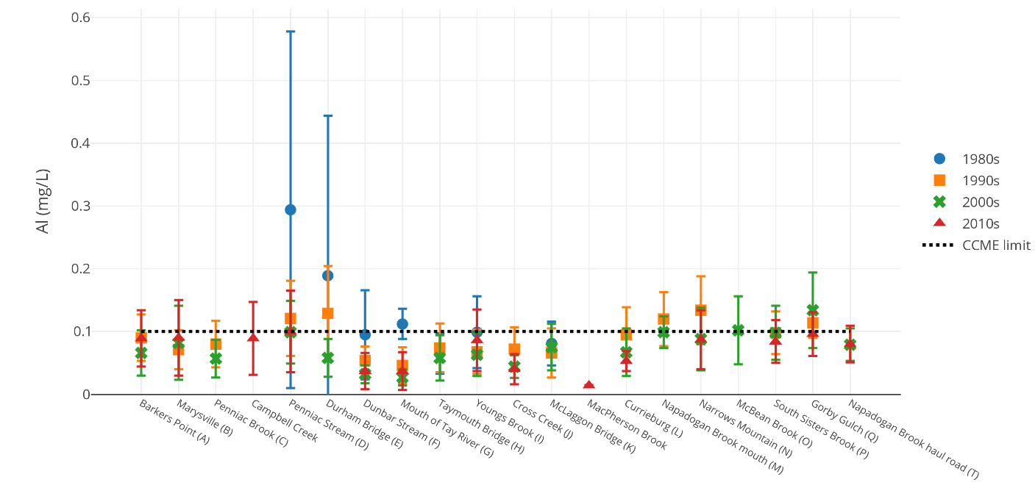
Figure 9 Aluminum content (mg/L) per site per decade. Error bars represent standard deviation. The dashed line represents the CCME limit of 0.1 mg/L.
Aluminum levels were the highest in the 1980s, especially in Penniac and around Durham Bridge where soil mining is more common (Fig. 9). Levels were slightly above the limit in the upper reaches of the watershed (Napadogan to Gorby Gulch) in the 1990s and 2000s as well. Aluminum levels at most sites did not change significantly at any site between 1980 and 2017. The exceedances are likely due to the underlying geology as well as sedimentation of streams due to removal of riparian vegetation and subsequent erosion.
Iron is another metal that occurs naturally in rocks and sediments. Bank erosion leads to increased levels of metals in streams due to run-off of those iron-rich sediments. However, it may also be derived from industrial waste or corroding metal pipes.

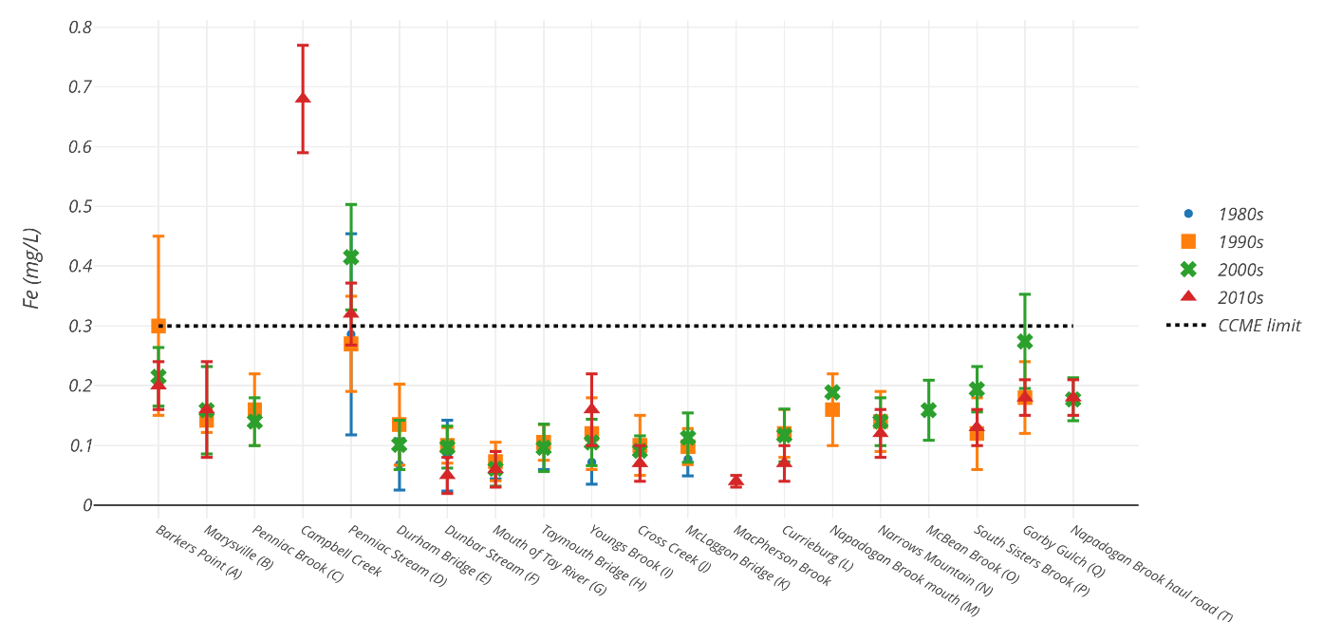
Figure 10 Mean iron content (mg/L) per site per decade in the watershed. Error bars represent standard deviation. The dotted line represents the CCME limit of 0.3 mg/L.
Iron contents have not changed significantly at any site since the 1980s. Mean values ranged from a low of 0.04 mg/L at MacPherson Brook to a high of 0.68 mg/L at Campbell Creek. Iron contents for the Nashwaak watershed were well below the CCME limit of 0.3 mg/L at all sites except for four: Barker’s Point, which exceeded the limit in the 1990s, Penniac Stream, which has consistently exceeded the limit throughout sampling history, Gorby Gulch, which exceeded the limit in the 2000s, and Campbell Creek, which was way above the CCME limit in 2017 (Fig. 10).
Soil erosion is likely the cause of elevated iron contents. Penniac Stream displayed high levels of both Al and Fe, particularly in the 1980s, indicating that soil erosion was likely an issue at this time. Iron concentrations are likely very high at Campbell Creek due to the amount of sediment still draining from the former headpond, though aluminum levels are below CCME guidelines.
Other metals (i.e., nickel, copper, cadmium, lead) can be associated with industrial inputs. Concentrations of these elements were mostly below detection levels and were relatively consistent throughout the watershed. Small exceedances for copper (Cu, limit 2 ppb) and lead (Pb, limit 1 ppb) occurred but were rare: NASH-A had exceedances in Cu and Pb values once in 2017, NASH-L had one sample and NASH-N had 2 samples over the limit of Pb in 2017, and NASH-O and NASH-T both had one Cu exceedance in 2001.

Escherichia coli
E. coli are bacteria that live in the digestive tract of warm blooded animals and are used to indicate the potential presence of harmful organisms. Potential sources of contamination include poorly maintained septic systems or sewage treatment plants, farms, domestic animals, aquatic wildlife, and livestock.

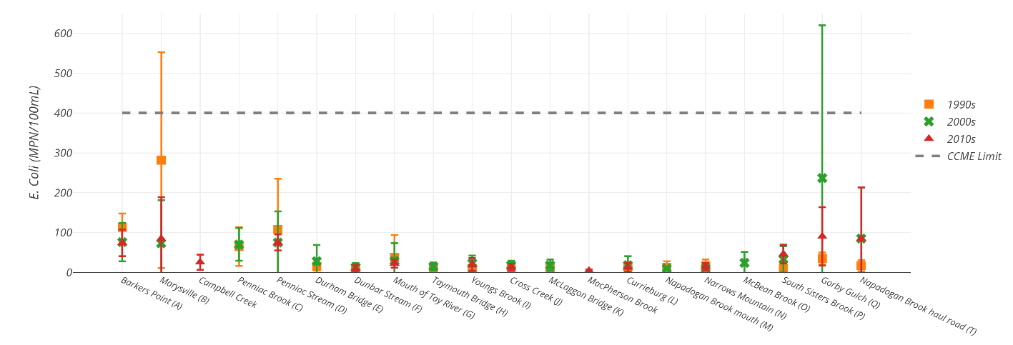
Figure 11 Mean E. coli contents (MPN/100 mL) per site per decade in the watershed. Error bars represent standard deviation. The CCME limit is 400 MPN/ 100 mL for a single grab sample.
E. coli contents were generally higher in the downstream sampling sites, particularly downstream from Penniac, where there is increased human habitation, and especially in the 1990s (Fig. 11). However, both NASH-Q and NASH-T had high concentrations of E. coli in the 2000s and in 2017. E. coli is lowest in the central watershed (Durham Bridge to South Sisters Brook), where there are fewer humans and more undeveloped, forested land. E. coli may be contaminating the water from faulty septic systems or sewage treatment plants or it may be coming from animal waste. Grab samples at two sites have exceeded the CCME limit 400 MPN/100 mL for recreational waters: NASH-Q (in 2001 (n=1), and 2002 (n=1)), NASH-B (in 1998 (n=1), 1999 (n=1), 2005 (n=1), and 2010 (n=1)). There is no CCME limit for the protection of aquatic life.

Fluoride
Fluoride is naturally present in bedrock, particularly in alkalic and silicic igneous and sedimentary rocks (e.g., shales), from which inorganic fluoride-containing minerals are leached by groundwater into surface water. Environmental concentrations in freshwater vary depending on the hydrogeological characteristics and mean fluoride concentration in freshwater across Canada is 0.05 mg/L. Anthropogenic sources include pesticides and fertilizers. The CCME limit for the protection of aquatic life is 0.12 mg/L. Changing detection limits made comparisons tricky. Fluoride toxicity results in shifts in migration patterns in salmonids and impaired reproduction in aquatic invertebrates.
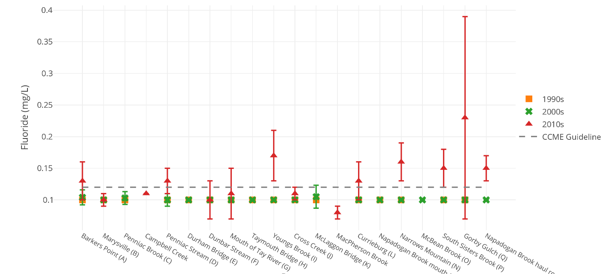
Figure 12. Fluoride concentrations (mg/L) per site per decade in the watershed. Error bars represent standard error. The dashed line represents the CCME guideline of 0.12 mg/L.
Fluoride concentrations have risen slightly from the 1990s/2000s to 2017 (Fig. 12). However, detection limits have also changed (the detection limit in 1990s/2000s was 0.01 mg/L and results were often below detection limits). Several sites were over the CCME guideline of 0.12 mg/L in 2017. The increase may be related to fertilizer or pesticide run-off or from increased mineral leaching from the bedrock.

Ammonia
Ammonia is an important component of the nitrogen cycle and, because it is oxidized in the environment by microorganisms (i.e., nitrification), it is a large source of available nitrogen in the environment. Ammonia is highly soluble in water and its speciation is affected by a wide variety of environmental parameters including pH, temperature, and ionic strength. The term total ammonia is used to describe the sum of ammonia (NH₃) and ammonium (NH₄⁺) (Environment Canada, 1997). Ammonia commonly enters the environment from municipal, industrial, agricultural, and natural processes. Natural sources of ammonia include the decomposition or breakdown of organic waste matter, gas exchange with the atmosphere, forest fires, animal waste, human breath, the discharge of ammonia by biota, and nitrogen fixation processes. Point sources of ammonia include emissions and effluents from a wide variety of industrial plants such as iron and steel mills, fertilizer plants, oil refineries, and meat processing plants (Environment Canada, 1997). The largest non-industrial point sources are sewage treatment plants. Other non-point sources of ammonia include agricultural, residential, municipal, and atmospheric releases. The CCME guideline for total ammonia for the protection of aquatic life changes depending on pH and temperature. For example, at pH of 8.0 and a temperature of 15°C, the limit is 0.715 mg/L. The limit decreases with increasing pH and temperature. Detection limits have changed over time. Previously (before September 2016), the detection limit was 0.01 mg/L but in 2017 RPC’s detection limit was 0.05 mg/L total ammonia.

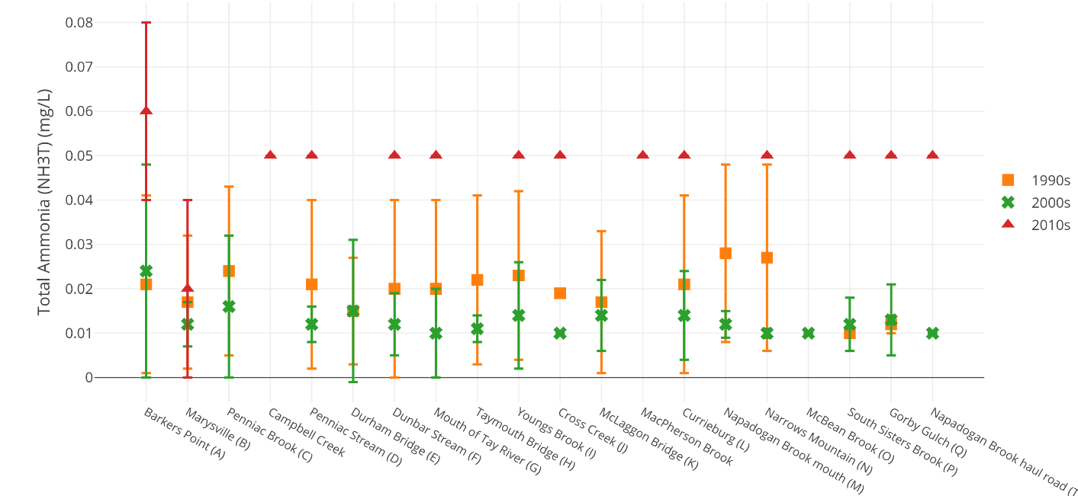
Figure 13. Total ammonia (NH_{3T}) concentrations per site per decade. Error bars represent standard deviation.
It is difficult to discern a trend in total ammonia concentrations because the detection limit increased in September 2016 (from 0.01 to 0.05 mg/L). Mean ammonia concentrations dropped between the 1990s and the 2000s but this drop was not significant an most sites (Fig. 13). Higher levels of ammonia are usually indicative of organic pollution. Therefore, we can conclude that levels of organic pollution have dropped insignificantly over time. Results were well under the CCME guideline.

Nitrogen and Phosphorus
Nitrogen and phosphorus are nutrients essential for all life forms and they occur naturally in rocks and soils. However, when present in elevated concentrations, they can degrade water quality by causing algal blooms, which lower DO contents leading to hypoxic or anoxic conditions. Nitrogen occurs as nitrate (NO₃), nitrite (NO₂), ammonia (NH₃), and organically bound nitrogen. Major sources of nutrients include wastewater discharges, agricultural run-off (chemical fertilizers), faulty septic systems, wastewater treatment plants, manure storage, and erosion.
Nitrate (as N) levels of 3 mg/L are considered acceptable by CCME for the protection of aquatic life. CCME does not set limits for phosphorous, nitrite, or nitrogen as they are not considered toxic to aquatic life; however, the lowest Canadian trigger range (ultra-oligotrophic) for total phosphorus is 4 ppb or 0.004 mg/L and the eutrophic trigger limit is 0.035 mg/L. Nitrate is the most important when determining water quality. Nitrate is released into the water when aquatic plants and animals die, from atmospheric deposition, and from bedrocks. Elevated nutrients are a bigger problem in lakes than in streams where they can result in blue-green algae blooms, such as the one that happened at Nashwaak Lake this summer.
Nutrient levels in the watershed were generally low with phosphorus levels typically around 0.01 mg/L and nitrate and nitrite levels below the detection limit of 0.05 mg/L at most sites. The highest levels of nitrite and nitrate were noted at NASH-B (Marysville), with nitrite concentrations spiking at 0.23 mg/L in 2015 and MacPherson Brook, which had a nitrate concentration of 0.35 mg/L in July 2017.
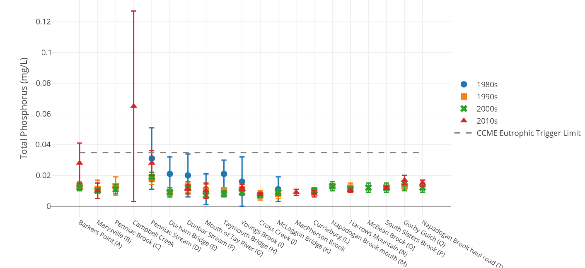
Figure 14. Total phosphorus concentrations (mg/L) per site per decade in the watershed. Error bars represent standard deviation and the dashed line represents the CCME Canadian Trigger for Eutrophic Waters (0.035 mg/L).
Highest levels of total phosphorus were recorded at Penniac Stream (an overall mean of 0.023 mg/L) and Campbell Creek (where a single sample measured 0.108 mg/L in October 2017 [the exceedance was attributed to a beaver dam directly upstream]). Agricultural inputs, soil erosion, and the presence of wildlife may be the source(s). It appears that phosphorus concentrations have remained relatively stable over time at most sites except at NASH-A (Barker’s Point), where mean concentrations were highest in 2017 and in the central watershed (Penniac to Young’s Brook), where mean concentrations were highest in the 1980s (Fig. 14).

Total Organic Carbon
Total Organic Carbon (TOC) is a combination of humic substances, as well as partly degraded animal and plant material. TOC may enter a watercourse via run-off from agriculture or from urban or industrial areas. It may also enter via wetlands. There is no CCME limit for TOC; however, low levels are important to prevent the consumption of oxygen during decomposition. In 2017, Dissolved Organic Carbon instead of TOC was measured. It is used here for comparison purposes.
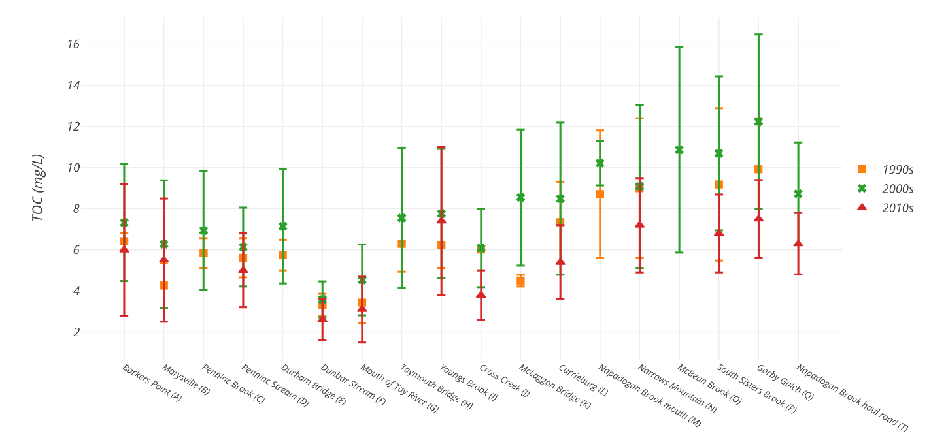
Figure 15. Total Organic Carbon concentrations (mg/L) per site per decade. Error bars represent standard deviation.
TOC levels were highest in the upper watershed at McBean Brook, South Sisters, and Gorby Gulch, where average values exceeded 10 mg/L. This may be due to the wetlands in this area. Penniac Stream also displayed high TOC, possibly due to the wetlands located in its headwaters. Levels were particularly high throughout the watershed in 2001 but have remained stable over time (Fig. 15).

Conductivity
Conductivity is a measure of a stream’s ability to carry an electrical current. It is recorded in microsiemens per centimetre (µs/cm). Conductivity can be influenced by the presence or absence of inorganic dissolved solids such as chloride, nitrite, sulfate, phosphate, sodium, magnesium, iron, and aluminum. It is also affected by water temperature (higher temperature means higher conductivity). Conductivity is generally determined by geology. The igneous rocks (granite) of the headwaters result in lower conductivities while glacial till and clay soils results in higher conductivities because of the presence of materials that ionize when washed into the water. Road salt run off can result in very high conductivity in waters.
There is no CCME limit for conductivity, but most rivers naturally have a conductivity range from 50 µs/cm to 1500 µs/cm but measurements between 150-500 µs/cm are within the desired range. If measurements are recorded outside of a typical range for a stream, it can be an indication of a change in chemistry. Wastewater, agricultural inputs, and failing septic systems can result in higher conductivities due the presence of nitrate, chloride, and phosphates. Conductivity in the lower watershed (below MacPherson Brook) were in the range of 50-80 µs/cm while in the upper watershed they were 30-40 µs/cm.

Water Quality Index
The Water Quality Index, or WQI, is a means to provide a consistent way to report water quality information and communicate it to the general public. The Canadian WQI was developed by the CCME and it provides a single number that expresses the overall water quality at a certain time and location based on selected parameters. Ratings are follows:
Table 1 Water Quality Index rating based on CCME guidelines.
Rating | WQI
Excellent | 95-100
Good | 80-94
Fair | 60-79
Marginal | 45-59
Poor | 0-44

WQIs for each site and year were calculated using the CCME’s Water Quality Index 1.2 Calculator. However, comparisons between years were difficult because some important parameters used in the calculations weren’t measured in certain years (e.g., Al wasn’t measured in 1980, DO and temperature were not consistently measured, and nitrate and nitrite were measured in the 1990s). In addition, detection limits have changed over time.
Parameters used to calculate the 2017 WQI were: Aluminum, Ammonia, Temperature, Cadmium, Copper, Lead, Arsenic, Hardness, pH (field), Chloride, Iron, Nitrite, Nitrate, Phosphorus, and Zinc. Results for the 2017 WQI calculations can be found in Figure 16. Water quality was good overall throughout the watershed. Surprisingly, NASH-B had a rating of 100. The poorest WQI results were from NASH-A, which had exceedances of Ammonia and Phosphorus, likely related to urban development in the area and possibly due to the nearby water treatment plant.

Figure 16. 2017 WQIs. Green = Excellent, Orange = Good, Yellow = Fair.

Figure 17 compares the 2017 WQIs to the 1980-2005 baseline WQI (depending on data available for a particular site). WQIs have remained relatively the same (within 5-10 points), except at NASH-A where they have dropped by 27 points and NASH-N where they dropped by 17 points. WQIs at NASH-B have improved by 13 points over the baseline.

Figure 17. Comparing 2017 WQIs (orange) to the 1980-2005 baseline

Water Quality Discussion
An action plan was developed (NWAI, 2004) to address the water quality issues noted above; however, the action plan was never implemented as the Water Classification Regulation did not go ahead. The action items from the 2004 report are listed below. These action items have been evaluated and reconsidered for the NWAI’s 2017-2020 Action Plan.

Overall Improvement of the Nashwaak Watershed’s Water Quality
In addition to continuing to monitor water quality and improve riparian buffer zones, several action items are suggested for the entire watershed:
- Addressing the practice of top soil mining by ensuring that existing legislation is adhered to and force fining or permit cancellation of operators who do not comply with regulations;
- Ensuring that BMPs are followed by logging companies and that any environmental infractions are communicated to DELG or DNRE;
- Working with landowners to ensure proper road construction and maintenance including road-stream crossings;
- Working with farmers on fencing projects and buffer planting to limit or restrict cattle access to the river and tributaries;
- Working with farmers to improve top soil conservation and manure management practices and BMPs;
- Partnering with waste water treatment facilities to improve current practices;
- Working with local and rural planning commission to ensure that proper riparian setbacks are adhered to and BMPs are being followed;
- Reporting any dumping or abuse of the river to DELG or DNRE; and
- Riverbank stabilization and problem area assessment.

Temperature Monitoring
28 out of 30 installed loggers were recovered. A map of the logger placement can be found in Figure 3. One was recovered in mid-September as a test and the 27 others were recovered between 13 and 16 October. One logger was known to have come out of the water in mid-August and therefore was not included in the analyses. For the calculations below, were used data from 10 loggers in tributaries and 17 loggers in the main stem of the Nashwaak river.
Peak temperatures ranged from 19.2°C in MacPherson Brook to 31.1°C upstream of Young’s Brook (Figure 18, Figure 19). Average maximum temperature was 26.1°C in the tributaries and 29.2°C in the main stem of the river. Most peak temperatures were recorded on July 20th at either 16:00 or 18:00. According to Environment and Climate Change Canada (ECCC), air temperatures in Fredericton peaked at 30.4°C that day. Four loggers recorded peak temperatures on July 19th at 18:00 when air temperatures were recorded to be 29.8°C in Fredericton and three recorded peak temperatures on August 4th at either 16:00 or 18:00 when air temperatures were ~29.0°C. Maximum air temperatures in 2017 were recorded on September 26th and peaked at 33.6°C (breaking recorded high temperatures).
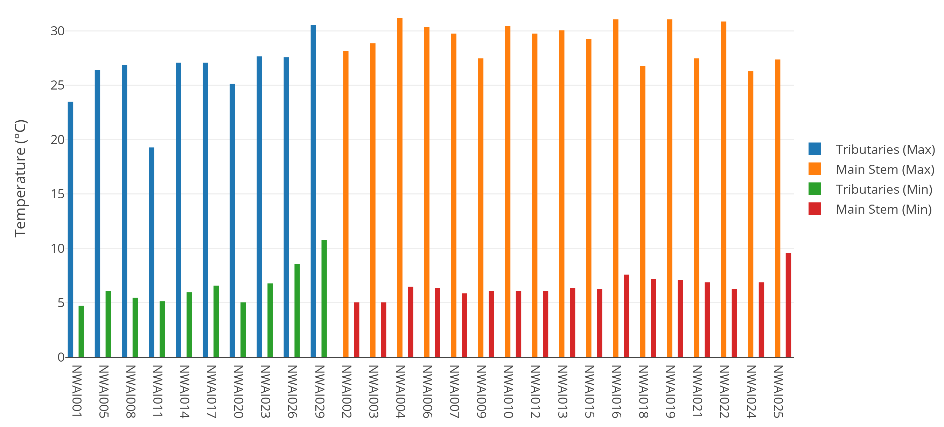
Figure 18. Maximum and Minimum temperatures recorded for each logger, grouped by tributaries and main stem.
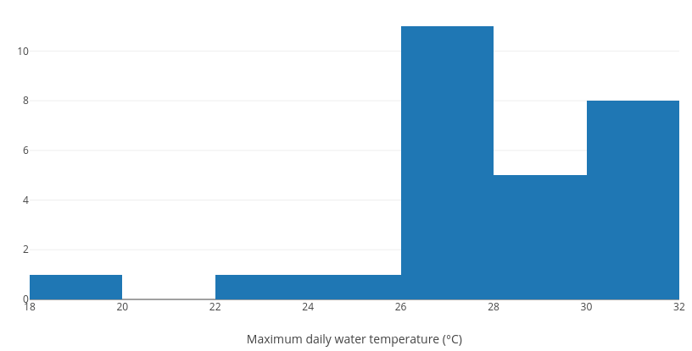
Figure 19 Histogram of maximum daily water temperatures from all loggers.
Minimum temperatures ranged from 4.7°C in South Sisters Brook to 10.7°C in Campbell Creek (Figure 18). Minimum temperatures were mostly recorded on October 13th at 10:00 just before most of the loggers were pulled out. Eight loggers recorded their minimum temperatures on October 3rd at either 8:00 or 10:00. Average minimum temperatures were 6.5°C for both the tributaries and the main stem.
The overall corrected average temperature (removing any readings logged in the office or truck after the logger had been pulled from the water) for all 27 loggers was 17.7°C±3.7°C. The overall average for the 17 main stem loggers was 18.4°C±3.9°C, while the tributaries averaged 16.7°C±3.4°C over the entire period they recorded.
The summer average (readings taken between 21 June and 21 September) for all loggers was 19.1°C±2.9°C. The summer average for main stem loggers was 19.7°C±3.0°C, while the tributaries remained a few degrees cooler with an overall average for those 10 loggers of 17.9°C±2.7°C (Figure 20).
The coolest site was MacPherson Brook (NWAI011), which averaged 14.6°C±1.7°C over the summer. The warmest site was upstream of Penniac Stream (NWAI022), which averaged 20.9°C±3.0°C
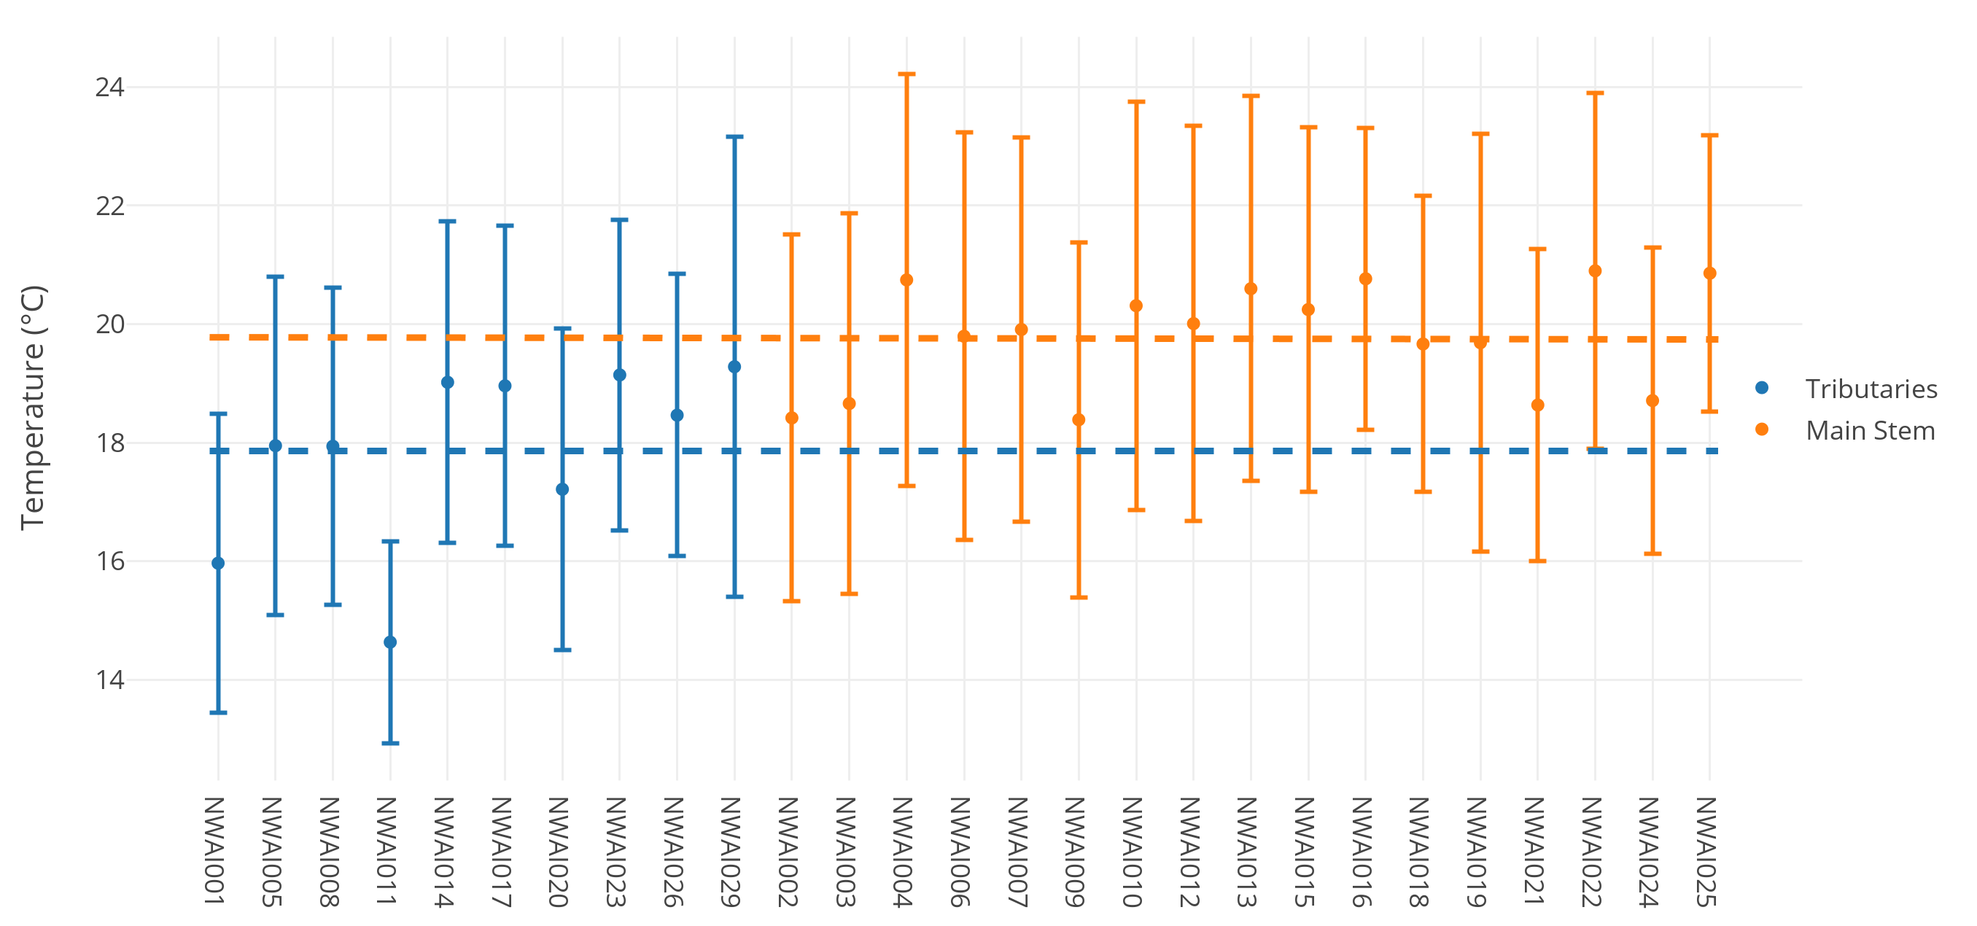
Figure 20. Average summer water temperatures (21 June to 21 September) separated by tributaries and main stem.
Finally, we calculated the number of days when maximum daily water temperatures exceeded 23°C and when minimum daily water temperatures exceeded 20°C. 20°C is considered the threshold minimum temperature for assessing physiological stress in Atlantic salmon (DFO, 2012). Additionally, it has been shown that when maximum daily water temperature exceeds 23°C, salmonids will seek cooler water refugia (Breau, 2013). On average, number of days when the minimum daily water temperature was above 20°C was 12 days in the main stem and 3 days in the tributaries (9 days over all). Number of days when the maximum temperature exceeded 23°C was 50 for the main stem, 21 for the tributaries, and 39 overall (Figure 21). Only one tributary remained below 20°C all summer: MacPherson Brook peaked at 19.2°C in July and averaged 14.6°C over the summer.
Data and graphs for all loggers are available in Appendix C.

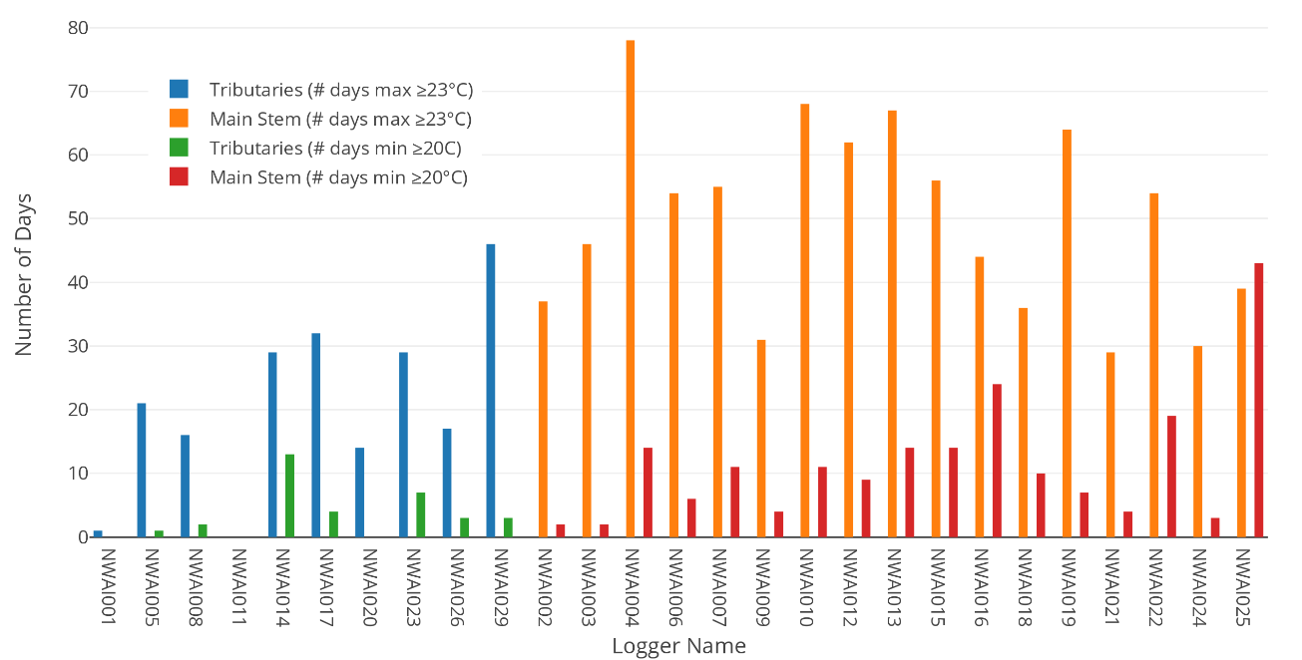
Figure 21. Number of days when minimum water temperatures exceeded 20°C and number of days when maximum daily water temperatures exceeded 23°C.

Discussion of Water Temperature
2017 experienced a hot, dry summer with little precipitation and low flow conditions between June and October. Water levels dropped to record low levels at the Durham Bridge station (AL002) on September 3rd (17.703 m asl). Historical average water levels in September are 18.17 m asl. This was followed in January 2018 with an extremely high-water period. The AL002 station recorded levels of 22.2 m asl on January 13th after a heavy rainfall and 22.9 m asl after a rainfall in early February.
Water temperatures, in general, got warmer moving from sites closer to the headwaters to sites closer to the mouth of the river. For the main stem upstream of South Sisters Brook (the site closest to the headwaters), summer averages were 18.4°C and minimum water temperatures exceeded 20°C only twice and 23°C 37 times. At the main stem site closest to the mouth (upstream of Campbell Creek), summer averages were 20.86°C, minimum water temperatures exceeded 20°C 43 times and maximum water temperatures exceeded 23°C on 39 days.
The tributaries appeared to have a small buffering effect on the main stem of the river, dropping average summer temperatures by 0.3 to 2.2°C between upstream and downstream sites (Figure 22).

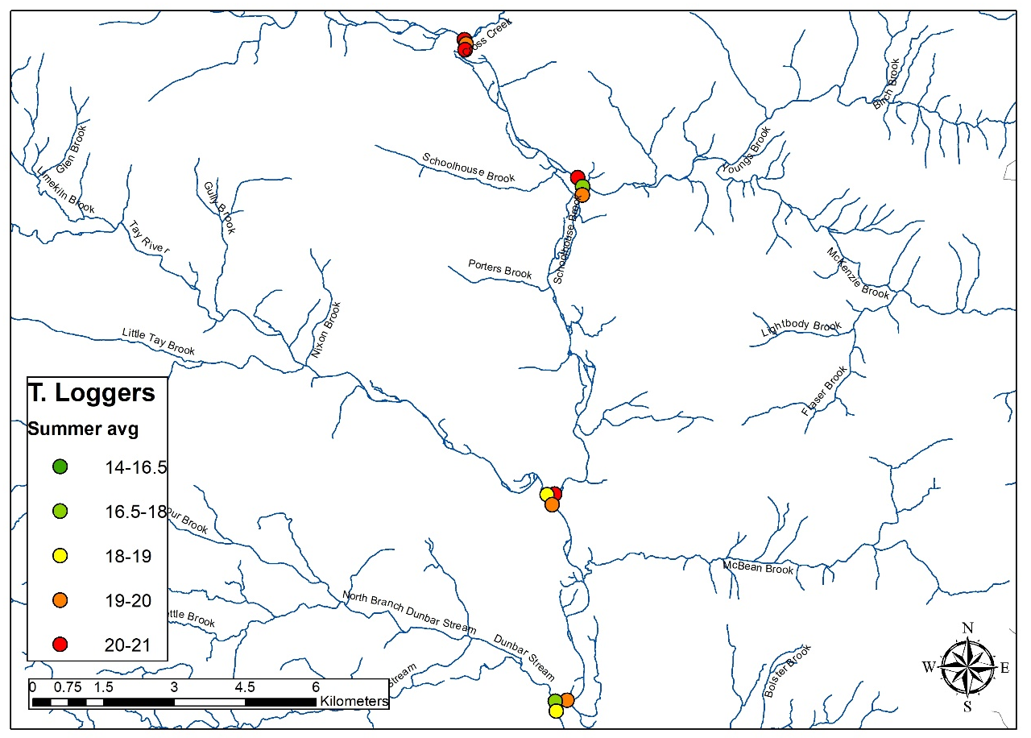
Figure 22. Results of the loggers placed in the central watershed. Coloured symbols show average summer water temperature from green (cooler) to red (warmer). The buffering ability of the tributaries is evident in most sets of three: the downstream station is cooler due to the incoming colder water tributary.

Challenges
Though temperature loggers were deployed by the NWAI previously in 2002 and 2005, the details of how and where they were deployed were not recorded. Therefore, this year provided a learning curve for the association. Initially, we were worried that people would remove or tamper with a large number of our loggers and we expected a loss of 10-20%. In fact, only one was taken and three were tampered with.
The hot, dry weather resulted in record low water levels on the Nashwaak and most loggers had to be moved in late July to ensure that they remained under water. We did find one logger in early August that had emerged; however, we are confident that the others remained submerged though many would have been quite close to the surface of the river, which will have had a result on the data collected. The loggers were initially installed in approximately knee-deep water (~0.5 to 0.75 m). However, in subsequent years, we will ensure that the loggers are deployed in slightly deeper water to prevent having to move too many of them in mid-summer. We found it difficult to find locations that were not too deep in the spring and fall (if the water is too deep, installation and removal is very difficult) but still remained underwater in mid summer. In addition, finding appropriate substrate (gravel substrate is ideal) was challenging in some locations.
The final challenge we faced was that the wire used to secure the logger to the casing began to rust very quickly, despite being stainless steel. Therefore, zip ties were added to the casing to prevent the logger from floating to the top and being lost. The bottom of the PVC was touching the substrate, which prevented the logger from falling out of the bottom of the casing. However, one logger was lost upon retrieval when the casing was pulled but the wire had snapped causing the logger to drop out of the bottom of the casing and into the current. In subsequent years, we will use stronger or coated wire and zip ties to ensure that the logger cannot come out of the casing.

Update to NWAI’s Action Plan
The NWAI’s Action Plan is a living document in that we update it in real time in reflection of the information gained and lessons learned over a particular field season.
The four main goals of this action plan are:
- Maintenance of the Nashwaak watershed a healthy, functional, and connected aquatic ecosystem;
- Increased capacity of the NWAI to monitor, protect, and restore the health of the watershed;
- Restoration of degraded riparian zones and salmon habitat; and
- Increased awareness amongst residents of all ages of the importance of a healthy Nashwaak watershed.

Monitoring the quality and temperature of the watershed addresses Goal 1:

FILLING information GAPS: The NWAI will work to improve the capacity of our organization to monitor the health of the river and use that information to identify and guide restoration projects that will provide the most benefits to water and habitat quality.
This year, we have completed our short-term goals of resuming water quality monitoring; deploying temperature loggers in the main stem and tributaries; and starting to develop a picture of the thermal refugia in the watershed.
This project also addressed Goal 2:

PARTNERSHIPS AND OUTREACH: the NWAI will work with stakeholders to develop management practices pertaining to the protection of the river and the restoration of riparian habitat
In particular, we continue to foster our relationships with St Mary’s First Nation, the City of Fredericton, CRI, and private landowners. We also participated in the Provincial Water Strategy.
We are working on reviewing and updating our Action Plan based on all of our 2017/18 projects. This will be made available to the public in our website.

Conclusions
Despite the hiatus, the reintroduction of water quality and temperature monitoring in 2017 will contribute to our understanding of the natural state of the water as well as evaluate the impacts of human activities. The NWAI strives to continue to monitor watershed health in order to create a long-term picture and improve our understanding of bot the natural variability of the system and in impacts of anthropogenic land-use have on the quality of the water. We hope that continued data collection will help us determine and address the greatest water quality concerns.

References
Breau, C. (2013). Knowledge of fish physiology used to set water temperature thresholds for in-season closures of Atlantic salmon (Salmo salar) recreational fisheries. DFO Can. Sci. Advis. Sec. Res. Doc. 2012/163. iii + 24 p.
Caissie, D. (2006). The thermal regime of rivers: A review. Freshwater Biology, 51(8), 1389-1406.
Canadian Rivers Institue. (2011). The Saint John River—A State of the Environment Report. A publication of the Canadian Rivers Institute.
CCME. (1999). Water Quality Guidelines for the Protection of Aquatic Life. Canadian Council of Ministers of the Environment. Retrieved November 2016, from http://ceqg-rcqe.ccme.ca/
Curry, R., & Gautreau, M. (2010). Freshwater fishes of the Atlantic Maritime Ecozone. In D. McAlpine, & I. Smith (Eds.), Assessment of Specieis Diversity in the Atlantic Maritime Ecozone (pp. 599-612). Ottawa, Ontario: NRC Research Press.
DFO. (2012). Temperature threshold to define management strategies for Atlantic salmon (Salmo salar) fisheries under environmentally stressful conditions. DFO Can. Sci. Advis. Sec. Sci. Advis. Rep. 2012/019.
DNR. (2007). Our Landscape Heritage: The Story of Ecological Land Classification. Fredericton, New Brunswick: NB Department of Natural Resources.
Environment Canada. (1997). Priority Substances List Assessment Report for Ammonia in the Aquatic Environment. In: Environmental Assessments of Priority Substances Under the Canadian Environmental Protection Act. Guidance Manual 1.0.
ISCRWB. (2010). Annual report. International St Croix River Watershed Board
Maine Rivers. (2005). Nonpoint Source Pollution: Our Biggest Challenge. Retrieved January 5, 2017, from http://www.mainerivers.org/nps.html
McCollough, D. (1999). A review and synthesis of effects of alterations to the temperature regime on freshwater life stages of salmonids, with special reference to the Chinook salmon. Seattle, Washington: United States Environmental Protection Agency, Water Division.
NWAI. (2004). Water quality of the Nashwaak River watershed. Nashwaak Watershed Association Inc.
Parish Aquatic Services. (2016). Nashwaak River Geomorphic Assessment. Report 150036.

Appendix B: Field Data Sheet
NAME OF GROUP/COMPANY: _____________________________________________
Station name: __________________________________________________________
DELG field number: ____________________ (unique number for this station for this day)
Date: ___________________________Time (00:00-24:00): _____________________
Sample collected by: _____________________________________________________
Weather: _____________________________________________________________
Rainfall in the last 24 hours: _______ None _______ Light _______ Heavy
Water level: _______ Low _______ Normal _______ High

Water clarity/colour? ____________________________________________________
____________________________________________________________________
Algae? _______________________________________________________________
Oil/film/foam on water? __________________________________________________
Garbage in water or on shore? ______________________________________________
Fish (dead or alive), aquatic insects? _________________________________________
____________________________________________________________________
Bank erosion / state of bank vegetation? ______________________________________
____________________________________________________________________
ATV crossings / cattle crossings? ___________________________________________
____________________________________________________________________
Construction (e.g. road, bridge) upstream of sample site? __________________________
____________________________________________________________________
People fishing/swimming upstream? __________________________________________
____________________________________________________________________
Natural/man-made barriers, beaver dams upstream/downstream? ___________________
____________________________________________________________________
Other general comments: _________________________________________________
____________________________________________________________________
____________________________________________________________________
____________________________________________________________________
____________________________________________________________________
____________________________________________________________________

Water Temperature (°C): ______________ Dissolved Oxygen: ________ (mg/L)

pH: Conductivity: _______ (µs/cm)

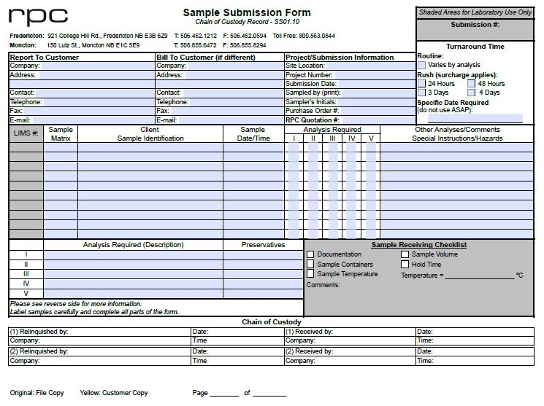

Appendix C: Logger data
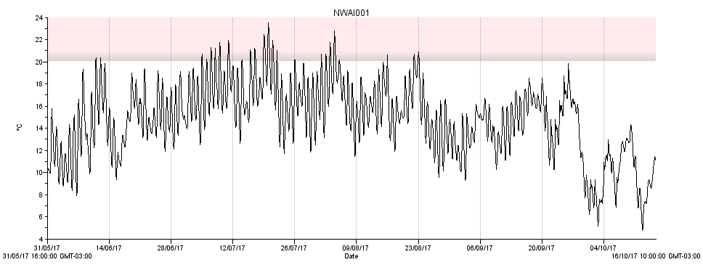
NWAI001. Located in the mouth of South Sisters Brook [46.3254, -67.1564].
Max temp: 23.5°C
Min temp: 4.7°C
Average summer temp*: 16.0°C ±2.5°C
Number of days >20°C = 25
Number of days >23°C = 1

*Average summer temperature is the mean of all readings taken between 00:00 on 21 June to 22:00 on 21 September.
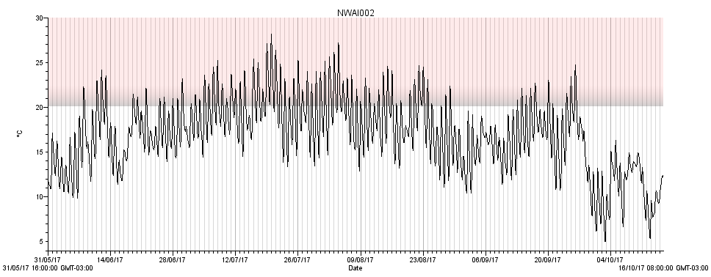
NWAI002. Located in Nashwaak River ~100 m upstream from South Sisters Brook [46.3258, -67.1568]
Max temp: 28.2°C
Min temp: 5.0°C
Average summer temp: 18.5°C ±3.1°C
Number of days >20°C = 79
Number of days >23°C = 37
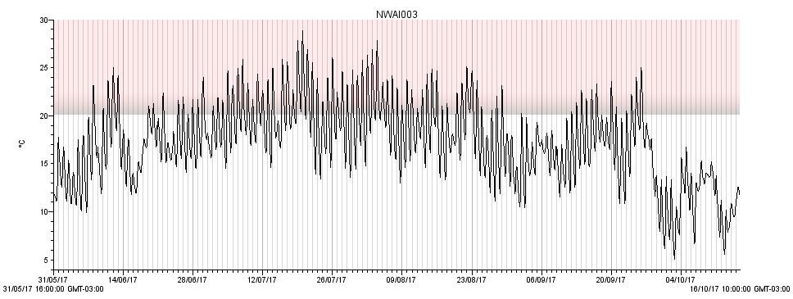
NWAI003. Located in Nashwaak River ~50 m downstream from South Sisters Brook [46.3255, -67.1556]
Max temp: 28.9°C
Min temp: 5.0°C
Average summer temp: 18.7°C ±3.2°C
Number of days >20°C = 84
Number of days >23°C = 46
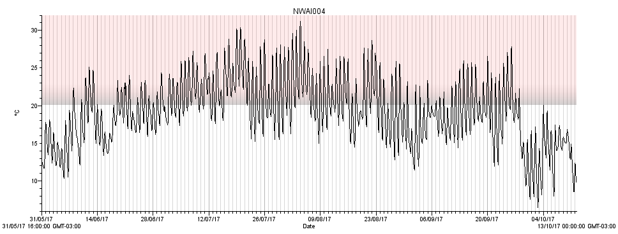
NWAI004. Located in Nashwaak River ~250 m upstream from Youngs Brook [46.2409, -66.6128]
Max temp: 31.1°C
Min temp: 6.5°C
Average summer temp: 20.7°C ±3.5°C
Number of days >20°C = 106
Number of days >23°C = 78

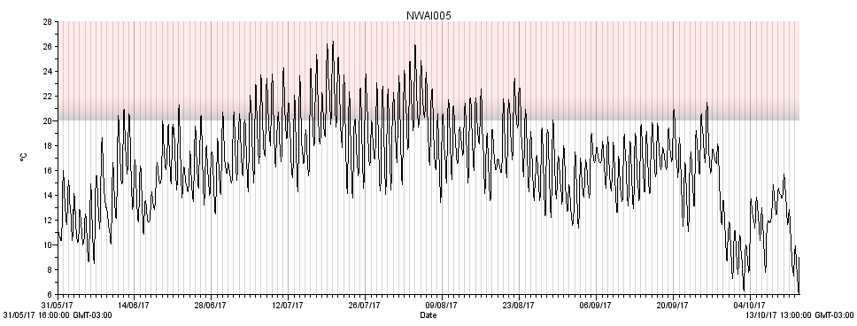
NWAI005. Located at the mouth of Youngs Brook [46.2392, -66.6115]
Max temp: 26.4°C
Min temp: 6.1°C
Average summer temp: 18.0°C ±2.9°C
Number of days >20°C = 59
Number of days >23°C = 21
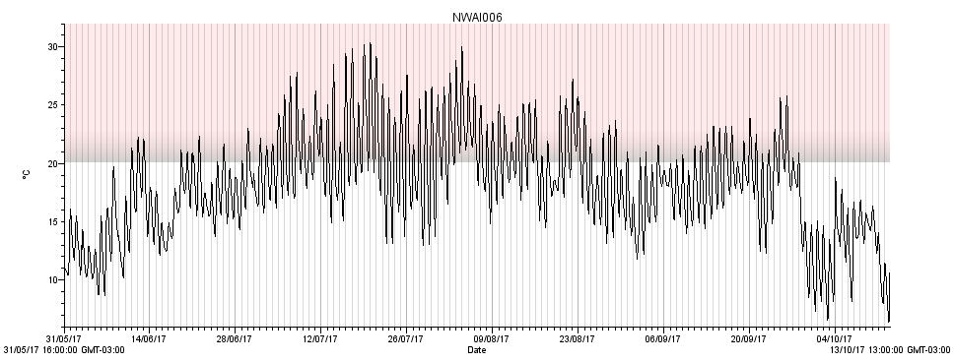
NWAI006. Located in Nashwaak River ~100 m downstream from Youngs Brook [46.2376, -66.6116]
Max temp: 30.4°C
Min temp: 6.4°C
Average summer temp: 19.8°C ±3.4°C
Number of days >20°C = 92
Number of days >23°C = 54

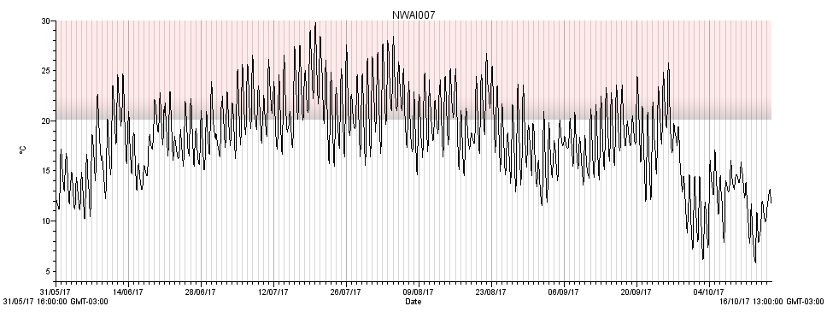
NWAI007. Located in Nashwaak River ~50 m upstream from Ryan Brook [46.3130, -66.8189]
Max temp: 29.8°C
Min temp: 5.9°C
Average summer temp: 19.9°C ±3.2°C
Number of days >20°C = 91
Number of days >23°C = 55
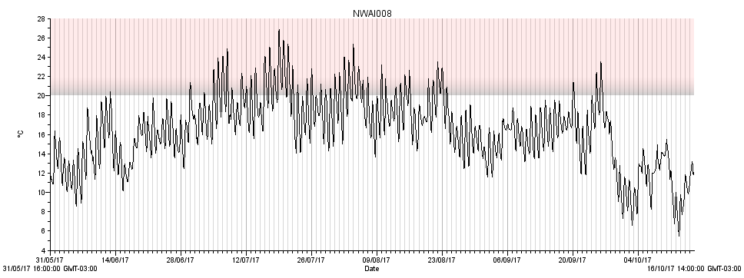
NWAI008. Located in the mouth of Ryan Brook [46.3130, -66.8188]
Max temp: 26.9°C
Min temp: 5.5°C
Average summer temp: 17.9°C ±2.7°C
Number of days >20°C = 49
Number of days >23°C = 16

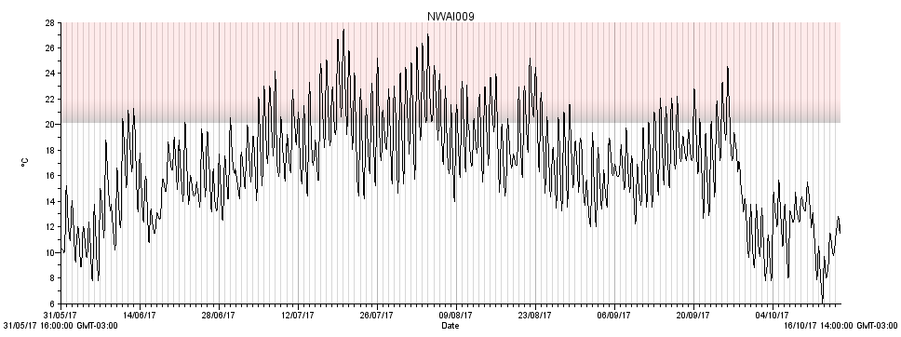
NWAI009. Located in Nashwaak River ~100 m downstream from Ryan Brook [46.3130, -66.8174]
Max temp: 27.5°C
Min temp: 6.1°C
Average summer temp: 18.4°C ±3.0°C
Number of days >20°C = 69
Number of days >23°C = 31
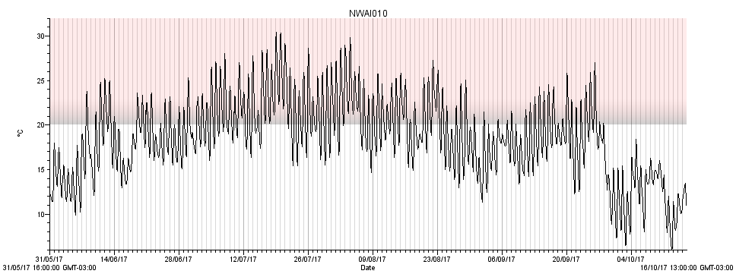
NWAI010. Located in Nashwaak River ~100 m upstream from MacPherson Brook [46.2999, -66.7843]
Max temp: 30.5°C
Min temp: 6.1°C
Average summer temp: 20.3°C ±3.5°C
Number of days >20°C = 99
Number of days >23°C = 68

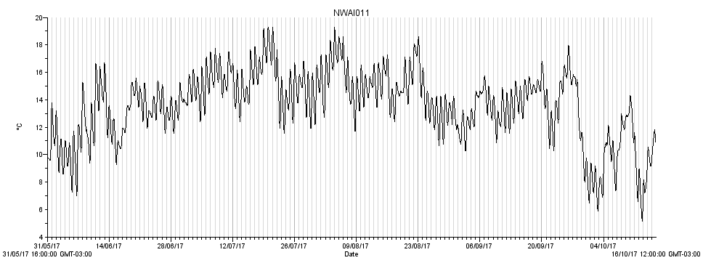
NWAI011. Located in MacPherson Brook at culvert plunge pool [46.2988, -66.7829]
Max temp: 19.3°C
Min temp: 5.1°C
Average summer temp: 14.6°C ±1.7°C
Number of days >20°C = 0
Number of days >23°C = 0
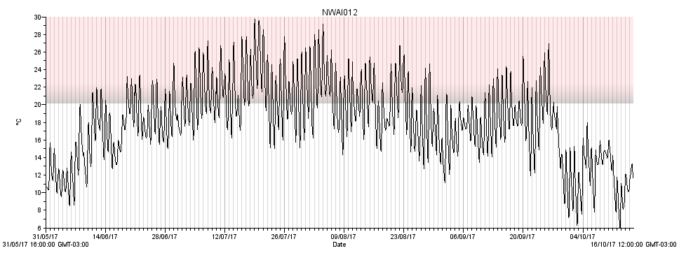
NWAI012. Located in Nashwaak River ~100 m downstream from MacPherson Brook [46.2977, -66.7832]
Max temp: 29.8°C
Min temp: 6.1°C
Average summer temp: 20.0°C ±3.3°C
Number of days >20°C = 92
Number of days >23°C = 62

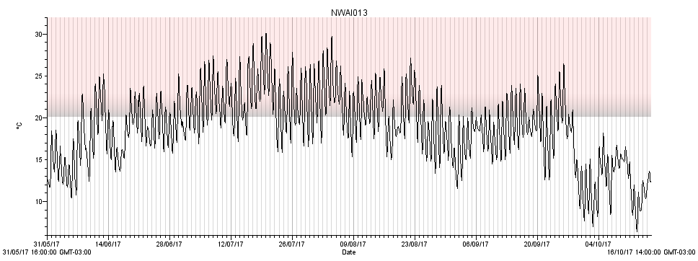
NWAI013. Located in Nashwaak River ~100 m upstream from Cross Creek [46.2671, -66.6440]
Max temp: 30.1°C
Min temp: 6.4°C
Average summer temp: 20.6°C ±3.2°C
Number of days >20°C = 99
Number of days >23°C = 67
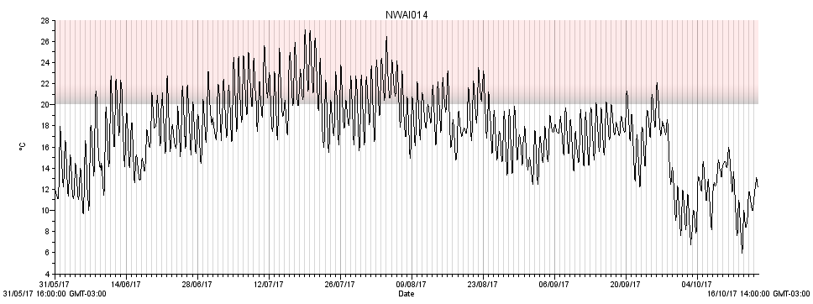
NWAI014. Located at mouth of Cross Creek [46.2663, -66.6435]
Max temp: 27.1°C
Min temp: 6.0°C
Average summer temp: 19.0°C ±2.7°C
Number of days >20°C = 69
Number of days >23°C = 29
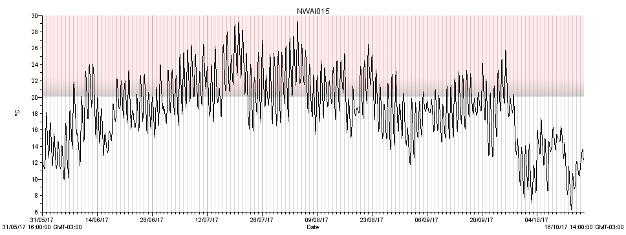
NWAI015. Located in Nashwaak River ~100 m downstream of Cross Creek [46.2652, -66.6438]
Max temp: 29.3°C
Min temp: 6.3°C
Average summer temp: 20.2°C ±3.1°C
Number of days >20°C = 93
Number of days >23°C = 56
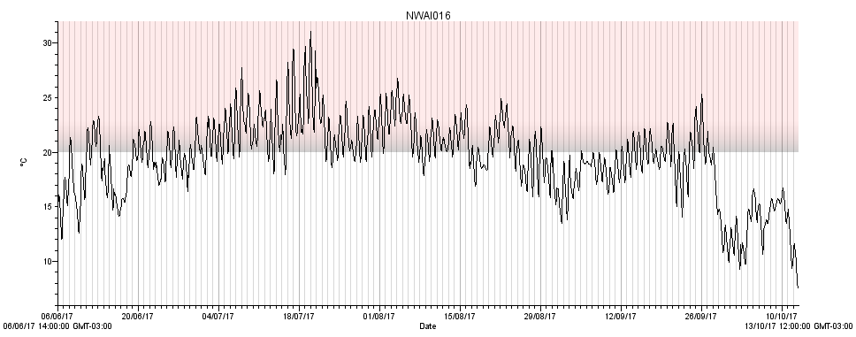
NWAI016. Located in Nashwaak River ~100 m upstream of Tay River [46.1807, -66.6190]
Max temp: 31.1°C
Min temp: 7.6°C
Average summer temp: 20.8°C ±2.5°C
Number of days >20°C = 92
Number of days >23°C = 44

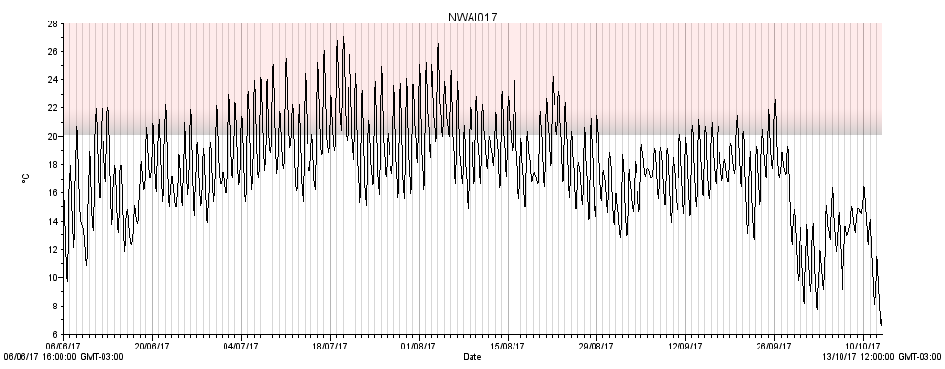
NWAI017. Located in Tay River ~25 m from mouth [46.1806, -66.6211]
Max temp: 27.1°C
Min temp: 6.6°C
Average summer temp: 19.0°C ±2.7°C
Number of days >20°C = 78
Number of days >23°C = 32
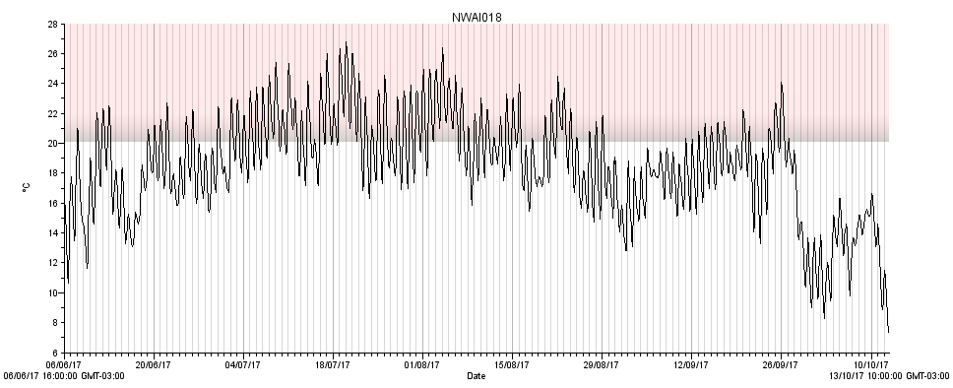
NWAI018. Located in Nashwaak River ~50 m downstream of Tay River [46.1787, -66.6197]
Max temp: 26.8°C
Min temp: 7.2°C
Average summer temp: 19.7°C ±2.5°C
Number of days >20°C = 80
Number of days >23°C = 36

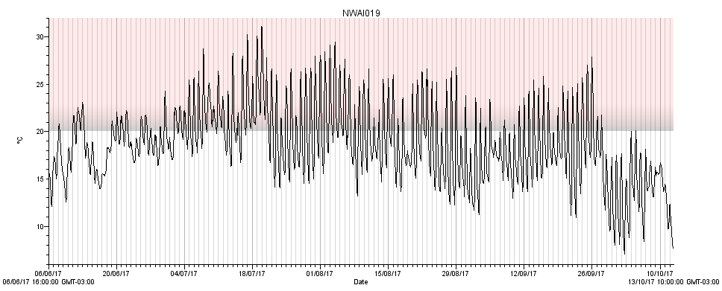
NWAI019. Located in Nashwaak River ~150 m upstream of Dunbar Stream [46.1415, -66.6155]
Max temp: 31.1°C
Min temp: 7.1°C
Average summer temp: 19.7°C ±3.5°C
Number of days >20°C = 97
Number of days >23°C = 64
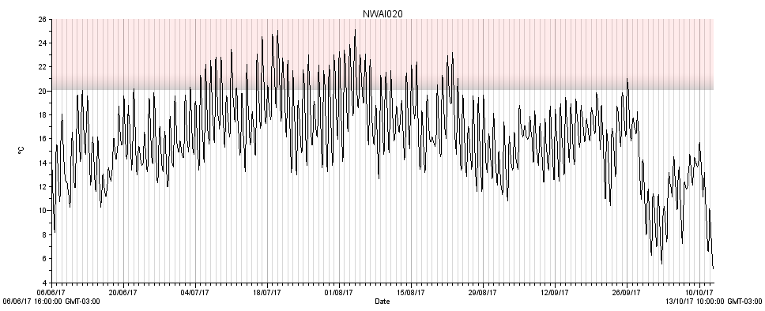
NWAI020. Located in Dunbar Stream ~50m from mouth [46.1413, -66.6187]
Max temp: 25.1°C
Min temp: 5.0°C
Average summer temp: 17.2°C ±2.7°C
Number of days >20°C = 44
Number of days >23°C = 14

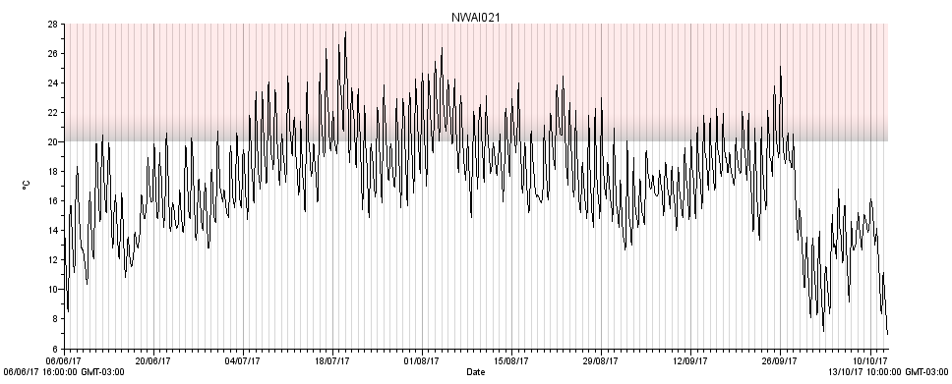
NWAI021. Located in Nashwaak River ~100 m downstream of Dunbar Stream [46.1394, -66.6185]
Max temp: 27.5°C
Min temp: 6.9°C
Average summer temp: 18.6°C ±2.6°C
Number of days >20°C = 72
Number of days >23°C = 29
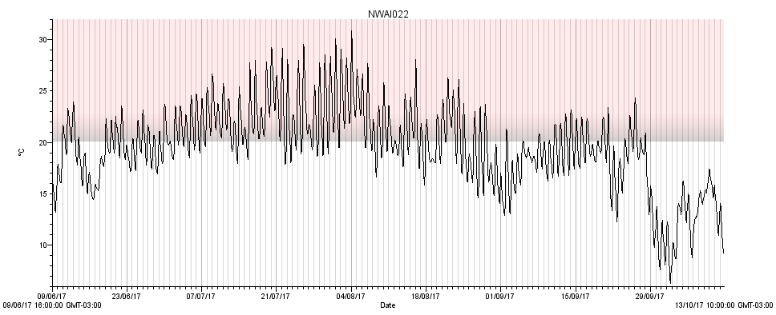 NWAI022. Located in Nashwaak River ~100 m upstream of Penniac Stream [46.0302, -66.5744]
Max temp: 30.9°C
Min temp: 6.3°C
Average summer temp: 20.9°C ±3.0°C
Number of days >20°C = 92
Number of days >23°C = 54

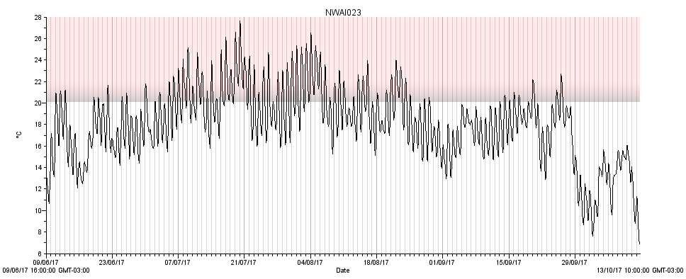
NWAI023. Located at mouth of Penniac Stream [46.0306, -66.5736]
Max temp: 27.7°C
Min temp: 6.8°C
Average summer temp: 19.1°C ±2.6°C
Number of days >20°C = 72
Number of days >23°C = 29
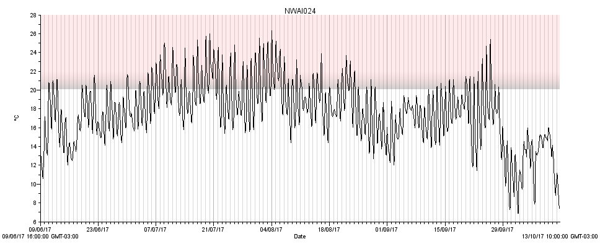
NWAI024. Located in Nashwaak River ~300 m downstream of Penniac Stream [46.0302, -66.5720]
Max temp: 26.3°C
Min temp: 6.9°C
Average summer temp: 18.7°C ±2.6°C
Number of days >20°C = 75
Number of days >23°C = 30

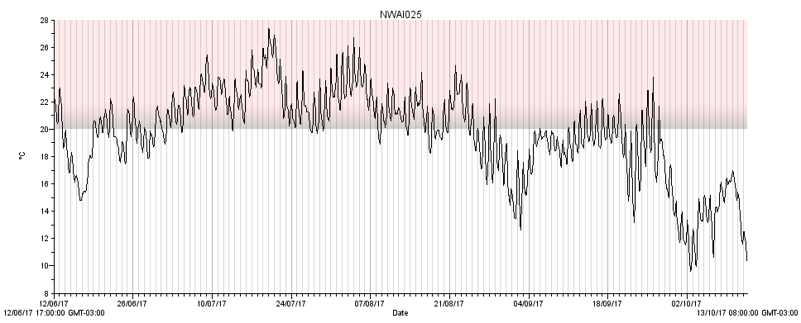
NWAI025. Located in Nashwaak River ~125 m upstream of Campbell Creek [45.9895, -66.5808]
Max temp: 27.4°C
Min temp: 9.6°C
Average summer temp: 20.9°C ±2.3°C
Number of days >20°C = 88
Number of days >23°C = 39
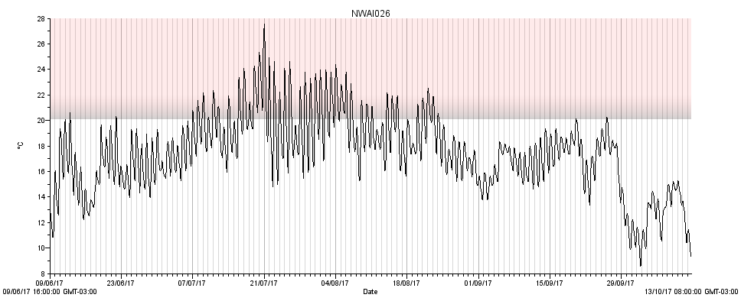
NWAI026. Located in Campbell Creek 20m down from dam [45.9872, -66.5799]
Max temp: 27.6°C
Min temp: 8.6°C
Average summer temp: 18.5°C ±2.4°C
Number of days >20°C = 46
Number of days >23°C = 17

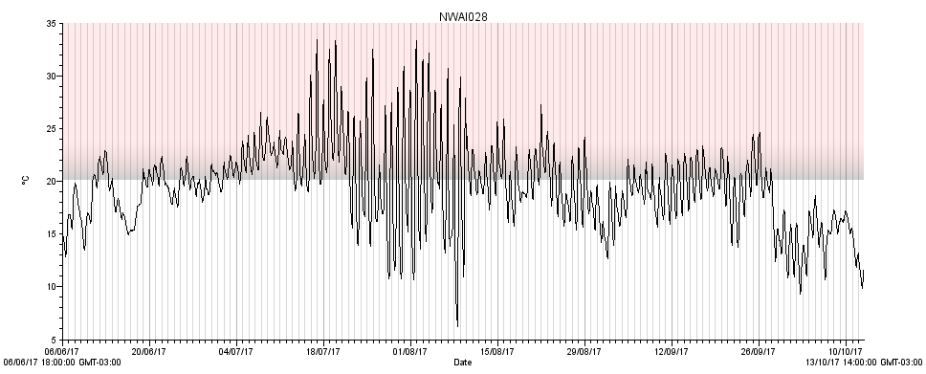
NWAI025 Located in Nashwaak River @Marysville ~50 m downstream of bank repair [45.9718, -66.5885]
*Came out of water in early August and was repositioned on the 12th.
Max temp: 33.4°C
Min temp: 6.3°C
Average summer temp: 20.5°C ±3.7°C
Number of days >20°C = 95
Number of days >23°C = 53
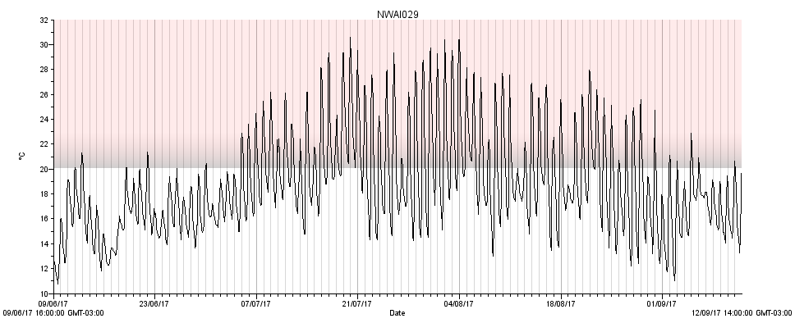
NWAI029. Located in Campbell Creek ~100 m upstream of dam [45.9852, -66.5780]
*This logger was removed about a month earlier than the others as a test to see if it had been recording properly
Max temp: 30.6°C
Min temp: 10.7°C
Average summer temp: 19.3°C ±3.9°C
Number of days >20°C = 67
Number of days >23°C = 46

