Loblaw Water Fund - Final Report Guidelines

Organization name:
Project title:

Instructions

Please provide a final report (due March 31, 2019) answering the questions below. Along with the final report, please submit:

- Any reports, publications or communications materials that were produced as a result of the project.
- Three or more photos (minimum of 300 dpi and taken with a good quality camera or Smartphone) of your project in action and/or the species being helped along with captions and credits. Please see photo and video tips in (Attachment 1) for more information.
- Any videos captured of your projects in action
- A year-end financial report using the template provided

Please answer all questions below in full

Final Report Template

- Project Results

- Summarize the goals and objectives of your project.

As the threat of habitat fragmentation of the Nashwaak Watershed was determined by WWF to be “high”, the overall objectives were as follows:
- Increase our knowledge of the aquatic connectivity of the watershed by surveying at least 50 road-stream crossings in terms of fish passage capabilities and analysing this information using GIS;
- Improve fish passage by restoring one or more barrier culverts;
- Share our data with local and national datasets, including the Nature Conservancy of Canada, the New Brunswick Department of Transportation (NBDTI), and the Atlantic Canada Culvert Assessment Toolkit (ACCAT), managed by the Petitcodiac Watershed Alliance.

The long-term goals of the project are to increase fish populations and biodiversity by managing human actions that impeded access to high-quality aquatic habitat and foster a more engaged watershed community.

- How did you work to accomplish those objectives? Describe the main activities of your project.

Over the course of 2017 and 2018, NWAI’s capacity to survey the Nashwaak watershed has greatly increased, as has our knowledge about the connectivity and fragmentation of our watershed. We have been able to inform the public about habitat fragmentation via online and printed resources, we have developed a relationship with NB Department of Transportation and Infrastructure (NBDTI), and we completed our first major remediation project. There are ~985 stream-road crossings in the Nashwaak watershed (Figure 2). In May 2017, the NWAI began to map, assess, and improve these crossings. In our first field season we completed a full survey on 75 culverts and 70% were determined to be full or partial barriers to fish passage. In 2018, our second field season, we started by mapping out priority areas in the central watershed to survey, we then visited 114 sites and conducted a full-survey of 67 crossings. We updated our survey form so that full surveys included collecting water temperature, pH, conductivity and total dissolved solids as well as some additional measurements and observations that were not included in 2017 surveys. We cleaned all 67 surveyed sites of debris and garbage (removing several kilograms including many discarded tires, rims, and car batteries!) (Figure 1).
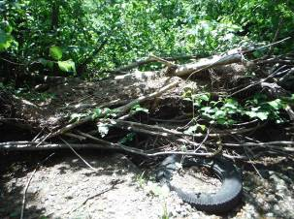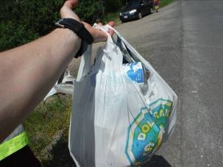
Figure 1. Garbage was cleaned from every survey site. We cleaned up lots of old tires, coffee cups and beer cans!

This survey information was entered into a central database and a GIS map, which will be shared with our partners at the end of the year. So far, we have assessed 252 of the 985 crossings in the watershed (~25% complete) and we have done a full survey on 142 culverts, surpassing our goal of surveying 100 culverts. Of these, 68% have been determined to be barriers to fish. We have surveyed almost all the crossings on public paved roads. From our database, the slope and outflow drop were calculated and from this the culvert could be categorized as a Full Barrier, Partial Barrier, or Passable. We have shared out data with the Atlantic Canadian Culvert Assessment Toolkit (run by Petitcodiac Watershed Alliance in 2017 but we are unsure of the status of the project at the moment). We have also shared our data with the NB Department of Transportation and Infrastructure. We mapped all the surveyed culverts using GIS. Photos of all culverts are available HERE. Online mapping is available HERE.

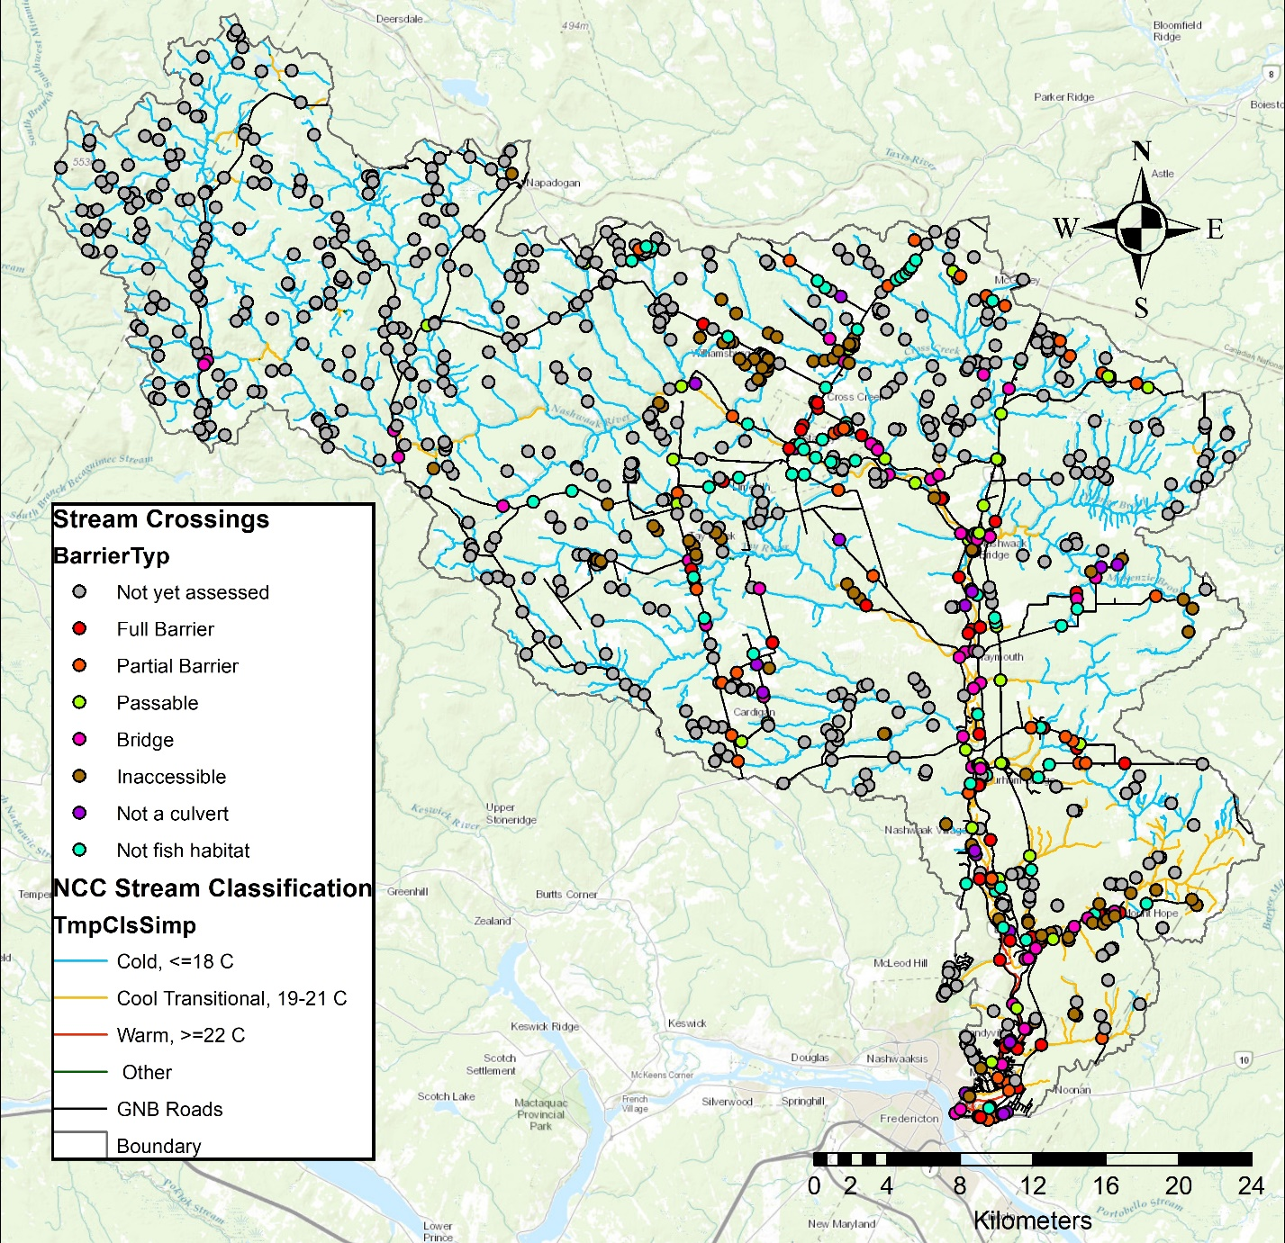
Figure 2. Stream classifications in the watershed superimposed on the Nature Conservancy of Canada's stream classification layer (used with permission). Crossings are classified by barrier type.

We have begun working with the Nature Conservancy of Canada (NCC) to use a GIS add-on developed by their American counterpart (TNC)’s: The Barrier Assessment Tool (BAT). This has allowed us to 1) prioritize sub-watersheds for assessment in the future and 2) prioritize assessed barriers for future remediation based on ecological and structural priority. We have shared the information with NBDTI at a meeting in December 2017. Working with NCC on this pilot project, that combines the BAT with their unpublished Freshwater Ecological Classification and Aquatic Blueprint, will allow us to contribute our data to an international effort focused on restoring connectivity for both ecological and climate change adaptation (flooding – emergency services provisioning- risk to culverts) purposes: The North Atlantic Aquatic Connectivity Collaborative. Figure 3 shows the results of the BAT analysis of our 2017 field season data. 2018 data is still being analysed and will be included in our final report, available in March 2019. This report will be shared with all funders and partners.

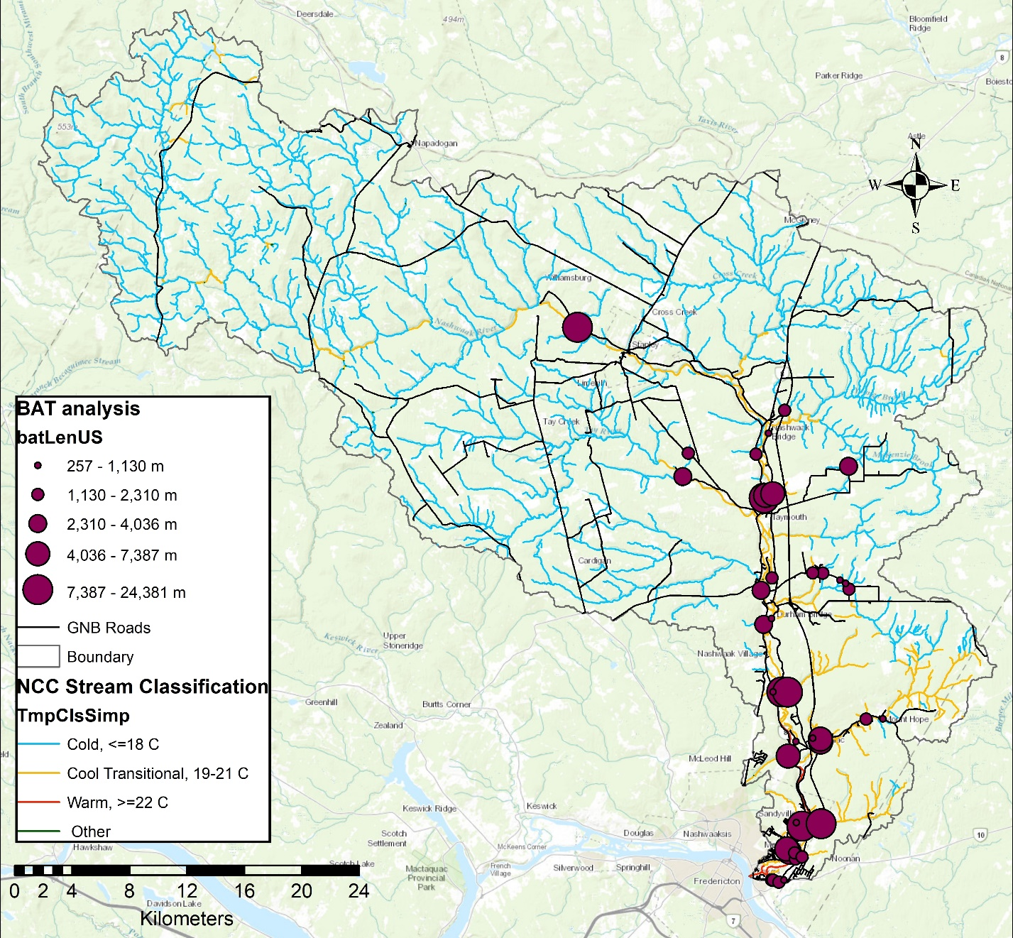
Figure 3. Barrier Assessment Tool (BAT) analysis of full and partial barriers assessed in 2017. The larger the dot, the more upstream habitat is blocked. The NCC stream classification layer has been used with permission.

Of the culverts surveyed in 2017 and 2018, only 32% (n=41) were passable to fish. 38% (n=48) were partial barriers while 30% were full barriers. Major issues preventing fish passage include: 1) culverts installed at steep slopes without baffles [this causes high velocities and eventually results in the erosion of the plunge pool resulting in a large outflow drop (Figure 4)]; 2) deteorating infrastructure including collapsing wooden box culverts and rusting metal pipes (we were informed by DTI that the wooden box culverts are slated to be replaced in the coming years and, therefore, we were told not to focus remediation efforts on these culverts); and 3) beaver activity completely blocking a number of culverts, especially along Rte. 8 (reported to DTI). Many of the existing culverts cannot be remediated to provide fish passage; they simply need to be replaced with new, properly designed and sized infrastructure.

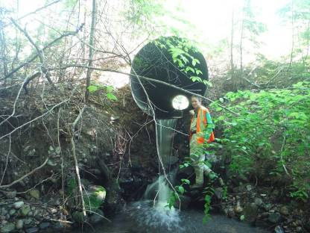
Figure 4. NWAI staff member Jillian Hudgins stands beside a culvert that has a 1.47 m outflow drop, which has caused a lot of erosion around the plunge pool. This culvert needs to be replaced.

For our first remediation project we chose to work on culvert M102 where Manzer Brook crosses Rte. 628. We chose Manzer Brook because is one of the larger fish-bearing watercourses in the lower watershed where stream-road crossings are culverts (larger streams have bridges as stream crossings). It is also on a well-traveled road. Based on conversations with surrounding landowners, it appears that the hydraulics of the brook have changed since Rte. 8 was built in 2009-2010. Department of Transportation and Infrastructure (DTI) remediated this culvert in 2000 but their fix washed out in the following year. Based on conversations with DTI, we were encouraged to focus our efforts on the Manzer Brook-Rte. 628 culvert as 1) many of the surveyed stream crossings in our watershed are either old wooden box culverts slated to be replaced by DTI in the near future, 2) the culvert is structurally in good shape, and 3) there was a previous (failed) attempt to instate fish passage for salmonids. The remediation was designed by HILCON Ltd. with input from Atlantic Salmon Federation and UNB Civil Engineering students. By reinstating fish passage at this stream crossing, we have opened 28 km² of previously inaccessible habitat.

In August 2018, we installed a 3 m long fish ladder on a barrier culvert on Manzer Brook where it crosses Rte. 628. This had been assessed in 2017 and was at the top of our priority list for remediation. Before remediation we electro-fished the site with the help of University of New Brunswick students. We found Atlantic salmon parr (Figure 5) and American eel below the barrier culvert but not above. Other species found below were: burbot, slimy sculpin, brook trout, white sucker, and black nosed dace. Above the culvert we found: sea lamprey, brook trout, black nosed dace, slimy sculpin, and creek chub. We will electrofish again the spring to determine the success of the ladder.
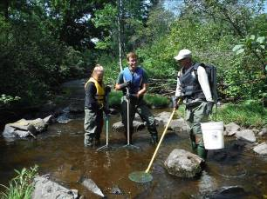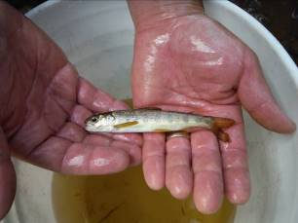
Figure 5. UNB staff and student help NWAI summer student Claire Ferguson electrofish downstream of Manzer Brook (L). One 12 cm Atlantic salmon parr was found downstream of the barrier culvert (R).
The lightweight aluminum fish ladder (Figure 6) was custom designed by a local hydraulic engineer and built by a local metalworks company. We had 10 volunteers assist with the installation. We also planted 100 live willow stakes around the plunge pool of the culvert to help prevent further erosion. We will electrofish the site again in the late spring of 2019 to see the changes in fish population.

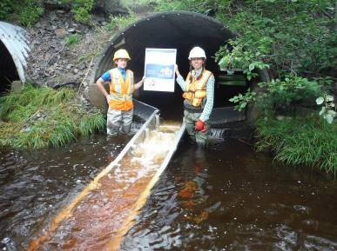
Figure 6. NWAI staff Jillian Hudgins and Marieka Chaplin stand beside the fish ladder after its installation on Manzer Brook
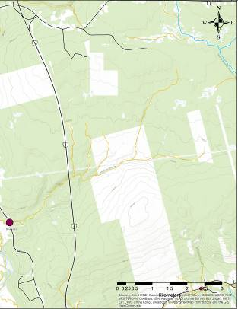
Figure 7. BAT analysis of M102.
In addition to this large repair, we have done at least 15 major debris removals, which have improved flow and fish passage in those culverts and improved water quality in those streams (Figure 7). We have recommended to NBDTI that they take immediate action on 9 culverts. We have received responses about 3 of these culverts – one was cleared of a beaver dam, one was cleared of a metal fence, and another collapsed culvert (Figure 8, which NBDTI was unaware of) is due to be replaced soon. We were also told that all the older wooden box culverts along Rte. 628 and 148 were due to be replaced in the coming years and to not focus our efforts on these culverts.
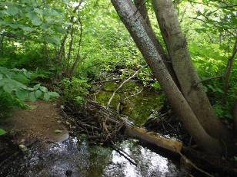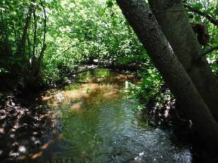
Figure 8. Before and after of a debris blockage removal downstream from a culvert on McLean Brook.
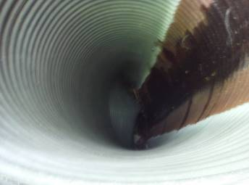
Figure 9. This collapsed pipe on the North Tay river was brought to DTI's immediate attention as it may cause the road to wash out during heavy rains
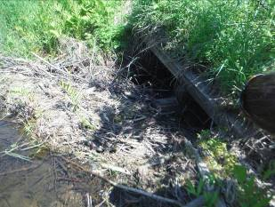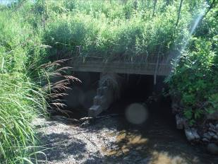
Figure 10. We brought this culvert to DTI's attention last year. A beaver was completely blocking the pipes. DTI removed the dam and the stream is now free flowing.
In September 2018 we began the next steps to remediate two more barrier culverts (Figures 11 & 12). Both are full barriers to fish passage. We are working together with the same engineering company who have conducted the hydraulic survey and they have decided that aluminum fish ladders will work as solutions for both of these culverts as well. Preliminary drawings are almost ready to share with NBDTI and Tek Steel has agreed to construct the ladders. Together these will open 6.3 km² of cool or cold water habitat that was previously inaccessible.
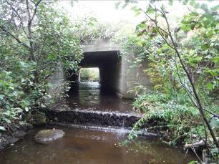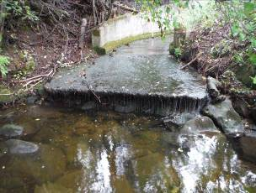
Figure 11. The culverts we have chosen to focus remediation efforts on next. Both have significant drops at their outlets and flat, wide bottoms. Fish ladders are in the design phase and will be installed in 2019.
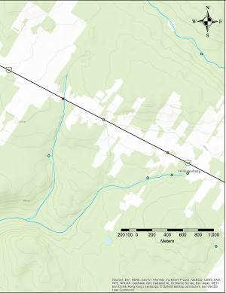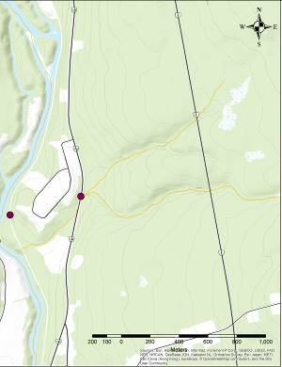
Figure 12. GIS mapping of the above 2 culverts. Ryan brook (left) is a cold-water tributary while the unnamed tributary (right) is cool. Both are mostly forested land use upstream.

- What challenges did you encounter and how did you overcome them?

Communication with NBDTI has been slow due to their chain of command; therefore, getting approval to do remediation work has taken much longer than expected. 4

Additionally, finding the right culvert to fix has been challenging – many are simply in too poor shape to be remediated; they simply must be replaced with new, properly designed and sized infrastructure. NWAI will continue to bring problem culverts to NBDTI’s attention and work with them to replace the worst barriers in the watershed. Initially we had anticipated carrying out several smaller projects, but the results of our surveys showed that remediation of the worst barriers would be bigger, higher budget projects then we thought. Therefore, we focused our efforts on the remediation of the Manzer Brook culvert in 2017/18 and of two additional culverts in 2018/19. We chose these three as they were all on cold or cool transitional streams (below 21°C). In a warming climate, it is important that thermal refuges remain accessible. We also realized that many of the existing culverts cannot be remediated to provide fish passage (for example, a collapsing wooden box culvert); they simply need to be replaced with new, properly designed and sized infrastructure.

- Briefly describe your project results. How do your project results benefit wildlife and people that depend on healthy freshwater ecosystems (immediate or long-term)?

Significant urbanization has occurred in the lower Nashwaak watershed in the last decade, leading to an increase in roads and associated stream crossings. Poorly designed, installed, or maintained culverts can restrict Endangered Atlantic salmon from reaching upriver spawning habitat, feeding grounds, or cold-water refuges, which can have significant impacts on their populations. A single culvert acting as a barrier can restrict fish from accessing several kilometres or more of important upstream habitat. Additionally, culverts can change water velocity, river hydrology, and become blocked with debris causing flooding and costly damage to infrastructure. Habitat fragmentation is a prolific issue in the Maritimes. Other groups assessing aquatic connectivity in the Maritimes found that 70-80% of culverts were either partial or full barriers to fish passage. Remediating these barriers will improve water quality, hydrology, access to upstream habitat, and prevent damage to infrastructure and even prevent communities from being cut off during flooding events.
The first two years of our aquatic connectivity project have been a huge success for NWAI. We surpassed our goal for number of culverts to map and survey. We trained four staff, two board members, two summer students, and three volunteers on the survey protocol. This has increased our capacity of our organization to survey the aquatic connectivity of the watershed, as well as our knowledge about the fragmentation of the river. We have made our data openly available online HERE.
Before remediation at Manzer Brook we electro-fished the site with the help of University of New Brunswick students. We found Atlantic salmon parr (Figure 5) and American eel below the barrier culvert but not above. Other species found below were: burbot, slimy sculpin, brook trout, white sucker, and black nosed dace. Above the culvert we found: sea lamprey, brook trout, black nosed dace, slimy sculpin, and creek chub. We will electrofish again the spring to determine the success of the ladder.

- What was the most significant conservation outcome of your project?

In 2018 we surveyed ~450 km² for aquatic connectivity adding to the 400 km² surveyed in 2017. Remediation of the Manzer Brook culvert has opened up 28 km² of previously inaccessible habitat to Endangered Atlantic salmon, American eel, bulbut, brook trout, slimy sculpin, white sucker, black nosed dace, and other aquatic species. Fish ladders to be installed in 2019 will open up almost 7km² more of cool/cold headwater habitat and debris removals have helped improve water quality and make additional habitat accessible.
- Using the table below, provide the conservation results or metrics that your project has produced to date, as applicable to your project. Include as many concrete measures and metrics as possible (add additional measurables as applicable).

Measurable | Conservation Result
Specific species benefitting from your project (highlight species at risk) | Atlantic salmon (Endangered by COSEWIC), American eel (Threatened), Brook trout, slimy sculpin, bulbot, black nosed dace, white sucker, other aquatic species, especially those that move between freshwater and ocean habitat
Surface area (m² or km²) habitat restored | 28 km² + 6.8 km² to be restored in 2019
Number or surface area (m² or km²) native plants planted (include a short list of the species of native plants) | 50 m² of live willow stakes
Number or surface area (m² or km²) invasive species removed | 0
Number of monitoring sites visited | 107 sites assessed with 62 full surveys conducted, one site electrofished, 2 engineering surveys completed
Number of new monitoring sites created

Number samples collected (i.e. water quality samples, benthic samples, etc.). | 62 water quality and fish passage assessments
Notable changes in metrics (e.g. water quality improvements, fish population increases, etc.) | Fish population will be assessed after the snow has melted
(other metrics as applicable)

- Community Engagement

- Who was involved in the execution of this project? Include number of employees, volunteers, and any other community partners and participants.

Project Participants | Number
Employees | 4
Volunteers | 8
Community partners (please specify) | Atlantic Salmon Federation, University of New Brunswick, Nature Conservancy of Canada, NB Community College
Other participants (please specify)

Field work has involved 180 volunteer hours (UNB students, ASF, St Mary’s First Nation, Nature Conservancy of Canada staff, NBCC, and NWAI board members. UNB also allowed us to borrow survey equipment valued at 500$. We continue to work hard to communicate the importance of connectivity of the river to the public via our social media channels, our annual newsletter, and conversations with landowners.
We had much more in-kind support than anticipated. Particularly from UNB Master’s student Calvin O’Neill and undergrad student Laura Wishart, who took on a special study of the Manzer Brook culvert (100 hours each). An NBCC student provided 40 hours of in-kind mapping work for a GIS course in 2017 and the Nature Conservancy of Canada (NCC) has provided 40 hours of in-kind training on using and piloting their Barrier Assessment Tool. In addition, NBDTI lent us road signs to use during the installation of the fish ladder.

We have been working with NCC to use a GIS add-on developed by their American counterpart to prioritize culverts for assessment and remediation and quickly calculate upstream habitat gain, land use information, and other parameters. This is an extremely useful tool to have when approaching DTI and other culvert owners. This partnership has turned into a pilot project, where NWAI’s culvert data is being combined with NCC’s unpublished Freshwater Ecological Classification and Aquatic Blueprint. This partnership will allow us to contribute our data to an international effort focused on restoring connectivity for both ecological and climate change adaptation (flooding – emergency services provisioning- risk to culverts) purposes: the North Atlantic Aquatic Connectivity Collaborative.

Our first remediation project was very successful. We had 10 volunteers involved in the installation and it went very quickly (2.5 hours to install). The ladder is performing as expected, backing up water in the middle pipe and channeling it through the ladder.

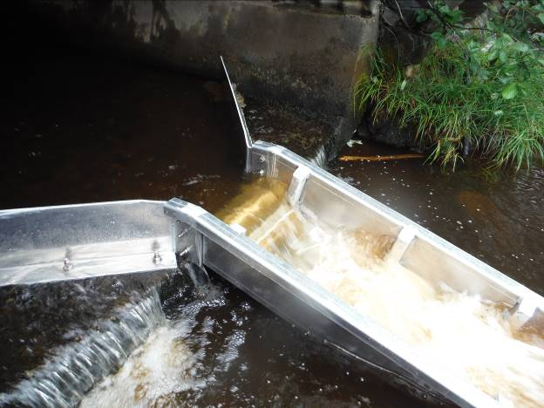
Figure 13. Close up of the fish ladder at Manzer Brook.

- What feedback did you receive about your project and from who? Please provide approved quotes from participants (could be your own staff/volunteers), project leaders or community members with names attributed. These quotes should describe what they did, learned or how it made them feel to be a part of an effort to help nature (we may use these quotes in future marketing materials, blogs etc. for the Loblaw Water Fund program). If possible, please provide contact information for participants who would be willing to share their stories with us directly.

“It was a great experience to help with the installation of the fish ladder! If you ever have other projects that need help in the field, feel free to ask me!” – Calvin O’Neill, UNB Masters student/volunteer

- Did your project receive media or community coverage and recognition? Provide links, documents, photos, social media posts etc. as necessary.

We use the social media hashtag #MyNashwaak on all of our posts. We had three dedicated posts about our fish ladder installation, which reached a total of 7,700 people with around 400 “likes” on Facebook. Additional posts about our culvert survey project reached another 600 people on Facebook. The posts were also shared on our Instagram, where we have fewer followers. Here, the hashtag #LoblawWaterFund was used. We also use the New Brunswick Watershed group hashtag #eauNBwater.

We have featured the topic of aquatic connectivity and barrier culverts a number of times on our “Watershed Word of the Week”, a weekly Wednesday feature on our Facebook page.

- Field and Project Stories (250-500 words)

- Please share a “story from the field” or interesting anecdote about a personal experience, major accomplishment or an at-risk species you helped that you think people would like to hear about. We may use this story in an upcoming newsletter, blog or on social media. Our donors love to hear about what you’re up to in the field (as do we!). For example, see a past story from a grantee online here. A member of our communications team may follow up with you to learn more.

Story by Claire Ferguson, education coordinator at NWAI
He had heard stories about the giants since he was just a small fry living in Manzer Brook, but Sal the Atlantic salmon had a hard time believing that these beings did exist. It was told that they were so tall they touched the clouds, and only a few fish had seen them up close. Sal only believed that these were tall tales from the past, until one morning, he came face to face with these giants.
It was a cold and crisp morning, similar to every other morning in Sal’s short life experience. He was only a few years old, and looked forward to heading out to sea with his siblings next year. As Sal began his daily morning swim, he heard an unfamiliar sound- the rumbling of the ground. Suddenly Brook trout were scattering, Sea lampreys were slithering away, and benthic macroinvertebrates were crawling under rocks. Before he knew where to go, he saw the giants enter the water. Rocks started to roll and the water began to churn. Sal moved closer to see the giants when suddenly, he couldn’t move his fins. Before he was able to swim away, he was plucked out of the water and placed into a container with other neighbouring fish. A few minutes later, he was placed onto a hard surface where the giants stared down at him. Sal heard them mention that they were from the “Nashwaak Watershed Association”, but he wasn’t sure what that meant. As quickly as he was put onto the hard surface, he was gently placed back into his home tributary.
A few days later, as he was starting his morning swim routine, that once unfamiliar rumbling began, but this time it was even stronger. Every fish and marine creature in the brook knew that the giants were coming, and left the scene as quickly as possible. Sal was anxiously waiting for the shock, but this time it didn’t come. He could see that the giants were moving around near the top of the brook, and this time they were putting something into the water. It was silvery and shiny, and divided up into small sections. Sal could see that the giants were crowded around the object, and were making loud noises while moving large rocks to the sides of the contraption. As he peaked out from behind a nearby rock, he could see that this silvery apparatus rose out of the water. Before long, the giants left and order returned to the brook.
Over the next few days, the entire marine community explored the slivery and shiny object. It was soon discovered that you could swim up it and into a dark world, which led to more possible habitat for Atlantic salmon and other aquatic species. Although Sal the Atlantic salmon had once been scared of these giants, he was excited that they had created a way for him to keep swimming upstream, and he looked forward to their return to Manzer Brook.

- Next Steps

- What are your next steps? How will this project continue in the future? Also, if possible, how does this project support or connect with other local efforts?

The NWAI has submitted grants to continue surveying and remediating culverts next year and beyond. 75% of the culverts in the watershed have yet to be surveyed and many of these lie on logging roads or trails. We have a list of priority culverts (attached), and we plan to work with DTI to remediate these culverts as our budget allows over the coming years. New additions will be made to priority list as they are discovered.

- What feedback do you have for WWF and the Loblaw Water Fund to help future grantees? How could WWF have helped to make your project more of a success?

We appreciate the support of WWF and Loblaw Water Fund in making this project possible and always being available to answer questions. We have no feedback on how to improve the process in the future.

- Please provide the Copyright information as well as descriptive captions for photos and videos submitted along with this report.

Photo | Caption | Copyright information: (Organization and/or photographer, e.g. ©WWF-Canada/Heather Crochetiere)
1. | Manzer Brook culvert before restoration. Each of the pipes had a drop of between 40 and 60 cm, preventing fish from moving upstream to important headwater habitat | Nashwaak Watershed Association Inc.
2. | Manzer Brook culvert in August 2018 immediately after the installation of the aluminum fish ladder. Fish are now able to pass through the culvert | Nashwaak Watershed Association Inc.
3. | Summer student Hannah Sharpe (right) and project coordinator Jillian Hudgins (left) measure the width of a culvert during a survey to investigate fish passage and aquatic connectivity of the watershed. | Nashwaak Watershed Association Inc.
4. | Summer students Hannah Sharpe and Claire Ferguson conduct a survey of a culvert in the Nashwaak Watershed. | Nashwaak Watershed Association Inc.
5. | Summer student Claire Ferguson surveys a barrier culvert on Ryan Brook in the Nashwaak Watershed to assess fish passage. | Nashwaak Watershed Association Inc.
6. | Atlantic salmon parr found below the Manzer Brook culvert during electrofishing. | Nashwaak Watershed Association Inc.

