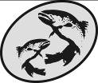
The Atlantic Salmon Conservation Foundation

Multiyear Project
End of Year Report

This form has been developed to simplify the reporting of your accomplishments to the ASCF. Please use this form for your End of Year Report, do not send report in other formats. The information you provide will be used to document the specific and overall accomplishments of your project and the effectiveness of the ASCF grants and may be subject to audit.

This report is distinct, and may be different, from other reports you may prepare for your project. The ASCF wishes to receive those reports in addition to this report.

Please note:
- Your Report and a statement of expenditures are due on the date provided in Schedule “C” of your contribution agreement.
- Attach copies of receipts for all ASCF funded expenditures.
- Any remaining balance of ASCF grant funds must be returned to the ASCF with the Final Report.
- Do not “refer to attachments” for information requested in this form.
- Reports are required on the date agreed top in your funding agreement. If the final report is not submitted, future applications to ASCF will not be considered. Amendment of the dates for reporting may be made by mutual agreement.
- Send reports, copies of receipts, photos, maps and final payment invoice to:

darla@salmonconservation.ca (NB or QC projects or projects resulting from an RFP for applied scientific research)
krystal@salmonconservation.ca (NS, PEI or NL projects)
or
The Atlantic Salmon Conservation Foundation
480 Queen Street, Suite 200
Fredericton, NB E3B 1B6

Need help?
For projects that are in New Brunswick or in Québec or projects resulting from an RFP for applied scientific research, please contact Darla Saunders (Darla@salmonconservation.ca).
For projects in Nova Scotia, Prince Edward Island or Newfoundland and Labrador, please contact Krystal Binns (krystal@salmonconservation.ca).
Office Numbers : Phone: 506-455-9900 Fax: 506-455-9905

Section A Project Information
Year Grant Acquired: 2017 End date: 1 December 2018
Year 1 of Project: 2017___ Year 2 of project:2018__ Year 3 of project: 20__
Year(s) covered by this report:__2017-2018______________________
Organization: Nashwaak Watershed Association Inc.
Project title: Assessing and restoring aquatic connectivity in the lower Nashwaak River
Contact: Marieka Chaplin, Executive Director
Address: P.O. Box 314, Station A, Fredericton, E3B 4Y2
Phone: 506-261-4664 Fax: E-mail: director@nashwaakwatershed.ca
ASCF Grant Amount: $ 12,175 / year for 2 years. Total 24,350
Section B Project Description
Category of Project (check all that apply):
- Development of an Atlantic salmon and salmon habitat watershed plan
- Protection and restoration of salmon habitat
- Rebuilding of stocks and restoration of salmon populations
- Restoration of access to critical salmon habitat | x
- Education and awareness on the importance of salmon conservation
Summary
Please state the importance, the objectives as stated in your funding agreement and the major results of this project.
Importance
Significant urbanization has occurred in the lower Nashwaak watershed in the last decade, leading to an increase in roads and associated stream crossings. Poorly designed, installed, or maintained culverts can restrict Endangered Atlantic salmon from reaching upriver spawning habitat, feeding grounds, or cold-water refuges, which can have significant impacts on their populations. A single culvert acting as a barrier can restrict fish from accessing several kilometres or more of important upstream habitat. Additionally, culverts can change water velocity, river hydrology, and become blocked with debris causing flooding and costly damage to infrastructure. Habitat fragmentation is a prolific issue in the Maritimes. Other groups assessing aquatic connectivity in the Maritimes found that 70-80% of culverts were either partial or full barriers to fish passage.
Prior to 2017, the aquatic connectivity of the Nashwaak Watershed was unknown. Therefore, the NWAI requested funds to conduct multi-year project to assess, prioritize, and restore barrier culverts in the Nashwaak watershed from the mouth of the river working up, to re-establish salmon access to important upstream habitat.

The project was developed from a High Priority Action Item in our 2017-2020 Action Plan. The Nashwaak River is an important salmon-producing tributary of the Saint John River and is one of DFO’s priority rivers for restoration under their 2014 “Recovery Potential Assessment”. This work is also in line with Atlantic Salmon Federation’s 2013 “Recovery Strategy for Wild Atlantic Salmon”. Habitat fragmentation and blocked access to cold-water or spawning habitats have been recognized as limiting factors for salmon populations.

Objectives
The objectives of the project were:
1) to increase the capacity of the NWAI to survey the Nashwaak River watershed;
2) to increase our knowledge of the aquatic connectivity and fragmentation of the watershed;
3) an overall decrease in habitat fragmentation within the Nashwaak watershed and an overall increase in habitat availability for the Atlantic salmon; and
4) to communicate the connectivity of the river to the public.

Results

Over the course of 2017 and 2018, NWAI’s capacity to survey the Nashwaak watershed has greatly increased, as has our knowledge about the connectivity and fragmentation of our watershed. We have been able to inform the public about habitat fragmentation via online and printed resources, we have developed a relationship with NB Department of Transportation and Infrastructure (NBDTI), and we completed our first major remediation project. There are ~985 stream-road crossings in the Nashwaak watershed (Figure 2). In May 2017, the NWAI began to map, assess, and improve these crossings. In our first field season we completed a full survey on 75 culverts and 70% were determined to be full or partial barriers to fish passage. In 2018, our second field season, we started by mapping out priority areas in the central watershed to survey, we then visited 114 sites and conducted a full-survey of 67 crossings. We updated our survey form so that full surveys included collecting water temperature, pH, conductivity and total dissolved solids as well as some additional measurements and observations that were not included in 2017 surveys. We cleaned all 67 surveyed sites of debris and garbage (removing several kilograms including many discarded tires, rims, and car batteries!) (Figure 1).
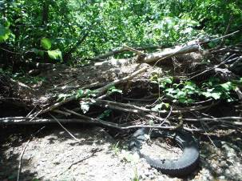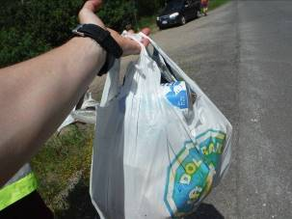
Figure 1. Garbage was cleaned from every survey site. We cleaned up lots of old tires, coffee cups and beer cans!

This survey information was entered into a central database and a GIS map, which will be shared with our partners at the end of the year. So far, we have assessed 252 of the 985 crossings in the watershed (~25% complete) and we have done a full survey on 142 culverts, surpassing our goal of surveying 100 culverts. Of these, 68% have been determined to be barriers to fish. We have surveyed almost all the crossings on public paved roads. From our database, the slope and outflow drop were calculated and from this the culvert could be categorized as a Full Barrier, Partial Barrier, or Passable. We have shared out data with the Atlantic Canadian Culvert Assessment Toolkit (run by Petitcodiac Watershed Alliance in 2017 but we are unsure of the status of the project at the moment). We have also shared our data with the NB Department of Transportation and Infrastructure. We mapped all the surveyed culverts using GIS. Photos of all culverts are available HERE. Online mapping is available HERE.

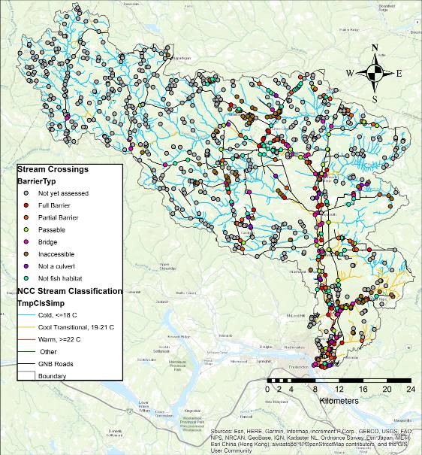
Figure 2. Stream classifications in the watershed superimposed on the Nature Conservancy of Canada's stream classification layer (used with permission). Crossings are classified by barrier type.

We have begun working with the Nature Conservancy of Canada (NCC) to use a GIS add-on developed by their American counterpart (TNC)’s: The Barrier Assessment Tool (BAT). This has allowed us to 1) prioritize sub-watersheds for assessment in the future and 2) prioritize assessed barriers for future remediation based on ecological and structural priority. We have shared the information with NBDTI at a meeting in December 2017. Working with NCC on this pilot project, that combines the BAT with their unpublished Freshwater Ecological Classification and Aquatic Blueprint, will allow us to contribute our data to an international effort focused on restoring connectivity for both ecological and climate change adaptation (flooding – emergency services provisioning- risk to culverts) purposes: The North Atlantic Aquatic Connectivity Collaborative. Figure 3 shows the results of the BAT analysis of our 2017 field season data. 2018 data is still being analysed and will be included in our final report, available in March 2019. This report will be shared with all funders and partners.

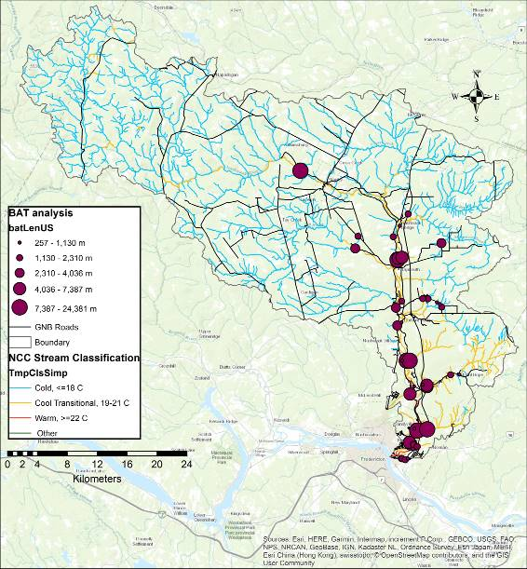
Figure 3. Barrier Assessment Tool (BAT) analysis of full and partial barriers assessed in 2017. The larger the dot, the more upstream habitat is blocked. The NCC stream classification layer has been used with permission.

Of the culverts surveyed in 2017 and 2018, only 32% (n=41) were passable to fish. 38% (n=48) were partial barriers while 30% were full barriers. Major issues preventing fish passage include: 1) culverts installed at steep slopes without baffles [this causes high velocities and eventually results in the erosion of the plunge pool resulting in a large outflow drop (Figure 4)]; 2) deteorating infrastructure including collapsing wooden box culverts and rusting metal pipes (we were informed by DTI that the wooden box culverts are slated to be replaced in the coming years and, therefore, we were told not to focus remediation efforts on these culverts); and 3) beaver activity completely blocking a number of culverts, especially along Rte. 8 (reported to DTI). Many of the existing culverts cannot be remediated to provide fish passage; they simply need to be replaced with new, properly designed and sized infrastructure.

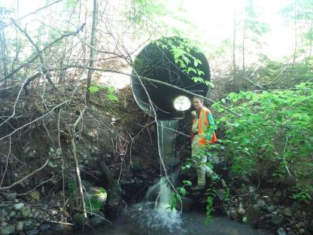
Figure 4. NWAI staff member Jillian Hudgins stands beside a culvert that has a 1.47 m outflow drop, which has caused a lot of erosion around the plunge pool. This culvert needs to be replaced.

For our first remediation project we chose to work on culvert M102 where Manzer Brook crosses Rte. 628. We chose Manzer Brook because is one of the larger fish-bearing watercourses in the lower watershed where stream-road crossings are culverts (larger streams have bridges as stream crossings). It is also on a well-traveled road. Based on conversations with surrounding landowners, it appears that the hydraulics of the brook have changed since Rte. 8 was built in 2009-2010. Department of Transportation and Infrastructure (DTI) remediated this culvert in 2000 but their fix washed out in the following year. Based on conversations with DTI, we were encouraged to focus our efforts on the Manzer Brook-Rte. 628 culvert as 1) many of the surveyed stream crossings in our watershed are either old wooden box culverts slated to be replaced by DTI in the near future, 2) the culvert is structurally in good shape, and 3) there was a previous (failed) attempt to instate fish passage for salmonids. The remediation was designed by HILCON Ltd. with input from Atlantic Salmon Federation and UNB Civil Engineering students. By reinstating fish passage at this stream crossing, we have opened 28 km² of previously inaccessible habitat.

In August 2018, we installed a 3 m long fish ladder on a barrier culvert on Manzer Brook where it crosses Rte. 628. This had been assessed in 2017 and was at the top of our priority list for remediation. Before remediation we electro-fished the site with the help of University of New Brunswick students. We found Atlantic salmon parr (Figure 5) and American eel below the barrier culvert but not above. Other species found below were: burbot, slimy sculpin, brook trout, white sucker, and black nosed dace. Above the culvert we found: sea lamprey, brook trout, black nosed dace, slimy sculpin, and creek chub. We will electrofish again the spring to determine the success of the ladder.
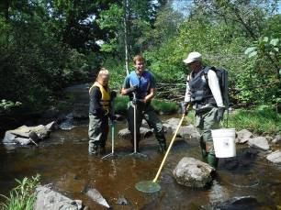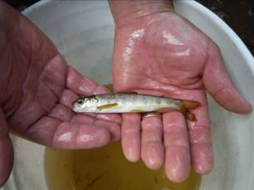
Figure 5. UNB staff and student help NWAI summer student Claire Ferguson electrofish downstream of Manzer Brook (L). One 12 cm Atlantic salmon parr was found downstream of the barrier culvert (R).
The lightweight aluminum fish ladder (Figure 6) was custom designed by a local hydraulic engineer and built by a local metalworks company. We had 10 volunteers assist with the installation. We also planted 100 live willow stakes around the plunge pool of the culvert to help prevent further erosion. We will electrofish the site again in the late spring of 2019 to see the changes in fish population.

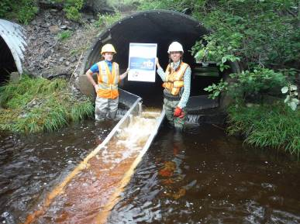
Figure 6. NWAI staff Jillian Hudgins and Marieka Chaplin stand beside the fish ladder after its installation on Manzer Brook
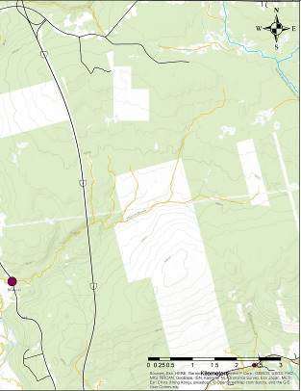
Figure 7. BAT analysis of M102.
In addition to this large repair, we have done at least 15 major debris removals, which have improved flow and fish passage in those culverts and improved water quality in those streams (Figure 7). We have recommended to NBDTI that they take immediate action on 9 culverts. We have received responses about 3 of these culverts – one was cleared of a beaver dam, one was cleared of a metal fence, and another collapsed culvert (Figure 8, which NBDTI was unaware of) is due to be replaced soon. We were also told that all the older wooden box culverts along Rte. 628 and 148 were due to be replaced in the coming years and to not focus our efforts on these culverts.
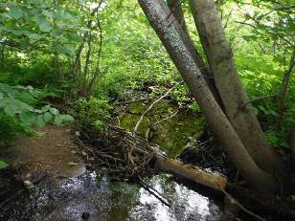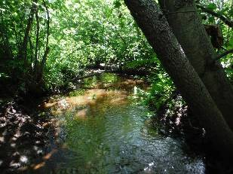
Figure 8. Before and after of a debris blockage removal downstream from a culvert on McLean Brook.
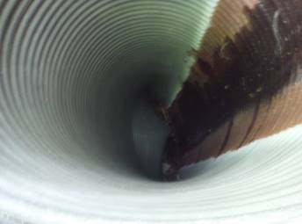
Figure 9. This collapsed pipe on the North Tay river was brought to DTI's immediate attention as it may cause the road to wash out during heavy rains
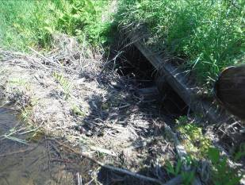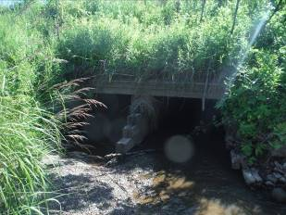
Figure 10. We brought this culvert to DTI's attention last year. A beaver was completely blocking the pipes. DTI removed the dam and the stream is now free flowing.
In September 2018 we began the next steps to remediate two more barrier culverts (Figures 11 & 12). Both are full barriers to fish passage. We are working together with the same engineering company who have conducted the hydraulic survey who is now working on remediation options. They hope to have preliminary drawings ready to share with NBDTI early in the new year. Together these would open 6.3 km² of cool or cold water habitat that was previously inaccessible.
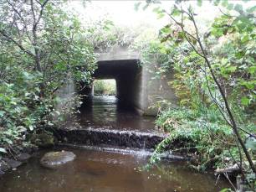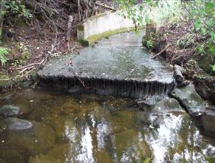
Figure 11. The culverts we have chosen to focus remediation efforts on next. Both have significant drops at their outlets and flat, wide bottoms
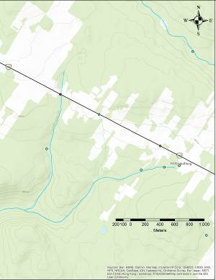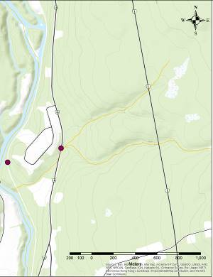
Figure 12. GIS mapping of the above 2 culverts. Ryan brook (left) is a cold-water tributary while the unnamed tributary (right) is cool. Both are mostly forested land use upstream.
Field work has involved 180 volunteer hours (UNB students, ASF, St Mary’s First Nation, Nature Conservancy of Canada staff, NBCC, and NWAI board members. UNB also allowed us to borrow survey equipment valued at 500$. We continue to work hard to communicate the importance of connectivity of the river to the public via our social media channels, our annual newsletter, and conversations with landowners.
Project performance and evaluation:
Please provide an evaluation and assessment of the performance of your project according to the performance measures outlined in the funding agreement. Include problems you encountered and how they were solved, unexpected outcomes, budget inaccuracies, timing changes, and recommendations for future work.
Evaluation and assessment
The first two years of our aquatic connectivity project have been a huge success for NWAI. We surpassed our goal for number of culverts to map and survey. We trained four staff, two board members, two summer students, and three volunteers on the survey protocol. This has increased our capacity of our organization to survey the aquatic connectivity of the watershed, as well as our knowledge about the fragmentation of the river.

We had much more in-kind support than anticipated. Particularly from UNB Master’s student Calvin O’Neill and undergrad student Laura Wishart, who took on a special study of the Manzer Brook culvert (100 hours each). An NBCC student provided 40 hours of in-kind mapping work for a GIS course in 2017 and the Nature Conservancy of Canada (NCC) has provided 40 hours of in-kind training on using and piloting their Barrier Assessment Tool. In addition, NBDTI lent us road signs to use during the installation of the fih ladder.

The partnership with NCC was unexpected at the time of application. We have been working with them to use a GIS add-on developed by their American counterpart to prioritize culverts for assessment and remediation and quickly calculate upstream habitat gain, land use information, and other parameters. This is an extremely useful tool to have when approaching DTI and other culvert owners. This partnership has turned into a pilot project, where NWAI’s culvert data is being combined with NCC’s unpublished Freshwater Ecological Classifcation and Aquatic Blueprin. This partnership will allow us to contribute our data to an international effort focused on restoring connectivity for both ecological and climate change adaptation (flooding – emergency services provisioning- risk to culverts) purposes: the North Atlantic Aquatic Connectivity Collaborative.

Our first remediation project was very successful. We had 10 volunteers involved in the installation and it went very quickly (2.5 hours to install). The ladder is performing as expected, backing up water in the middle pipe and channeling it through the ladder.

As this project has other funders and funding has been provided until March 30, 2019, a final report will be produced for this deadline and shared with all project partners and funders.
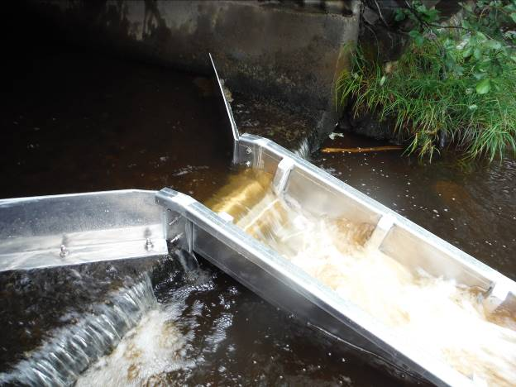
Figure 13. Close up of the fish ladder at Manzer Brook.

Problems encountered & solutions:

When we applied for this grant in 2016, we had no knowledge of the aquatic connectivity of the watershed, the scale or budgets of remediations that might be needed, how many cuvlerts we could remediate in a year, or the timeline of getting DTI’s approval to move forward on projects. Initially we had anticipated carrying out several smaller projects but the results of our surveys showed that remediation of the worst barriers would be bigger, higher budget projects then we thought. Therefore, we focused our efforts on the remediation of the Manzer Brook culvert in 2017/18 and of two additional cuverts in 2018/19. We chose these three as they were all on cold or cool transitional streams (below 21°C). In a warming climate, it is important that thermal refuges remain accessible. We also realized that many of the existing culverts cannot be remediated to provide fish passage (for example, a collapsing wooden box culvert); they simply need to be replaced with new, properly designed and sized infrastructure.

One setback we had was the difficulty communicating with DTI. It took over a year for someone to be our primary contact person (we were passed around to several people beforehand and had to re-explain the project and send files multiple times). We were able to get a meeting with four staff in December 2017, which pushed our project forward. However, timelines for approval of projects and remediation designs were long, particularly because the summer is very busy for their department and due to the chain of command. Over the last two years we have built the trust of DTI and proven ourselves with our first remediation project at Manzer Brook. DTI remains 15oncerned about the safety and liability aspects of our group working on their infrastructure but has tentatively offered in-kind support to future projects.

Future Work

The NWAI has submitted grants to continue surveying and remediating culverts next year and beyond. 75% of the culverts in the watershed have yet to be surveyed and many of these lie on logging roads or trails. We have a list of priority culverts (attached), and we plan to work with DTI to remediate these culverts as our budget allows over the coming years. New additions will be made to priority list as they are discovered.

Performance measure  Take from Attachment “A” of Contribution Agreement | Results
# of NWAI staff and volunteers attending training workshop. | Three staff and two board members attended a training workshop in May 2017 with Peticodiac Watershed Alliance. An additional one staff, two summer students and three volunteers were trained by NWAI project coordinator
# of culverts mapped in a desktop survey in Year 1 / Year 2. | Thanks to assistance from a NBCC student this spring, we mapped all the stream crossings in our watershed
# of culverts surveyed in preliminary field survey in Year 1 and >50 additional surveyed in Year 2. | We have assessed 252 stream crossings and have done a full survey on 142, which was above our goal of 50 per year.
Area (x km²) surveyed for connectivity in Year 1/ Year 2. | In year 1 we surveyed ~400 km² for connectivity (from Barkers Point to Nashwaak Bridge between Rte. 148 and Rte. 8 and along Upper Durham Rd, Penniac Rd, Lower Durham Rd, English Settlement Rd, and Nashwaak West Road). In Year 2 we surveyed an additional 450 km² (Stanely, Cross Creek, Rte. 620, Rte. 107, Irving Roads)
List of priority culverts to re-examine in follow-up survey in Year 1 | We have made a list of priority culverts and shared this with DTI twice, once in December 2017 and again in the summer of 2018 (updated with new surveyed culverts). We have remediated one of these culverts and have begun the design of two more.
# of culverts examined with a hydraulic engineer in Year 1 and # additional culverts surveyed in Year 2. | Three culverts were examined with a hydraulic engineer. 1 in 2017 and 2 in 2018.
# of conversations with culvert owners in Year 1/ Year 2. | We have approached DTI about several problem culverts in the area. The City of Fredericton has been contacted about problem culverts along the walking trail in Marysville – one has been replaced in 2018.
# of recommendations made to culvert owners for remediation of a problem culvert in Year 1/ Year 2. | In 2017, we recommended to DTI that they take immediate action on 6 culverts. We have received responses about 3 of these culverts, which were either cleaned or a beaver was removed.  In 2018, we recommend they take immediate action on a collapsed culvert and on another culvert that was about to collapse. DTI said they would send a team out but we did not receive any additional communication. In addition, we sent them a priority list of culverts in the watershed that should be replaced.  We were also told that all the older wooden box culverts along Rte. 628 and 148 were due to be replaced in the coming years and to not focus our efforts on these culverts. Several beaver blockages have been brought to their attention.
# of culverts remediated, repaired, or unblocked in Year 1 and # in Year 2 | 16 culverts have been unblocked including the beaver dam that was removed by DTI. One culvert has been repaired and two more are in the design phase.
Permits acquired, as necessary, to complete activities | A WAWA permit was issued for the work done on culvert M102. Permission from DTI and landowners was also granted for the work.
# of culvert owners who agree to reinstall or remove a culvert in the future (for culvert repairs beyond our capacity). | DTI has noted that all wooden box culverts on Rte. 628 and 148 will be replaced in the coming years. We continue to bring problem culverts to their attention. Three culverts in the watershed were replaced 2017 (one on Fisher Brook that was a major barrier to fish passage, one on Bradley Brook, and small unnamed tributary to Manzer Brook), one large culvert on Ryan Brook is currently being replaced and the City has replaced one culvert on the Nashwaak Trail.  They City has also approved the removal of the worst barrier in the watershed, Campbell Creek Dam, but does not yet have a timeline or plan for the removal.
Area (km²) of previously inaccessible habitat opened upon removal of barriers in Year 1/ Year 2. | The remediation of culvert M102 has resulted in 28km² of previously inaccessible habitat opened to salmonids. We estimate that at least 60 km² was opened by unblocking 15 culverts (removing debris) and that 5.4 km² will be opened upon remediating the two culverts that are in design.
Length (km) of river made accessible to fish in Year 1/Year 2. | The Manzer Brook project opened 19.1 km of stream. We anticipate that the debris removals opened another 20 – 30 km and the two new projects will open ~4 km of stream.
Report and GIS maps are shared with project funders and with public. | We have made our data openly available online HERE. Maps are included in this report. As this project has others funders and is funded until spring 2019, a final report will be produced then.
# of people reached through social media posts and newsletters. | Social media engagement is difficult to quantify but our three posts about our fish ladder reached 7,700 people and generated 290 “reactions” (our average posts only reach 506 people and generate 25 “reactions”)  The Aquatic Connectivity Project was featured in our 2017 and 2018 newsletter, distributed to 10,000 households in October and at our 2017 AGM.
# of Action Items added to our Action Plan. | As this project has other funders will address this performance measure in March 2019. A number of priority culverts have been added to our action plan and the need to protect, restore, and reconnect cold water tributaries remains a high priority item.

Section C Project Results

Stream(s) or river(s) where project took place: Nashwaak watershed from Napadogan to confluence with the Saint John River, including tributaries (Manzer Brook, McLean Brook, Tay River, Penniac Stream, Campbell Creek, and others).
Total length (km) of stream if known: Unknown
Geographic area inventoried, mapped or assessed (km²): ~250 km²
UTM/GPS coordinates: See attached database
If applicable, please provide the following information as they apply to your project. Please include only new achievements that have not been reported to ASCF in past projects.

Check | Indicator | Measure | Project Achievement
Check | Indicator | Measure | Year 1  20--- | Year 2  20__ | Year 3  20__
Development of Atlantic salmon and salmon habitat watershed plan
 | Watershed plans developed/  implemented | Number of watersheds involved
 | Watershed plans developed/  implemented | Number of plans
 | Watershed plans developed/  implemented | Km² of watershed under planning and priority setting
Restoration of salmon habitat
 | In-stream habitat restored | Area (m²)
 | Estuarine habitat restored | Area (m²)
 | Lake habitat restored | Area (m²)
 | Riparian area restored or stabilized | Area Area (m²)
 | Trees and shrubs planted | Number of trees/shrubs |  | 100 willow stakes planted
  x
 | Trees and shrubs planted | Area (m²) |  | 200
 | In-stream structures installed | Number of structures |  | 1 fish ladder
  x
 | Non-native species removed | Number of species
 | Other species protected or restored | Number of species
Rebuilding of stocks and restoration of salmon populations
 | Fry released/raised | Number of fish
 | Parr released/raised | Number of fish
 | Smolts released | Number of fish
 | Grilse released | Number of fish
 | MSW released | Number of fish
 | Fish tagged | Number of fish tagged
 | Total fish released | Number of fish
 | Stock assessment | Number of fish
Restoration of access to salmon habitat
 | Restored access to habitat | Area (m²) | >44,000 (debris removals) | 28,000 at Manzer Brook and 16,000 from debris removals
  x
 | Debris removed | Tonnes | Debris removed at every culvert, 11 large blockages of debris (garbage) were removed. Weight is unknown | Debris removed at every culvert, 4 large blockages of debris (garbage) were removed. Weight is unknown
  x
Education and Awareness on the importance of salmon conservation
 | Type of project | Community stewardship
 | Type of project | Education and awareness
 | Type of project | Volunteer training
 | Target Audience and participants | Number of Grade k-12
  x
 | Target Audience and participants | Number of Post Secondary |  | 2
 | Target Audience and participants | Number of Landowners contact |  | 2
 | Target Audience and participants | Number of Volunteers | 9 | 6
 | Target Audience and participants | Number of Public presentations | 1
 | Target Audience and participants | Number of Community planning
Other indicators of success
 | Culverts assessed for fish passage | Number of full assessments | 75 | 67
  x
 | Area assessed for aquatic connectivity | Km² | 400 | 450
  x
 |  | Value or unit of measure

Section D Communications and Media

- Did you use the ASCF logo or sign?
Yes | x | ___often___ quantity | No

If No, please explain why not:

- Did you provide recognition to the Foundation for its grant?
Yes | x | No
Please explain the nature of the recognition:
The ASCF logo was included on a signboard with our other funders’ logos displayed at all of our community events; we displayed the ASCF sign at our AGM and thanked the Foundation verbally; the ASCF logo was included on our annual newsletter that was distributed to 10,000 households and business in the watershed; a number of social media posts also thanked ASCF for helping to fund our work; a staff participated in a tasting event at an NB liquor store; and, finally, the ASCF sign is displayed daily in our office. Aquatic Connectivity was one of our key topics at our 2017 AGM._____

- Please indicate which communication tools were used to highlight the project as well as the quantity (check all that apply). Be sure to attach any news clippings to the Final Report.

Newspaper |  | _____________ quantity
Interview | x | _1 interview on Joy FM____________
Brochure | x | _10,000 newsletters were distributed to landowners and businesses in the watershed and Fredericton (attached) in 2017 and 2018__
Website | x | www.nashwaakwatershed.ca
Other | x | _Social media (Facebook, Instagram, twitter) and The project was highlighted in a presentation at our 2017 AGM .

- Are you submitting a project report (other than this one)?
Yes | x | No
If yes, please be sure to send the foundation a pdf copy.

- Did you send your data and results to another organization or data warehouse where people can access the information? Please state the organizations.

Culvert assessment data will be shared with the Peticodiac Watershed Alliance for inclusion on their Atlantic Canada aquatic connectivity map, with NB Department of Transportation and Infrastructure, with the Nature Conservancy of Canada for inclusion in their Classification and Blueprint for the Maritimes.
Section E Partner and Funding Information
- Please list all involved partners in the project and their contributions.

Please verify that the total below matches the total presented in Part 5 of the Budget.

Organization name | Type of group* | Description or function of partner | Amount
Organization name | Type of group* | Description or function of partner | Cash | In-kind
ASCF | NG | Funding partner | 12,175
Patagonia | NG | Funding partner | 5,138.80
Wildlife Trust Fund | G | Funding partner | 9,300
WWF Loblaws | NG | Funding partner | 13,000
Environmental Trust Fund | G | Funding partner | 30,000
UNB | NG | In kind partner (equipment, field assistance, project design) |  | 4,000
NCC | NG | In kind partner (GIS) |  | 3,000
Board of Directors and Tree Nursery | Applicant | In kind partner (oversight and willows from nursery) |  | 3,300
Atlantic Salmon Federation | NG | In kind partner (field work, oversight) |  | 500
St Marys First Nation | NG | In kind partner (field work) |  | 500
NBDTI | G | In kind partner (meetings, equipment) |  | 1,200
NWAI equipment bank | Applicant | In kind partner (equipment) |  | 500
Sub-total |  |  | 69,613.80 | 13,000
Total (Cash + In-kind Sub-totals) |  |  | 82,613.80
*Government (g), non-government (ng)

- Total number of staff* paid through ASCF grant: Year 1: _2_ Year 2: _1_ Year 3: __
Total number of staff* paid through other organizations: Year 1: _2_ Year 2:_3_ Year 3:__
*including students
- Total number of studens paid through ASCF grant: Year 1: _0_ Year 2: _0_ Year 3: __
Total number of students paid through other organizations: Year 1: _1_ Year 2: 2 Year 3: _
- Total number of volunteers involved in the project: Year 1: _9__ Year 2: _6__ Year 3: ___
Total hours worked for the project: Year 1: _120_ Year 2: _270_ Year 3: ___
- Statement of Expenditures
Please provide a detailed financial statement of ASCF grant expenditures, in-kind and other funds using the Budget spreadsheet.

Section G Recommendations to ASCF
To assist us in improving our process, please provide any comments or suggestions you may have on your experience with the ASCF.
We recommend that ASCF move their final reporting deadline (at least for the written portion) so that it does not coincide with other major provincial granting deadlines and their own grant deadline. NGO staff end up overwhelmed at this time of year and the quality of the reporting suffers due to lack of time.

The two budget sections should be in one document (excel) to reduce confusion

