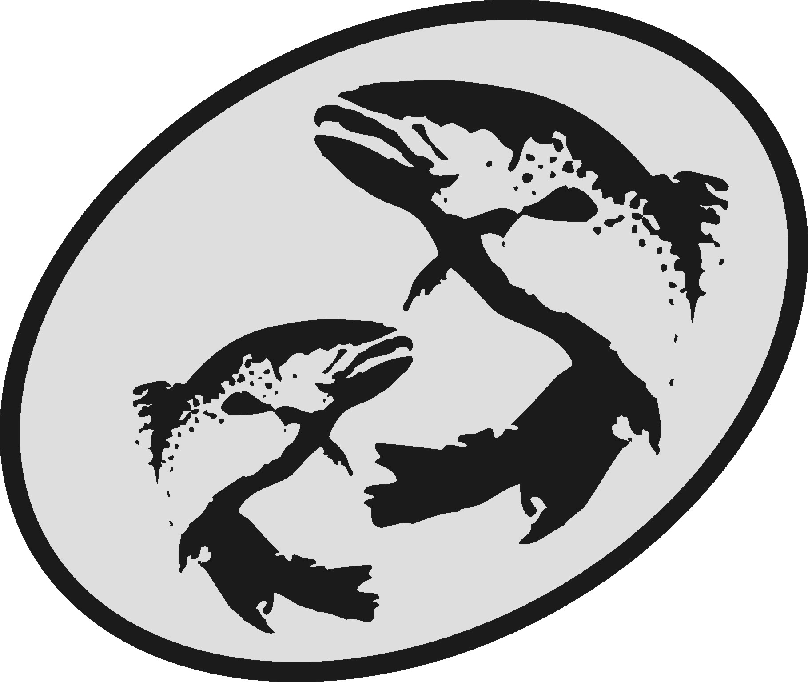The Atlantic Salmon Conservation Foundation

Final Report

This form has been developed to simplify the reporting of your accomplishments to the ASCF. Please use this form for your Final Report, do not send final report in other formats.

The information you provide will be used to document the specific and overall accomplishments of your project and the effectiveness of the ASCF grants and may be subject to audit.

This report is distinct, and may be different, from other final reports you may prepare for your project. The ASCF wishes to receive those reports in addition to this report.

Please note:

- Your Final Report and a statement of expenditures are due on the date provided in Schedule “C” of your contribution agreement.
- Attach copies of receipts for all ASCF funded expenditures.
- Any remaining balance of ASCF grant funds must be returned to the ASCF with the Final Report.
- Do not “refer to attachments” for information requested in this form.
- A final report is required on the date agreed top in your funding agreement. If it is not submitted, future applications to ASCF will not be considered. Amendment of the dates for reporting may be made by mutual agreement.
- Send reports, copies of receipts, photos, maps and final payment invoice to:

darla@salmonconservation.ca (NB or QC projects or project resulting from an RFP for applied scientific research)
allyson@salmonconservation.ca (NS, PEI or NL projects)
or
The Atlantic Salmon Conservation Foundation
480 Queen Street, Suite 200
Fredericton, NB E3B 1B6
Need help?
For projects that are in New Brunswick or in Québec or that resulted from an RFP for applied scientific research, please contact Darla Saunders (Darla@salmonconservation.ca).
For projects in Nova Scotia, Prince Edward Island or Newfoundland and Labrador, please contact Allyson Heustis (allyson@salmonconservation.ca).

Office Numbers : Phone: 506-455-9900 Fax: 506-455-9905

Section A Project Information
Year Grant Acquired: 2019 End date: December 1, 2019
Organization: Nashwaak Watershed Association Inc.
Project title: Reducing sedimentation through riverbank restoration on the Nashwaak river
Contact: Marieka Chaplin
Address: P.O. Box 314, Station A, Fredericton, NB, E3B 4Y2
Phone: 261-4664 Fax: N/A E-mail: director@nashwaakwatershed.ca
ASCF Grant Amount: $11,800
Section B Project Description
Category of Project (check all that apply):
- Development of an Atlantic salmon and salmon habitat watershed plan
- Protection and restoration of salmon habitat | x
- Rebuilding of stocks and restoration of salmon populations
- Restoration of access to critical salmon habitat
- Education and awareness on the importance of salmon conservation

Summary
Please state the importance, the objectives as stated in your funding agreement and the major results of this project.
Our 2004 Water Classification project and 2016 geomorphic survey noted that eroding riverbanks were a major source of water quality and salmon habitat degradation through sedimentation. The input of sediment into a river has been recognized as a potential threat to the well being of aquatic organisms (DFO, 2000). Sediment has the potential to harm fish and their habitat and therefore contravene provisions of the Fisheries Act. Elevated levels of sediment and turbidity have detrimental effects on salmon’s entire life cycle, from reduced survival of eggs through suffocation by fine sediments to gill irritation in adults.
An eroding bank at Nashwaak Valley Farm in Penniac was noted in 2017 as a significant source of sediment. The landowner is cooperative and well-respected within the community. He interested in restoring the bank and eventually turning the property into an ecotourism destination. Therefore, the NWAI requested funding for a bio-engineered bank stabilization and re-vegetation project at Nashwaak Valley Farm. The engineering survey and design was completed by HILCON Ltd and a Watercourse and Wetland Alteration Permit was obtained from the NB Department of Environment and Local Government. The restoration project was completed between August 14 and 16 2019. Malcolm Foster was the contractor hired to do the work and the project was inspected by the engineering firm upon completion of the earth works. The landowner hydroseeded by repaired bank with native grass seed and NWAI staff and summer students live staked 250 native willow species (stakes were cut from our native tree nursery). 20 silver maples were be dug up from our tree nursery in early October and planted on site along with volunteers from the Maritime College of Forest Technology (MCFT) .
Prior to the restoration of the site, a temperature logger was installed downstream from the bank. It was removed in mid-October. In addition water quality samples were taken upstream and downstream of the bank both before and after the restoration. We sampled for benthic invertebrates in October 2019 along with two volunteers from MCFT.
Restoration of this site will reduce sediment loading to the Nashwaak River, improving water quality and habitat for native salmonids. In the long term, we hope that this project contributes to a cleaner, cooler, Nashwaak Watershed with healthier salmon populations and improved aquatic habitat. We realize that stabilizing one eroding bank along the Nashwaak will not solve the issue of sedimentation in the river; however, the landowner is well-known in the community and has plans to turn the property into an ecotourism destination. This project has continued to build the capacity of our organization to restore larger riverbanks and share this information with other watershed groups interested in bioengineering restoration. We are working with other St John River watershed groups throughout this fall and winter to develop a Restoration Handbook. It is currently in draft stages.
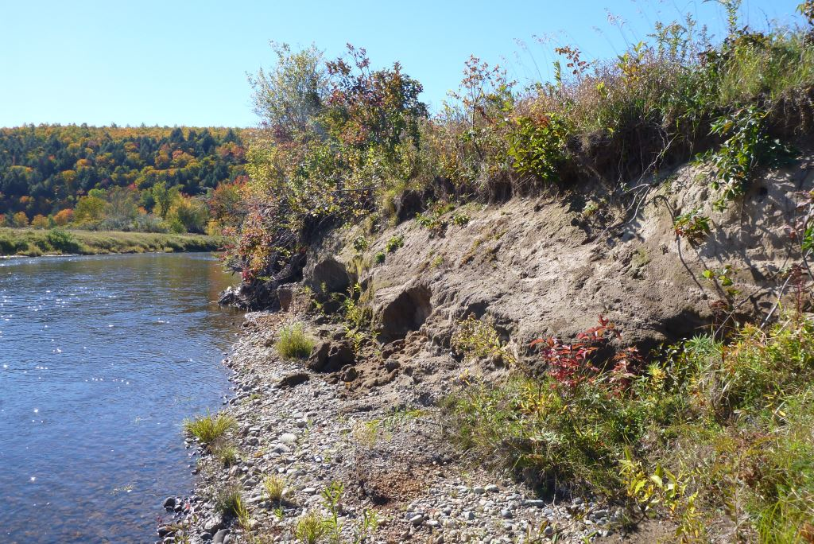
Figure 1. What the eroding bank at Nashwaak Valley Farm looked like in fall 2018
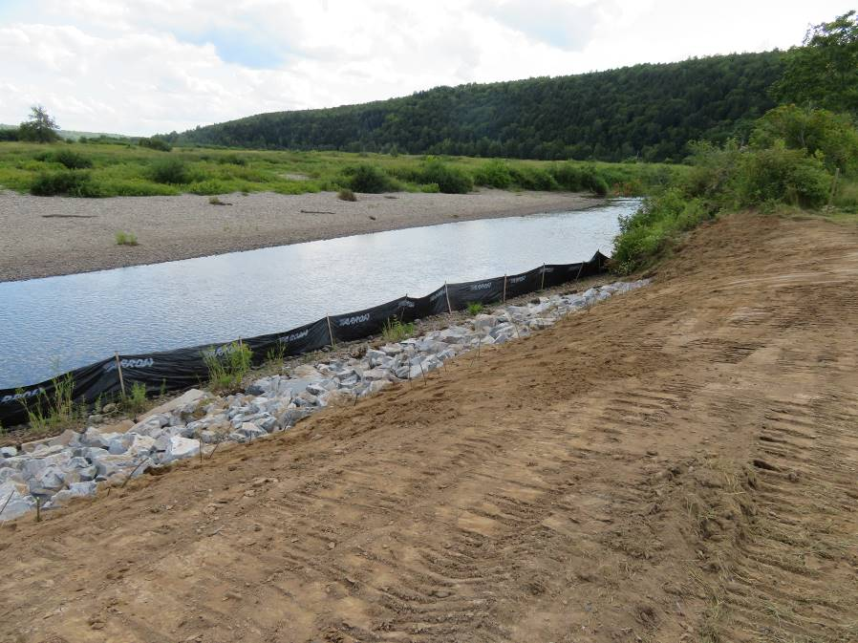
Figure 2. What the eroding bank at Nashwaak Valley Farm looked like after the earth works
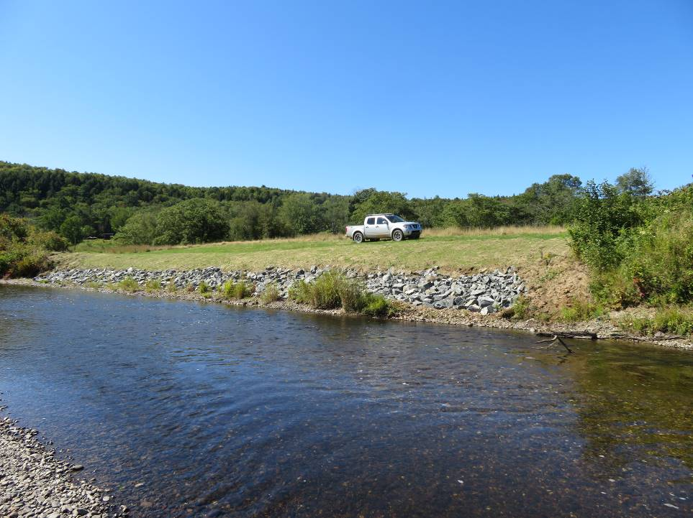
Figure 3. The restored bank 3 weeks after restoration
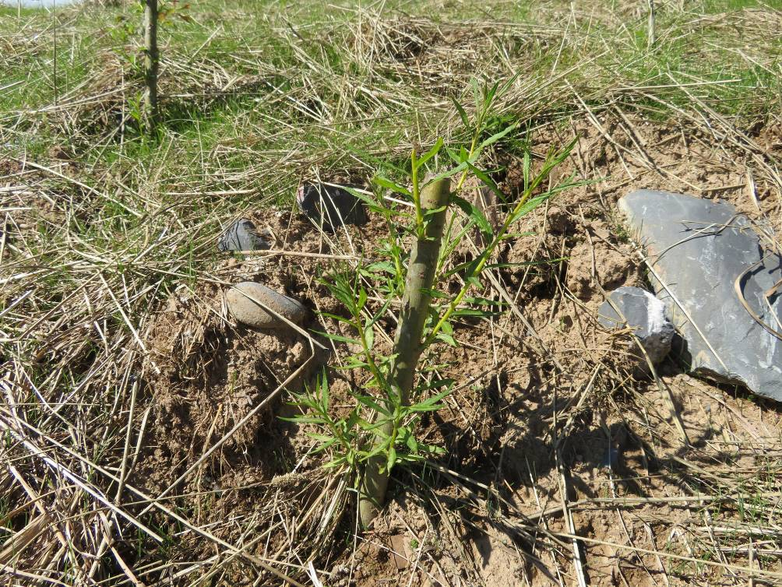
Figure 4. The willow stakes 3 weeks after restoration
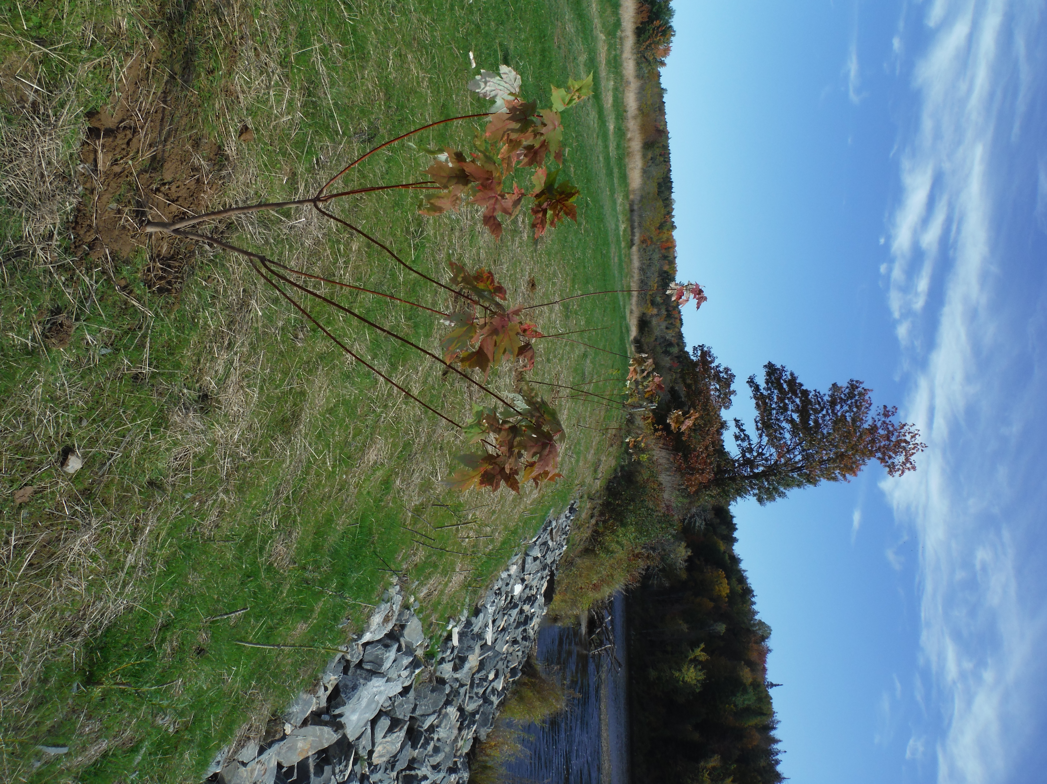
Figure 5 Trees were planted along with volunteers from MCFT in October

Project performance and evaluation:
Please provide an evaluation and assessment of the performance of your project according to the performance measures outlined in the funding agreement. Include problems you encountered and how they were solved, unexpected outcomes, budget inaccuracies, timing changes, and recommendations for future work.
We restored ~160 m² of eroding bank at Nashwaak Vallye Farms. Two summer students as well as the landowner were mentored in bioengineering techniques. We worked with HILCON Ltd. engineering firm to properly design the restoration including the size and amount of rock that would be included in the toe, how far up the bank the toe would extend, and the slope of the bank.

Before we restored the bank, we took water quality samples upstream and downstream and we installed a temperature logger. After restoring the bank we took additional water quality samples upstream and downstream. We compared water quality but measurable differences were not noticed aside from a drop in Total Dissolved Solids and some metals (most notably zinc). We will continue to monitor water quality next year to see if long term differences can be determined. We also sampled benthic invertebrates using the CABIN method along with two volunteers. We have not yet received the results of this sampling.

Thanks to two volunteers from Maritime College of Forest Technology, we planted 20 silver maple trees. We also planted 250 willow stakes along the bank, which started growing very quickly.

Compared to before the restoration, sediment is no longer falling into the stream. The bank is stable thanks to the shallower slope and the vegetation planted on top of it. We will be watching the bank closely over the winter and spring to see how it holds up. We are committed to doing any repairs necessary. The landowner will reinstall his fence in the spring and pasture his animals next year. We received much traditional media coverage (TV, radio, and newspaper) for this project via CBC TV, CBC Radio, CBC.ca, CTV News, Global News, and the Daily Gleaner. Some coverage can be found here https://www.nashwaakwatershed.ca/2019/08/15/eroding-riverbank-restoration/.

Along with other groups along the lower St John River, we have completed the first draft of the Restoration Handbook. The Kennebecasis Watershed Restoration Committee are heading up this project. The NWAI recommended that the Handbook be reviewed by DFO, NBNRED, and NBDELG before it is finalized. No social media post have yet been made as the Handbook is still in the draft stage.

Performance measure  Please take from Attachment “A” of the Funding Agreement | Results
Number of NWAI staff and volunteers trained/ mentored in bioengineering techniques | 2 summer students and the landowner were trained in bioengineering techniques
NWAI has input into the Restoration Handbook/Toolkit to be shared with other watershed groups in the future | The NWAI is working with other St John River watershed groups (headed by KWRC) this winter to finalize the restoration handbook/toolkit
Stamped engineering drawing produced | The drawing is complete
Length and area of bank to be restored | A 40 m long and 160 m² area of bank was restored
Number of willow stakes planted | 250 willow stakes were planted
Number of native trees planted | 20 silver maples planted in October
Area re-vegetated (m²) | 160 m² revegetated with trees, willow stakes, or grass
Number of water quality samples taken | 4 water quality samples have been taken
Comparison of the change in water quality (before/after) | Water quality results were compared. There were minimal differences before/after the restoration. There was a significant drop in TDS and some metals. We will continue to sample water quality next year.
Comparison of the quality of habitat (before/after) | What was originally a crumbling bank of hard clay sediment, is now a well vegetated bank with a slope that will allow flood water to pour over it into the floodplain instead of scouring the toe of the bank. As the vegetation along the bank grows, it will provide riparian habitat for animals and will shade the river.
Report is shared with project funders, partners, and the public | This report will be made public this winter.
Number of people reached through social media and newsletter | The project was featured in our annual newsletter (October). We received much traditional media coverage of this project via CBC TV, CBC Radio, CBC.ca, CTV News, Global News, and the Daily Gleaner. Some coverage can be found here https://www.nashwaakwatershed.ca/2019/08/15/eroding-riverbank-restoration/
Number of volunteers engaged | Three volunteers, including the landowner, was engaged in the project (restoration, planting, sampling). Unfortunately due to logistics, we could not involve more volunteers in the actual restoration.  We also had in kind contribution from ASF and KWRC for the technical aspect of the project
Number of volunteer hours | So far, the landowner has contributed 50 hrs of volunteer time to remove his fence, hydroseed the bank, cover the bank with hay, water the bank, and be present on the day of the restoration. Two students from MCFT contributed a total of 20 hours of volunteer time helping with planting and CABIN sampling.  KWRC and ASF contributed 25 hours in total
Number of social media posts and other communications about the Restoration Handbook and Toolkit, which will be finalized in 2020 | No social media posts have been made yet as the Handbook is in the draft stages.

Section C Project Results

Stream(s) or river(s) where project took place: Nashwaak river at Nashwaak Valley Farms

2. If applicable, please provide the following information as they apply to your project. Please include only new achievements that have not been reported to ASCF in past projects.

Check | Indicator | Measure | Project Achievement
Development of Atlantic salmon and salmon habitat watershed plan
 | Watershed plans developed/implemented | Number of watersheds involved
 |  | Number of plans
 |  | Km² of watershed area under planning and priority setting
Restoration of salmon habitat
 | In-stream habitat length restored | Length (m)
 | In-stream habitat area restored | Area (m²)
x | Riparian length restored or stabilized | Length (m) | 40
x | Riparian area restored or stabilized | Area (m²) | 160
x | Trees and shrubs planted | Number of trees/shrubs | 20 trees, 250 willows
 | In-stream structures installed | Number of structures
Rebuilding of stocks and restoration of salmon populations
 | Fish tagged | Number of fish tagged
Restoration of access to salmon habitat
 | Restored access to habitat | Area (m²)
 | Debris removed | Tonnes
Education and Awareness on the importance of salmon conservation
 | Type of project | Community stewardship
 |  | Education and awareness
 |  | Volunteer training
 | Target Audience and participants | Number of Grade k-12
 |  | Number of Post Secondary
 |  | Number of Landowners contacted
 |  | Number of audience members at public presentations
 |  | Number of participants at community planning
Other indicators of success
 |  | Value or unit of measure
 |  | Value or unit of measure
Section D Communications and Media

Yes | x | ______ quantity | No
- Did you use the ASCF logo or sign?
If No, please explain why not:
__The sign is displayed at all times in our office. The logo is displayed on our website and on our newsletter._____________

Yes | X | No
- Did you provide recognition to the Foundation for its grant?
Please explain the nature of the recognition:

Recognition was given on our newsletter, website, verbally at our AGM, mentioned in all of our interviews with media covering the restoration project, and on social media.

- Please indicate which communication tools were used to highlight the project as well as the quantity (check all that apply). Be sure to attach any news clippings to the Final Report.
Newspaper | x | _Daily Gleaner____________ quantity
Interview | x | CBC TV, Radio, CTV News, Global TV, CBC.ca____________
Brochure | x | __Newsletter___________
Website | x | __www.nashwaakwatershed.ca___________
Other |  | https://www.nashwaakwatershed.ca/2019/08/15/eroding-riverbank-restoration/

Yes |  | No | x
- Are you submitting a project report (other than this one)?
If yes, please be sure to send the foundation a pdf copy.

- Did you send your data and results to another organization or data warehouse where people can access the information? Please state the organizations:
__Water quality will be put on Atlantic Datastream and is shared with DELG for their water portal. CABIN data will be uploaded to ECCC’s data portal.

Section E Partner and Funding Information
- Please list all involved partners in the project and their contributions.
Please verify that the total below matches the total presented in Part 5 of the Budget.
Organization name | Type of group* | Description or function of partner | Amount
 |  |  | Cash | In-kind
ASCF | NG | Funding partner | 11,800
Landowner | NG | Volunteer/in kind materials |  | 2,000
MCFT students | NG | Volunteer |  | 450
Eco Action | NG | Funding partner
KWRC | NG | Technical support |  | 2,500
ASF | NG | Technical support |  | 1,200
NWAI Board of Directors | NG | Project oversight |  | 1,200
NWAI Tree Nursery | NG | Tree seedlings and willow stakes |  | 3,600
NWAI equipment bank | NG | Safety, monitoring, and tree planting equipment |  | 1,350
Sub-total |  |  |  | 12,300
Total (Cash + In-kind Sub-totals)
*Government (g), non-government (ng)

- Total number of staff (including students) paid through ASCF grant: ____2____ and staff paid through other organizations:___2_____.

- Total number of students paid through ASCF grant: ____0____ and students paid through other organizations:____2____.

- Total number of volunteers involved in the project _5__ and their total hours worked for the project ___95 hrs_____.

- Statement of Expenditures

Please provide a detailed financial statement of ASCF grant expenditures, in-kind and other funds using the Budget spreadsheet.

Be sure to attach copy of receipts for ASCF expenditures only to this Final Report.

Section F Recommendations to ASCF
To assist us in improving our process, please provide any comments or suggestions you may have on your experience with the ASCF.

