Expenditure Responsibility Mandatory Report Form

Grant # 1801-50275

Reporting Information
Award Date: | February 9, 2018 | Grant Period: 12 months
Grant Amount: | $8,000.00
Grant Purpose: | project, Assessing and Improving Fish Passage in the Nashwaak Watershed
Fiscal Year* End Date: | 3/30 | Report Due Date: March 1, 2019
* Fiscal year is your business or financial year, also known as your organizational accounting period.

Organizational Information
Contact Name & Title: | Ms. Marieka Chaplin, Executive Director
Organization Name: | Nashwaak Watershed Association Inc
Organization Address: | PO Box 341 Station A  Fredericton, New Brunswick E3B 4Y2  Canada
Please list any corrections:

I. Compliance Confirmations

Funds were used only for purposes stated in the Award Letter. ________________ (signature)
All Terms and Conditions of the grant were met. ________________ (signature)

II. Financial Report
Please provide a financial report detailing the expenditures made from this grant using this format:

Expenditures (e.g. salaries, rent, supplies) | Expended | Balance to be Spent
 | $ | $
 | $ | $
 | $ | $
 | $ | $
 | $ | $
Total | $ | $
Please be sure your report is in U.S. dollars.
Exchange Rate: ______________ Date of Exchange Rate: ____________

III. Narrative Report
Please provide a short narrative indicating the progress made towards the purpose of the grant.

The project deliverables were as follows: 1) conduct a preliminary field survey of at least 50 culverts in the central watershed, 2) clean up garbage and debris from all assessment sites; 3) prioritize them for remediation in terms of barriers to fish using The Nature Conservancy’s Barrier Assessment Tool (A GIS-add on); 4) update our aquatic connectivity map of the watershed, 5) remediate at least one priority culvert, using a local hydraulic engineering company’s expertise as a guide; 6) conduct electrofishing surveys; and 7) share results with the Department of Transportation and other partners.

The objectives of the project were met and surpassed. All deliverables were completed within the time frame of the grant; however, the project was set up to be a multi-year project. Therefore, the deliverables will carry over into the 2019-2020 field season and beyond.

We believe that the project had, and will continue to have, the intended socio-economic and environmental impacts. By remediating culverts, we have facilitated fish passage through these barriers and increased the amount of available upstream aquatic habitat for migratory fish, especially Species of Concern such as the Endangered Atlantic salmon.

Over the course of 2017 and 2018, NWAI’s capacity to survey the Nashwaak watershed has greatly increased, as has our knowledge about the connectivity and fragmentation of our watershed. We have been able to inform the public about habitat fragmentation via online and printed resources, we have developed a relationship with NB Department of Transportation and Infrastructure (NBDTI), and we completed our first major remediation project. There are ~985 stream-road crossings in the Nashwaak watershed (Figure 1). In May 2017, the NWAI began to map, assess, and improve these crossings. In our first field season we completed a full survey on 75 culverts and 70% were determined to be full or partial barriers to fish passage. In 2018, our second field season, we started by mapping out priority areas in the central watershed to survey, we then visited 114 sites and conducted a full-survey of 67 crossings. We updated our survey form so that full surveys included collecting water temperature, pH, conductivity and total dissolved solids as well as some additional measurements and observations that were not included in 2017 surveys. We cleaned all 67 surveyed sites of debris and garbage (removing several kilograms including many discarded tires, rims, and car batteries!).

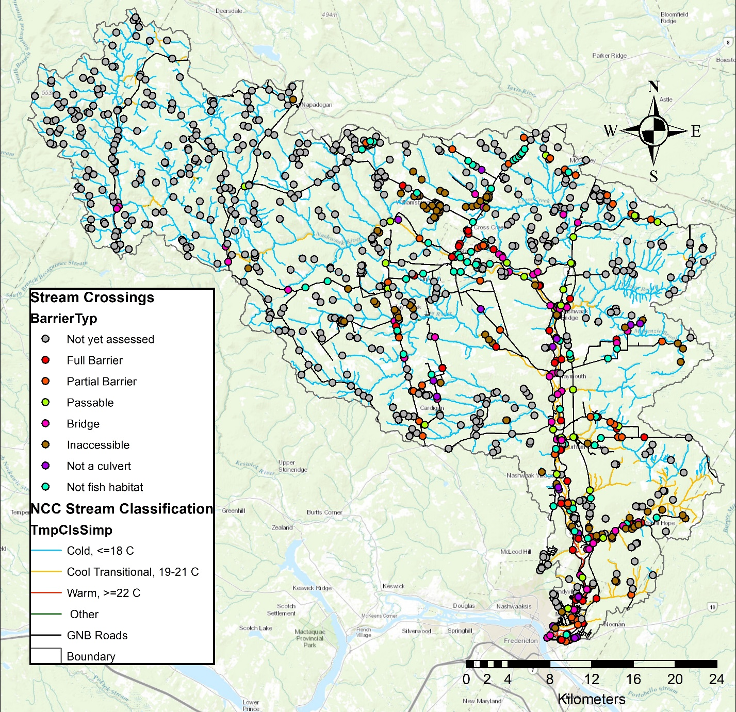
Figure 1. Stream classifications in the watershed superimposed on the Nature Conservancy of Canada's stream classification layer (used with permission). Crossings are classified by barrier type.

This survey information was entered into a central database and a GIS map, which will be shared with our partners at the end of the year. So far, we have assessed 252 of the 985 crossings in the watershed (~25% complete) and we have done a full survey on 142 culverts, surpassing our goal of surveying 100 culverts. Of these, 68% have been determined to be barriers to fish. We have surveyed almost all the crossings on public paved roads. From our database, the slope and outflow drop were calculated and from this the culvert could be categorized as a Full Barrier, Partial Barrier, or Passable. We have shared our data with the Atlantic Canadian Culvert Assessment Toolkit (run by Petitcodiac Watershed Alliance in 2017 but we are unsure of the status of the project at the moment). We have also shared our data with the NB Department of Transportation and Infrastructure. We mapped all the surveyed culverts using GIS. Photos of all culverts are available HERE. Online mapping is available HERE.

We have begun working with the Nature Conservancy of Canada (NCC) to use a GIS add-on developed by their American counterpart (TNC)’s: The Barrier Assessment Tool (BAT). This has allowed us to 1) prioritize sub-watersheds for assessment in the future and 2) prioritize assessed barriers for future remediation based on ecological and structural priority. We have shared the information with NBDTI at a meeting in December 2017 and during the summer of 2018. Working with NCC on this pilot project, that combines the BAT with their unpublished Freshwater Ecological Classification and Aquatic Blueprint, will allow us to contribute our data to an international effort focused on restoring connectivity for both ecological and climate change adaptation (flooding – emergency services provisioning- risk to culverts) purposes: The North Atlantic Aquatic Connectivity Collaborative. Figure 2 shows the results of the BAT analysis of our 2017 field season data.

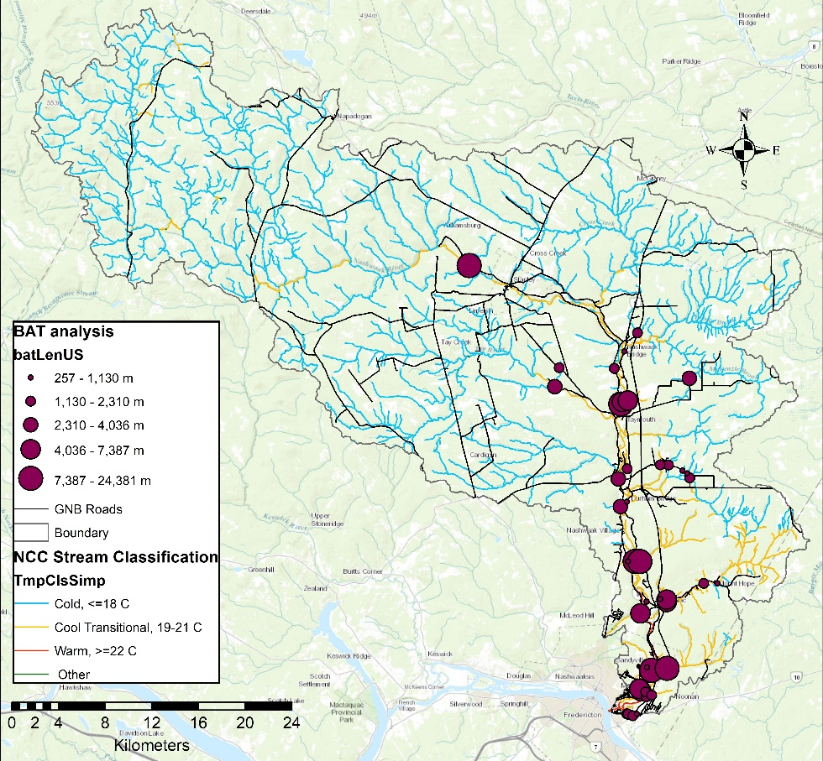
Figure 2. Barrier Assessment Tool (BAT) analysis of full and partial barriers assessed in 2017. The larger the dot, the more upstream habitat is blocked. The NCC stream classification layer has been used with permission.

Of the culverts surveyed in 2017 and 2018, only 32% (n=41) were passable to fish. 38% (n=48) were partial barriers while 30% were full barriers. Major issues preventing fish passage include: 1) culverts installed at steep slopes without baffles [this causes high velocities and eventually results in the erosion of the plunge pool resulting in a large outflow drop (Figure 3)]; 2) deteriorating infrastructure including collapsing wooden box culverts and rusting metal pipes (we were informed by DTI that the wooden box culverts are slated to be replaced in the coming years and, therefore, we were told not to focus remediation efforts on these culverts); and 3) beaver activity completely blocking a number of culverts, especially along Rte. 8 (reported to DTI). Many of the existing culverts cannot be remediated to provide fish passage; they simply need to be replaced with new, properly designed and sized infrastructure.

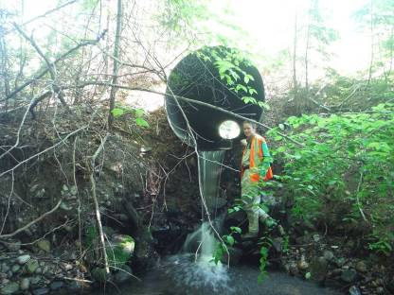
Figure 3. NWAI staff member Jillian Hudgins stands beside a culvert that has a 1.47 m outflow drop, which has caused a lot of erosion around the plunge pool. This culvert needs to be replaced.

For our first remediation project we chose to work on culvert M102 where Manzer Brook crosses Rte. 628. We chose Manzer Brook because is one of the larger fish-bearing watercourses in the lower watershed where stream-road crossings are culverts (larger streams have bridges as stream crossings). It is also on a well-traveled road. Based on conversations with surrounding landowners, it appears that the hydraulics of the brook have changed since Rte. 8 was built in 2009-2010. Department of Transportation and Infrastructure (DTI) remediated this culvert in 2000 but their fix washed out in the following year. Based on conversations with DTI, we were encouraged to focus our efforts on the Manzer Brook-Rte. 628 culvert as 1) many of the surveyed stream crossings in our watershed are either old wooden box culverts slated to be replaced by DTI in the near future, 2) the culvert is structurally in good shape, and 3) there was a previous (failed) attempt to instate fish passage for salmonids. The remediation was designed by HILCON Ltd. with input from Atlantic Salmon Federation and UNB Civil Engineering students. By reinstating fish passage at this stream crossing, we have opened 28 km² of previously inaccessible habitat (Figure 5).

In August 2018, we installed a 3 m long fish ladder on a barrier culvert on Manzer Brook where it crosses Rte. 628. This had been assessed in 2017 and was at the top of our priority list for remediation. Before remediation we electro-fished the site with the help of University of New Brunswick students. We found Atlantic salmon parr (Figure 4) and American eel below the barrier culvert but not above. Other species found below were: burbot, slimy sculpin, brook trout, white sucker, and black nosed dace. Above the culvert we found: sea lamprey, brook trout, black nosed dace, slimy sculpin, and creek chub. We will electrofish again the spring to determine the success of the ladder.

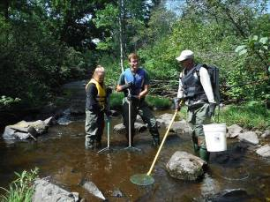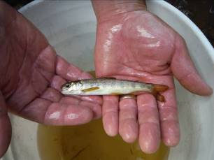
Figure 4. UNB staff and student help NWAI summer student Claire Ferguson electrofish downstream of Manzer Brook (L). One 12 cm Atlantic salmon parr was found downstream of the barrier culvert (R).

The lightweight aluminium fish ladder (Figures 5 and 6) was custom designed by a local hydraulic engineer and built by a local metalworks company. We had 10 volunteers assist with the installation. We also planted 100 live willow stakes around the plunge pool of the culvert to help prevent further erosion. We will electrofish the site again in the late spring of 2019 to see the changes in fish population.

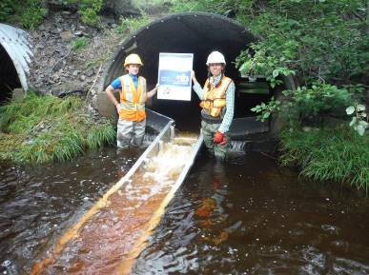
Figure 5. NWAI staff Jillian Hudgins and Marieka Chaplin stand beside the fish ladder after its installation on Manzer Brook.

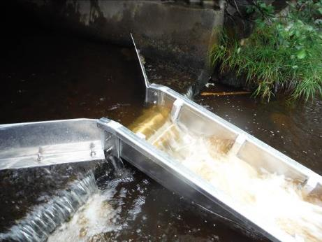
Figure 6. Close up of the fish ladder at Manzer Brook.

In addition to this large repair, we cleared 6 major debris blocks in 2018 that improved flow and fish passage in those culverts and improved water quality in those streams. We have recommended to NBDTI that they take immediate action on 4 culverts. We have received responses about 2 of these culverts –a collapsing culvert and an already collapsed culvert that is due to be replaced soon. We were also told that all the older wooden box culverts along Rte. 628 and 148 were due to be replaced in the coming years and to not focus our efforts on these culverts.

In September 2018 we began the next steps to remediate two more barrier culverts (Figure 7). Both are full barriers to fish passage. We are working together with the same engineering company who have conducted the hydraulic survey who is now working on remediation options. They hope to have preliminary drawings ready to share with NBDTI early in the new year. Together these would open 6.3 km² of cool or cold-water habitat that was previously inaccessible.

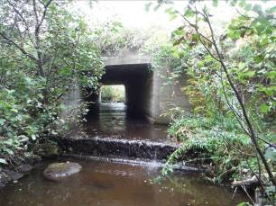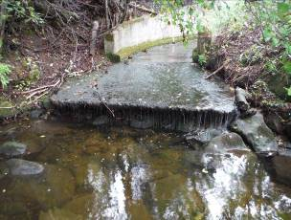
Figure 7. The culverts we have chosen to focus remediation efforts on next. Both have significant drops at their outlets and flat, wide bottoms.

Field work has involved 90 volunteer hours (UNB students, ASF, St Mary’s First Nation, Nature Conservancy of Canada staff, NBCC, and NWAI board members. UNB also allowed us to borrow survey equipment valued at 500$. We had much more in-kind support than anticipated. Particularly from UNB Master’s student Calvin O’Neill and undergrad student Laura Wishart, who took on a special study of the Manzer Brook culvert (100 hours each). The Nature Conservancy of Canada (NCC) has provided 40 hours of in-kind training on using and piloting their Barrier Assessment Tool. In addition, NBDTI lent us road signs to use during the installation of the fish ladder. Our first remediation project was very successful. We had 10 volunteers involved in the installation and it went very quickly (2.5 hours to install). The ladder is performing as expected, backing up water in the middle pipe and channeling it through the ladder.
We continue to work hard to communicate the importance of connectivity of the river to the public via our social media channels, our annual newsletter, and conversations with landowners.
We have begun working with the Nature Conservancy of Canada (NCC) to use a GIS add-on developed by their American counterpart (TNC): the Barrier Assessment Tool (BAT). Working with NCC on this pilot project that combines the BAT with their unpublished Freshwater Ecological Classification and Aquatic Blueprint, will allow us to contribute our data to an international effort focused on restoring connectivity for both ecological and climate change adaptation (flooding – emergency services provisioning- risk to culverts) purposes: the North Atlantic Aquatic Connectivity Collaborative. We are also contributing the data to a regional database: the Atlantic Canada Culvert Assessment Toolkit.

IV. Report Submission
Each grant must be reported on separately. Your organization is required to submit a report for each year in which your organization receives or spends any portion of these funds.

To submit all reports, please visit www.tidesgrantreports.org and follow the instructions on the website. If you do not have internet access, please mail one copy of your report to our national office in San Francisco, Attn: Grants Administration.

The undersigned officer or authorized representative of the organization affirms that all the foregoing information is correct and accurate.

Name of Officer or Representative Title

Signature of Officer or Representative Date

