

Figure 1: NWAI Project Assistant Claire Ferguson weeding at our native tree nursery in Durham Bridge.

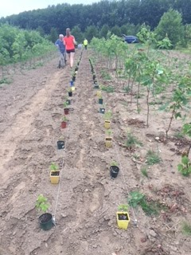

Figure 2: Planting silver maples at the native tree nursery.

Figure 3: Interviewed by CBC News about the willows that we use for our restoration projects.

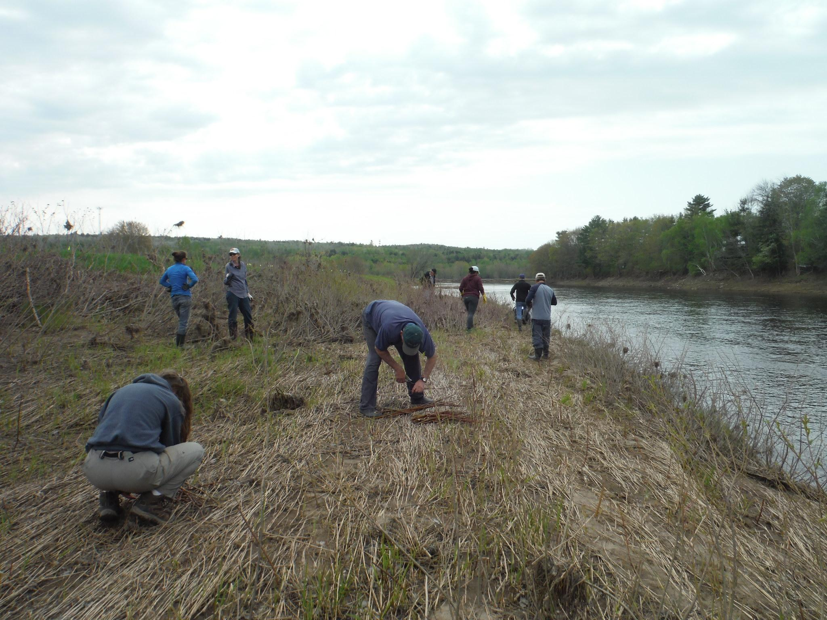

Figure 4: Live willow staking along the river.

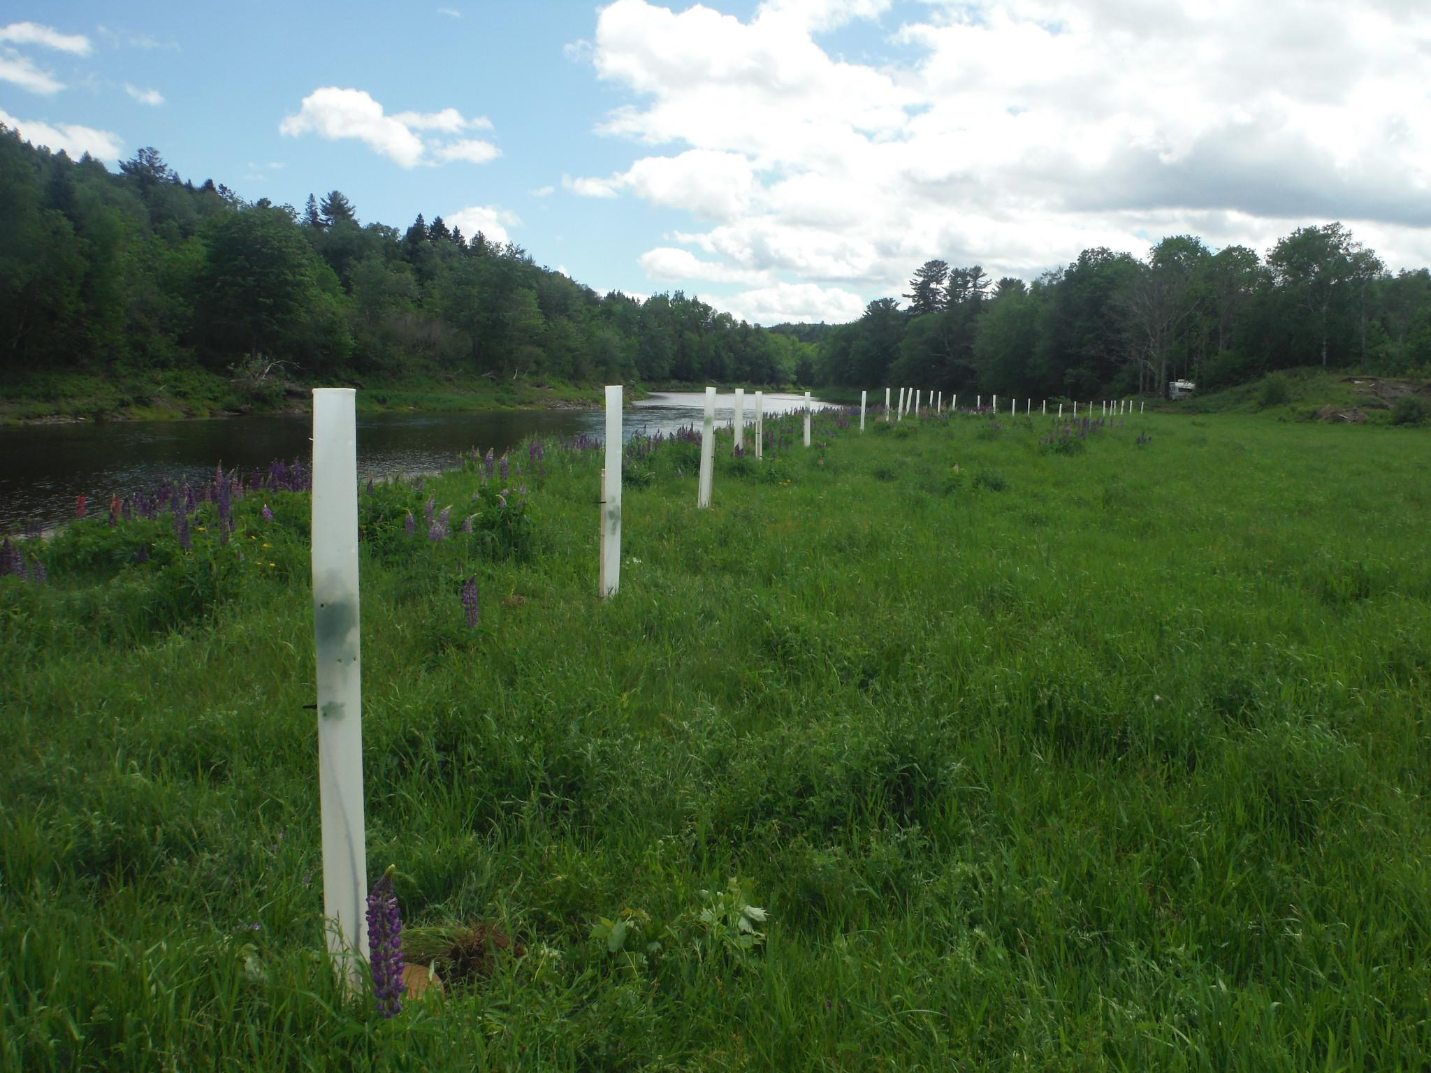

Figure 5: Using Miracle Tube Tree Shelters during shoreline plantings to increase survival rates.

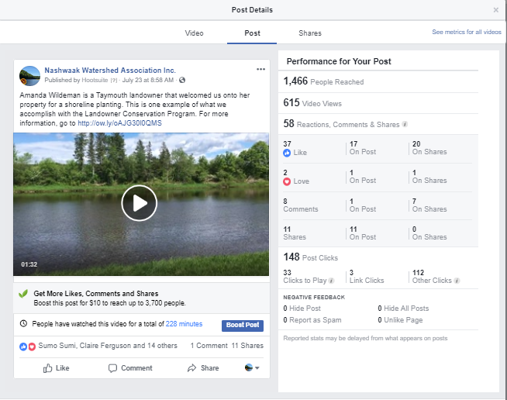

Figure 6: Social media post of landowner talking about a shoreline planting that we did on her property.

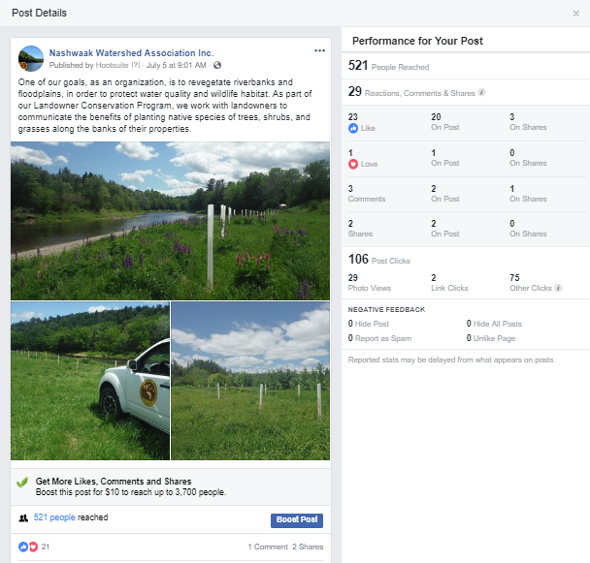

Figure 7: Social media post promoting the Landowner Conservation Program.